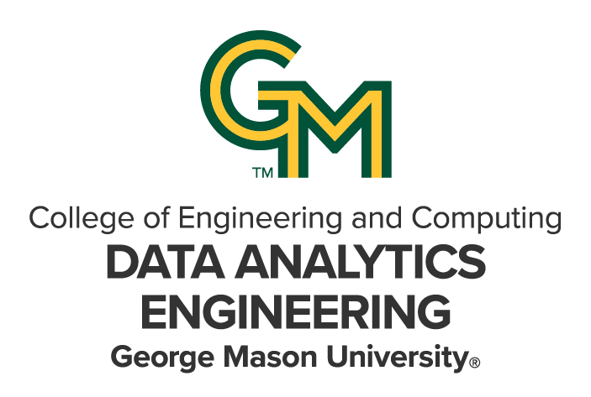

DAEN 690

Project Report

Rohith Panjala

Santosh Vardhan Nayudu

Praneeth Reddy Vattipally

Mahesh Tanniru

Preetham Reddy Dhareddy

Fall 2024

Generative AI Retrieval-Augmented Generation (RAG) Chatbot Prototype for City Governments

**About the Cover**

James Baldo is an associate professor and serves as the Director of the George Mason University (GMU), College of Engineering and Computing (CEC), Volgenau School of Engineering (VSE), MS Data Analytics Engineering (DAEN) program. Dr. Baldo has served in this position since Fall 2018 and recently returned this past May after a 2-year sabbatical applying state-of-the-art data analytics engineering concepts and technologies to solve real world problems.

Prior to becoming director of the DAEN program he served 19 years as a CEC adjunct professor while working as a practicing engineer. His career has over 45 years of industry and government experience with roles as a data analytics engineer and software engineer.

His interest in large scale data, data management, analytics, and tools has provided him with opportunities to engage in assessing and applying new technologies across a diverse range of problems. The adoption of new technologies is exciting; however, adoption of new technologies requires careful planning and in addition to the technology, taking special care for planning how to successfully address for both organizational and cultural factors of the enterprise. This requires not only engineering knowledge and skills, but the ability to work on teams that interact across different corporate stakeholders.

Dr. Baldo continues to consult part-time with industry and leverages this knowledge and experience as feedback to the DAEN program. With technology moving at a lightening pace and technology adoption rates increasing, Dr. Baldo closely monitors the skillset needs of industry and how the DAEN program can provide graduates to fulfill these needs.

Dr. Baldo is currently researching applications of data mesh and data fabric for data management and exploring how analytics will be integrated into agentic systems.

Contents

Table of Contents

Section 1: Introduction 3

1.1 Report Purpose 3

1.2 Report Readership 3

1.3 Report Structure 3

Section 2: Problem Definition 4

2.1 Problem Space 4

2.2 Research 4

2.3 Solution Space 7

2.4 Project Objectives 9

2.5 Primary User Stories 10

2.6 Product Vision 10

2.6.1 Scenario 1: Faster City Services with AI Chatbot 10

2.6.2 Scenario 2: Simplifying Tasks for City Employees with AI 10

Section 3: Datasets 11

3.1 Overview 11

3.2 Field Descriptions 11

3.3 Data Context 12

3.4 Data Conditioning 13

3.4.1 QnABot-VirginiaBeach Stack: 14

3.5 Data Quality Assessment 27

3.6 Other Data Sources 28

3.7 Storage Medium 28

3.8 Storage Security 28

3.9 Storage Costs 28

3.10 IAM Roles 29

3.11 Cost Optimization Approach 29

Section 4: Implementation 30

4.1 Solution Approach 30

4.1.1 Systems Architecture 31

4.1.2 Systems Security 31

4.1.3 Systems Data Flows 32

4.1.4 Bedrock Models and Our Selected Implementations 32

4.1.5 Default Chatbot 33

4.1.6 Updated chatbot 33

Section 5: Testing and Validation 35

5.1 Testing 35

5.1.1 Testing Categories 35

5.2 Validation 53

Section 6: Findings 54

Section 7: Summary 54

Section 8: Future Work 55

Table of Contents

Figure 1: Reference Architecture 6

Figure 2: System Architecture 8

Figure 3: Data Collection using Webcrawlerv2. 12

Figure 4: Count of crawled documents. 12

Figure 5: Storage used for crawled documents. 13

Figure 6: Cost Optimization with Data Backup 27

Figure 7: System Architecture 28

Figure 8: Operating Hours Query 33

Figure 9: Library Hours Query 34

Figure 10 : News Update Query-1 34

Figure 11: News Update Query -2 34

Figure 12 : News Update Query -3 35

Figure 13: VB Update Query -1 35

Figure 14: VB Update Query -2 35

Figure 15: VB Update Query-3 36

Figure 16: VB Update Query-4 36

Figure 17: VB Update Query-5 36

Figure 18: Emergency Update Query-1 37

Figure 19: Emergency Update Query-2 37

Figure 20: Emergency Update Query-3 37

Figure 21: Emergency Update Query-4 38

Figure 22: Emergency Update Query-5 38

Figure 23: Road closures Query-1 38

Figure 24: Road closures query-2 39

Figure 25: Road closures query-3 39

Figure 26: Road closures query-4 39

Figure 27: Road closures query-5 40

Figure 28: Career opportunities query-1 40

Figure 29: Career opportunities query-2 40

Figure 30: Career opportunities query-3 41

Figure 31: Career opportunities query-4 41

Figure 32: Career opportunities query-5 41

Figure 33:Community Engagement query-1 42

Figure 34: Community Engagement query-2 42

Figure 35: Community Engagement query-3 42

Figure 36: Community Engagement query-4 43

Figure 37: Community Engagement query-5 43

Figure 38: Permit Related Query-1 43

Figure 39: Permit Related Query-2 44

Figure 40: Permit Related Query-3 44

Figure 41: Permit Related Query-4 44

Figure 42: Permit Related Query-5 45

Figure 43: Permit Related Query- 6 45

Figure 44: Permit Related Query-7 45

Figure 45: Permit Related Query-8 46

Figure 46: Report Related Query-1 46

Figure 47: Report Related Query-2 46

Figure 48: Report Related Query-3 47

Figure 49: Report Related Query-4 47

Figure 50: Report Related Query-5 47

Figure 51: Voting Related Query-1 48

Figure 52: Voting Related Query-2 48

Figure 53: Voting Related Query-3 48

Figure 54: Voting Related Query-4 49

Figure 55: Typo Error in Query 49

Figure 56: Grammatical Mistake in Query 50

Figure 57: Response Quality 50

Figure 58: Feedback on Thumbs Down 51

Figure 59: Feedback on Thumbs Up 51

Figure 60: The conceptual flow of using RAG with LLMs 56

Figure 61: Sprint project dates. 64

Table of Tables

Table 1: Glossary Table 30

Table 2: Sprint 1 Risks 32

Table 3: Sprint 2 Risks 32

Table 4: Sprint 3 Risks 33

Table 5: Sprint 4 Risks 33

Table 6: Sprint 5 Risks 34

**This page intentionally left blank**

Abstract

Abstract

This project lays the foundation for a Generative AI Retrieval-Augmented Generation (RAG) chatbot aimed at transforming how city governments deliver accessible and timely information to residents and the public. The chatbot addresses a critical gap in providing real-time support for frequently asked questions, public services, and key information such as policies, city budgets, and spending data. By offering clear and straightforward responses, the chatbot seeks to enhance public engagement and ensure reliable information is available 24/7, particularly during off-hours or periods of high demand. The chatbot prototype leverages the AWS QnAbot framework, integrating Amazon Kendra to build and maintain an up-to-date knowledge base from city government resources and Anthropic Claude 3.5 Sonnet via Amazon Bedrock to deliver conversational responses. Prompt engineering techniques were implemented to ensure the chatbot handles diverse queries effectively, providing personalized answers while maintaining clarity and relevance. Manual testing was conducted to evaluate the chatbot’s functionality and assess its error-handling capabilities. The testing outcomes demonstrate the chatbot’s effectiveness in providing reliable responses while handling diverse queries. Test cases and findings were documented to verify that the chatbot delivers the intended outcomes. The final deliverables will include documentation on integration, prompt engineering strategy, and operational guidelines, laying the groundwork for an innovative, user-friendly tool to improve public service communication.

**This page intentionally left blank**

Report

# Introduction

## Report Purpose

This report presents the development of a Generative AI Retrieval-Augmented Generation (RAG) chatbot prototype designed to enhance interactions between the City of Virginia Beach website and its users. The purpose of this report is to address the need for improved accessibility and accuracy of information provided by the city government. It details the project’s goals, which include leveraging AWS services to build a robust and scalable chatbot, evaluating different AI models to ensure optimal performance, and estimating the operational costs involved. The report documents the efforts undertaken to create a solution that facilitates efficient and reliable communication between the city’s website and its users.

## Report Readership

This report is intended for city government officials, IT professionals involved in enhancing citizen engagement and information accessibility. The primary audience includes decision-makers within the City of Virginia Beach government who are responsible for implementing and maintaining digital solutions for public services. Additionally, AI researchers, developers, and engineers interested in the practical applications of Generative AI Retrieval-Augmented Generation (RAG) chatbots will find this report valuable for understanding the project’s goals, methodologies, and outcomes.

Furthermore, this report is prepared for Allwyn Corporation, headquartered in Washington DC, which has provided the project. Allwyn Corporation will use this report to oversee the project’s progress and ensure it aligns with their mission of solving complex technology problems for their clients. The report will help them evaluate the effectiveness of the proposed solution and its potential impact on improving user engagement and information accessibility.

## Report Structure

This report provides a comprehensive overview of the project, starting with the Problem Definition, which identifies the challenges and goals addressed by the chatbot prototype. The Datasets section describes the data selection and preparation methods used to support the chatbot’s development. The Implementation section outlines the development process, including the integration of AWS services and the application of different AI models. The Testing section details the evaluation methods used to assess the chatbot’s performance and refine its capabilities. Following the testing phase, the findings section presents the key results of the evaluation, highlighting the chatbot’s strengths, areas for improvement, and overall effectiveness. The Summary section provides an overview of the project outcomes, reiterating the main achievements and insights gained. Finally, the Future Work section offers recommendations for further development and potential enhancements, suggesting areas where the chatbot could be expanded or improved in future iterations.

# Problem Definition

## Problem Space

City governments repeatedly facing challenges in providing timely and correct information to their citizens. Traditional methods of obtaining information, such as making phone calls, visiting government offices in person, or navigating online websites, are often inefficient and lead to user frustration among citizens and increased workload for government employees. As many people live in cities and technology gets better, number of questions and requests from citizens is increasing. Therefore, there is a clear need for a more efficient, scalable, and user-friendly solution to address these challenges.

Generative AI Retrieval-Augmented Generation(RAG) chatbot offer a promising solution to these challenges. By mixing the strengths off generative models and retrieval-based systems, RAG chatbots can provide accurate and contextually relevant responses to user inquiries. However, the implementation of such systems is not without its challenges.

First, developing and maintaining a RAG chatbot involves complex engineering and fine-tuning of both retrieval and generative components. Also, ensuring the data privacy and security used by chat is important mainly in the context of government data where sensitive information may be handled. To prevent unauthorized access and data breaches strong data protection measures must be placed. Next, latency can be introduced while retrieving information and generating responses which needs to be managed to confirm smooth user experience and sometimes it can lead to user dissatisfaction and reduced effectiveness of chatbot. Lastly, chatbot must be able to handle wide range of inputs at peak times. This requires the ability to dynamically adjust to varying loads.

## Research

Our research for developing the Generative AI Retrieval-Augmented Generation (RAG) chatbot prototype leveraged several key resources that provided deep technical insights into RAG and best practices for implementing a scalable, efficient chatbot for city governments.

**Amazon Web Services (AWS) QnABot Documentation**:

The AWS QnABot solution documentation was key in helping us understand how to build a conversational interface using AWS services. It provided clear guidance on deploying a chatbot that interacts with users through text and highlighted important services such as Amazon Lex for natural language processing, Amazon Kendra for intelligent search, and Amazon S3 for secure data storage. The documentation also offered best practices for integrating AWS Lambda to manage serverless backend processes and using Amazon Bedrock for pre-trained foundational models. These components form the core of our RAG system, ensuring that services like Kendra provide responses that are both factually accurate and contextually relevant.

Additionally, if needed, we can integrate Amazon Translate to support multiple languages. This would enable the chatbot to understand and respond to user queries in various languages, making it more accessible and improving the user experience for a diverse population. Together, these services offer a scalable and flexible solution that ensures accuracy, security, and relevance in real-time responses, meeting the needs of the City of Virginia Beach [2].

**Amazon Web Services RAG Overview**:

According to AWS’s official explanation of RAG, the architecture combines retrieval-based systems with generative AI models to improve the quality of chatbot responses. In this system, generative models, such as Meta AI’s LLaMA, are enriched with information drawn from predefined datasets, such as the City of Virginia Beach’s public records. The RAG architecture enhances both accuracy and relevance by grounding the chatbot's generated responses with current, authoritative data. This mitigates the challenge of hallucination—often associated with purely generative models—ensuring that the chatbot provides reliable and precise answers to city service queries. [3]

**Online Learning Resources - Krish Naik on Udemy, Coursera, and YouTube**:

Krish Naik’s educational materials, particularly his YouTube series and Udemy courses, offered hands-on guidance for the practical implementation of RAG systems. His tutorials provided a comprehensive explanation of how to fine-tune large language models (LLMs) and integrate them seamlessly with retrieval systems like Amazon Kendra. These resources were critical in helping us understand the workflow for integrating retrieval mechanisms that extract relevant data from both structured and unstructured sources, ensuring that the chatbot can effectively address a broad range of citizen queries. Additionally, his content explored optimization techniques for LLMs to manage diverse query types and scale them using cloud-based solutions like AWS, significantly influencing our approach to designing the chatbot’s architecture.

**Amazon Bedrock for Foundation Model Selection**:

As part of our research, we evaluated foundational models offered by Amazon Bedrock, including those from AI21 Labs and Stability AI. Bedrock enabled us to experiment with and select the most suitable models for RAG applications. Selecting the right foundational model is crucial for ensuring that the chatbot delivers human-like, contextually accurate responses while maintaining low latency for real-time user interactions. This evaluation of models informed our decision to incorporate Amazon Bedrock into our solution, leveraging both its retrieval and generative capabilities. [6]

By combining the insights gained from these resources, we identified the essential components required to build a scalable, secure, and efficient RAG chatbot. The integration of retrieval-based systems with generative models backed by AWS services like Lex, Kendra, S3, and Bedrock forms the backbone of our chatbot solution, ensuring its efficacy in providing accurate and timely responses to citizen queries.

**Reference Architecture:**

The reference architecture analysed for this project is based on AWS’s QnABot solution. This architecture incorporates several essential AWS services, including Amazon API Gateway to manage REST API calls, Amazon Cognito for user authentication, and Amazon Lex for conversational AI. Additionally, Amazon Kendra is utilized for retrieval-augmented generation, enabling accurate responses by indexing relevant data sources. Amazon DynamoDB is used to store user queries and chat history, while Amazon S3 manages the storage of QnABot metrics and content. Furthermore, advanced services such as Amazon Bedrock and Amazon SageMaker are integrated to support large language models (LLMs) and enhance the generative AI capabilities of the system.

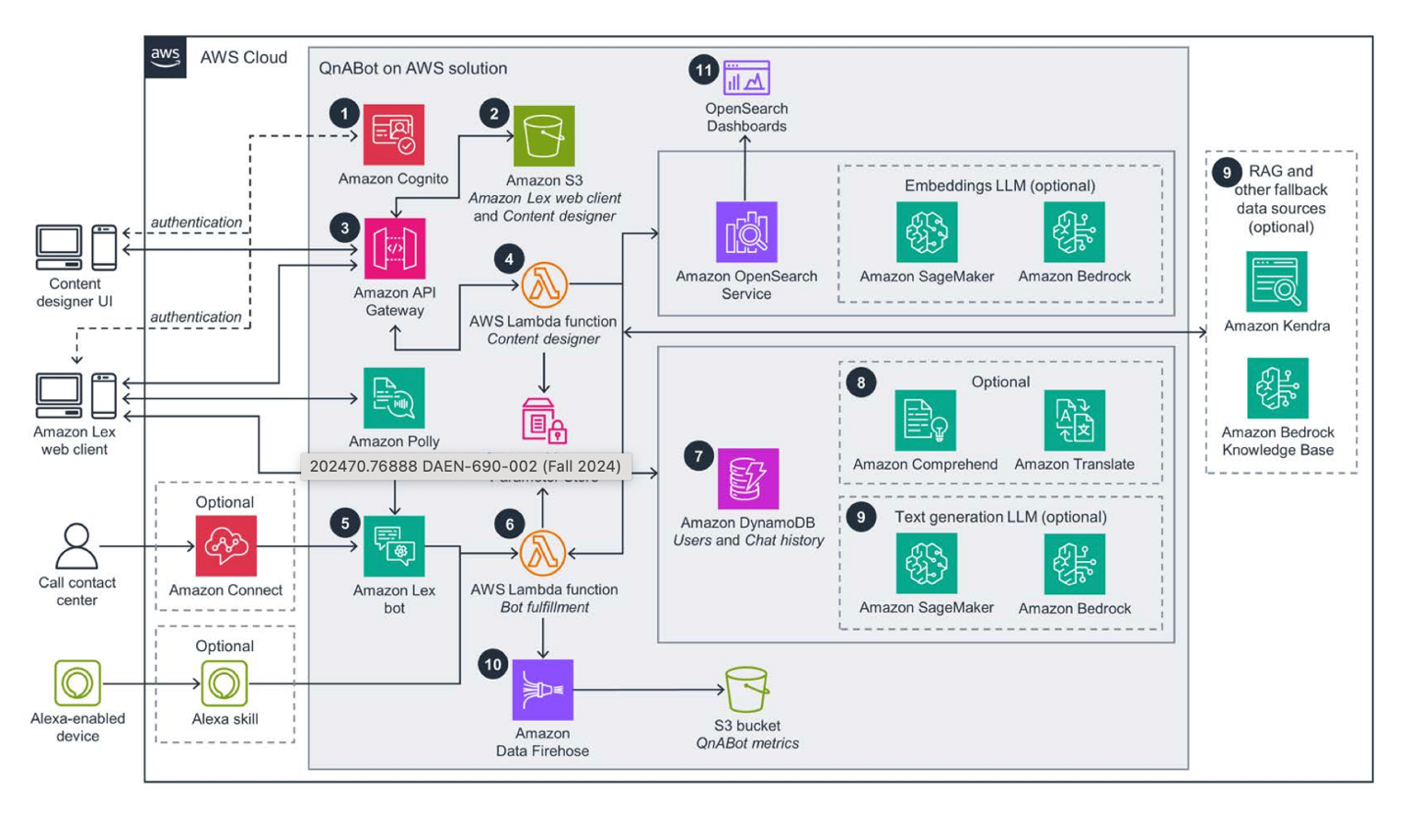

Figure : Reference Architecture

The reference architecture also emphasizes flexibility and scalability, incorporating optional components such as Amazon OpenSearch for advanced data analytics and Amazon Connect for voice-based interaction. This architecture is optimized for multi-channel AI solutions, supporting various input types such as text and voice, and enabling seamless integration with LLMs to enhance the relevance and accuracy of responses.

**Testing:**

During testing, we will fine-tune these models using real-world website dataset from the City of Virginia Beach, focusing on text-based queries to ensure factually correct and contextually relevant responses. To enhance accuracy, we will employ the following approaches:

**Iterative Testing with User Feedback Loops**

User feedback on responses will be collected and used to fine-tune the models, enabling continuous learning and improvement in accuracy.

Example: Users will rate responses, and flagged inaccuracies will guide further model tuning.

**Contextual Query Testing**

Dynamic prompting will be used to test how well the models handle multi-turn conversations, adapting based on prior queries.

Example: Testing how the chatbot responds to evolving queries, from general questions to more specific department-related inquiries.

**Error Handling Testing:**

This testing focuses on evaluating the chatbot's strength and adaptability to errors commonly made by users during interaction. This testing involves submitting queries that contain typos, grammatical mistakes, and uncertainties to see how well the chatbot can interpret and respond to less-than-perfect user input. This testing ensures the chatbot is capable of handling real-world interactions generously, providing accurate responses or seeking clarifications when necessary. By thoroughly testing the bot's ability to manage these flawed inputs, we can refine its error-handling capabilities to improve overall user satisfaction and engagement.

**Functional Testing**

It is a phase where we carefully check the chatbot's performance by feeding it with diverse questions across major user inquiry domains. This helps us verify that the chatbot can correctly understand and respond to typical questions that users might ask. By testing the bot with these queries, we assess its accuracy, relevance, and user interaction quality, ensuring that the responses are both informative and helpful. This process allows us to identify and correct any issues, ensuring the chatbot delivers a reliable and effective user experience.

Overall, these approaches ensure a comprehensive testing strategy that addresses a wide range of query types and scenarios. By functional testing with real-world data and leveraging iterative feedback, we can significantly enhance the chatbot’s performance. This will ultimately lead to a more reliable, contextually accurate, and user-friendly chatbot for the City of Virginia Beach.

## Solution Space

The solution space for the Generative AI Retrieval-Augmented Generation (RAG) chatbot prototype centre’s around designing a robust, scalable, and efficient system that leverages AWS services to enhance citizen engagement with city government services.

**Architecture Design:**

As part of the development of the Generative AI Retrieval-Augmented Generation (RAG) chatbot prototype, A thorough analysis of existing architectural solutions was conducted to identify the optimal framework for the chatbot and designed a system personalised specifically to the requirements of the City of Virginia Beach. The architectural design emphasizes the integration of key AWS services to ensure security, content relevant and real-time response capabilities.

**Final Architecture:**

The final architecture designed for this project builds upon the reference architecture shown in figure 1, with specific adaptations to meet the operational needs of the City of Virginia Beach. Using Amazon QnABot user queries are handled, while Amazon Cognito is employed to manage secure authentication. One of the core enhancements is the integration of Amazon Kendra, which retrieves data from the city’s databases (Virginia Beach data source), ensuring accurate and data-backed responses. The architecture also leverages Amazon Bedrock, which provides pre-trained foundational models that allow the chatbot to deliver real-time, accurate responses. The knowledge base is dynamically updated to ensure that the information remains relevant and accurate.

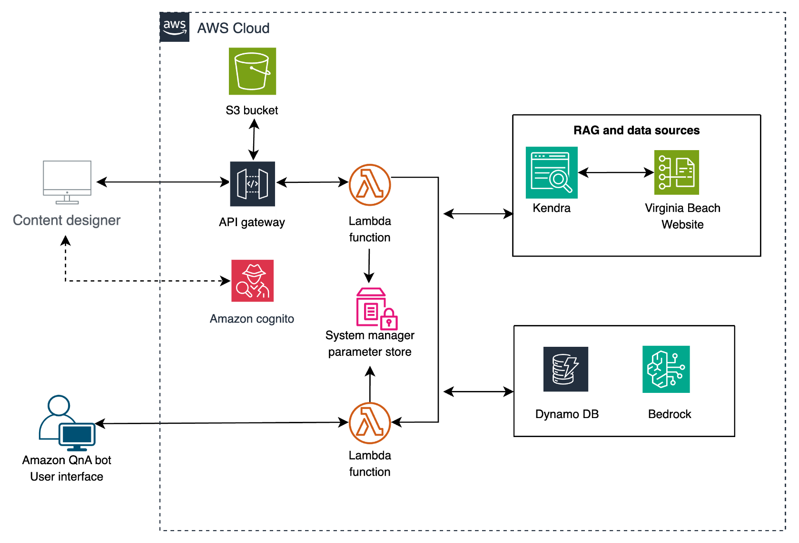

Figure : System Architecture

In addition, Amazon API Gateway and Lambda functions are employed to manage incoming requests and process backend operations, ensuring seamless integration and communication between all architectural components. This final architecture is designed to prioritize real-time data retrieval, scalability, and the delivery of reliable, contextually relevant information to the citizens of Virginia Beach.

**Technology Stack:**

Our solution leverages key AWS services, including Amazon S3 for data storage, Amazon Kendra for intelligent search, and Amazon Bedrock for integrating large language models (LLMs). AWS Lambda will be used for serverless computation, ensuring scalability, while Amazon Cognito will manage user authentication. These services collectively form the backbone of our RAG chatbot system, ensuring that it can efficiently handle user queries in real-time while providing secure and reliable responses.

**AI Model Selection:**

As part of our research, we focused on evaluating foundational models offered by Amazon Bedrock, particularly Claude 3.5 Sonnet from Anthropic, to determine its suitability for our Retrieval-Augmented Generation (RAG) chatbot solution. The selection of the right foundational model is crucial to ensure that chatbot delivers contextually accurate responses that are almost indistinguishable from human interaction, while also maintaining low latency for real-time user interactions. Claude 3.5 Sonnet is known for superior performance in complex reasoning and text generation, making it our primary choice. Our evaluation helped us identify the essential components needed to build a scalable, secure, and efficient RAG chatbot. The integration of Claude 3.5 Sonnet from Amazon Bedrock with AWS services such as Kendra, and S3 forms the backbone of our solution, ensuring it effectively delivers accurate and timely responses to citizen queries.

**Scalability and Security:**

Scalability is a fundamental consideration for the solution, ensuring that the chatbot can dynamically adjust to varying query loads, especially during peak times. Claude 3.5 Sonnet LLM support large volume of queries at a time. The solution leverages AWS Lambda's serverless architecture to ensure scalability and cost-efficiency. Security is another critical aspect, particularly data privacy. As the chatbot interacts with potentially sensitive information, strong security measures, such as encryption and secure authentication via Amazon Cognito, will be implemented to safeguard the data.

**User Experience and Interaction Design:**

Enhancing the user experience is a core goal of the solution. The integration of retrieval-based systems ensures that the chatbot provides contextually relevant and factually accurate responses, thereby improving user satisfaction. The architecture will also prioritize minimizing latency to ensure seamless, real-time interactions. This solution aims to offer a simple interface where citizens can access information about city services without delays or confusion.

**Performance Metrics:**

To evaluate the effectiveness of the chatbot, several performance metrics will be tracked, including response accuracy, user satisfaction, latency, and system uptime. Continuous monitoring and performance optimization will be part of the solution, ensuring that the chatbot consistently meets the needs of the users and adapts to their feedback.

This solution space summarises the architectural choices and technology stack required to deliver a scalable, secure, and efficient RAG chatbot for city governments. By integrating retrieval-based systems with generative models, the chatbot will be able to provide accurate, timely, and contextually relevant responses to a wide variety of citizen queries, ensuring high user satisfaction and improved accessibility to government services.

## Project Objectives

After finishing this project, our team aims to increase our understanding and practical application of Generative AI technologies, specifically focusing on the development of a Generative AI Retrieval-Augmented Generation (RAG) chatbot for city government use. This chatbot is designed to address the challenges city governments face in providing real-time, accurate, and accessible information to the public. By integrating advanced Natural Language Processing and Generative AI through the AWS QnABot framework, Amazon Kendra, and Anthropic Claude 3.5 Sonnet via Amazon Bedrock, our chatbot will facilitate smoother, more effective interactions. Team goal is to create a fully functional chatbot that improves communication between the city government and its citizens, offering faster, more accurate, and personalized responses. This will help reduce wait times and minimize the common errors associated with traditional methods of communication. The chatbot will particularly excel during off-hours or periods of high demand by providing consistent and reliable information access.

The project will test problems such as accuracy of responses, and systems ability to manage large volumes of queries, especially during peak times. The successful implementation of this chatbot will offer significant value not only to the city government but also to its citizens, who are the primary beneficiaries. This project can set an example for other city governments, proving how incorporating AI can transform public interactions. Our work could inspire similar initiatives globally.

## Primary User Stories

To focus on improving the communication between city governments and their citizens using a Generative AI chatbot, we have identified several primary user stories to guide the development and functionality of the system. These stories are based on scenarios that users might encounter when interacting with city services.

As a User, I want to quickly find information on the upcoming events in and around my area for kids this weekend without having to navigate through complex websites or wait on hold with city services.

As a business owner, I need to seek information on business permits, taxes, and zoning regulations. I need details on how to register for an account, what are application fees for zoning permits.

As a traveler, I want to know the restriction areas while visiting the beach, so I can stay away from those area.

As a senior citizen, need to ask about community support services available for elder people and get information through a simple conversation with the chatbot, without the difficulty of searching through various online resources.

As a city official, I want to access real-time data on user inquiries, so that I can make decisions about where improvements are needed.

## Product Vision

### Scenario 1: Faster City Services with AI Chatbot

* For: Citizens of Virginia Beach
* Who: Want quick and accurate information about city services
* The: RAG chatbot
* Is a: Conversational AI tool.
* That: Provides accurate, timely and relevant responses to user queries
* Unlike: Traditional methods of communication like phone call and visiting offices In-person
* Our product: Offers more efficient and user-friendly experience.
* Caveats: The chatbot may require continuous update of information and improvements to maintain accuracy and relevance.

### Scenario 2: Simplifying Tasks for City Employees with AI

* For: City Government Employees
* Who: Need to manage a high volume of routine inquires.
* The: RAG chatbot
* Is a: support tool
* That: Automates responses to citizen questions
* Unlike: Manual handling of inquiries
* Our product: Frees up time for employees to focus on more complex tasks.
* Caveats: Chatbot’s performance may vary depending on the quality of underlying Large language models and data.

# Datasets

## Overview

Virginia Beach website data is our primary dataset, it is designed to be a helpful resource for everyone like residents, visitors, and business owners. [12] Virginia Beach data is packed with variety of information and services, making it as a go-to place for anything related to city. For residents, website data offers easy access to important city services like public safety and utilities, along with community resources that help them get the support they need quickly. It also provides complete details on government operations, including city council meetings, which keeps community informed and involved in local governance. For those who planning to visit Virginia Beach, this website data with full of information on local attractions and events will help them a lot and makes it simple for tourists to plan their visits and enjoy the city’s attractions.

This data has plenty of information on permits, licenses, and economic development, which are valuable for business growth and operations in the city. Whether you’re a resident needing city services, a visitor planning a trip, or a business looking for resources, the Virginia Beach website data provides essential support and resources. If you have specific questions or need more help, the website is ready to assist.

This data is important for the Generative AI chatbot, it is used as knowledge base for the chatbot to respond to citizen inquiries. To ensure the chatbot is equipped with the latest and most accurate information, the project utilizes Amazon Kendra to crawl the Virginia Beach website data. The integration of AWS services ensures that the data collection process is seamless and continuous, providing the chatbot with a strong foundation of up-to-date information directly from the source. This method guarantees that the chatbot remains a reliable and effective resource for users seeking information about Virginia Beach.

## Field Descriptions

**1.URL (Type: string):**

The dataset can be accessed at <https://virginiabeach.gov/>. This is the official website for the City of Virginia Beach, serving as a central hub for information about city services, events, and important announcements.

**2. Title (Type: string):**

The title of the homepage is simply "Virginia Beach Homepage." This straightforward title indicates to visitors what they can expect to find on the site, helping them quickly identify it as the official page for Virginia Beach.

**3. Authors (Type: string):**

The content on this homepage is created by the Virginia Beach City Council. This approach underscores the reliability of the information, as it comes from an official government body rather than individual contributors, ensuring that the content is authoritative and relevant to the community.

**4. Publication Date (Type: datetime):**

11-24-2024(assumed as the last updated date based on the latest blog entry).

**5. Text (Type: string):**

The homepage features various quick links, services, and information about the city, including a section titled "Latest News, Events, and Blogs" that highlights recent articles.

## Data Context

The Virginia Beach Government website dataset equips RAG chatbot with essential links to city services, public policy documentation, and user interactions.

3.3.1 Source of data

The primary data repository for the project is the Virginia Beach Government website, which can be accessed at “<https://virginiabeach.gov/>”. This site is the only source for our project data, focusing exclusively on content directly available from the website without incorporating external data.

3.3.2 Collection Methodology

The data collection process for the Virginia Beach Government website starts with an advanced web crawler integrated in Amazon Kendra to systematically collect a variety of content. [8] This crawler is designed to navigate the extensive resources of the website, capturing essential information such as public notices, FAQs, service updates, and policy documents. As it scrapes the site, Kendra indexes the content, enhancing its searchability and accessibility for the chatbot’s use. The website was crawled using Webcrawler v2, enabling the collection of approximately 8,350 documents.

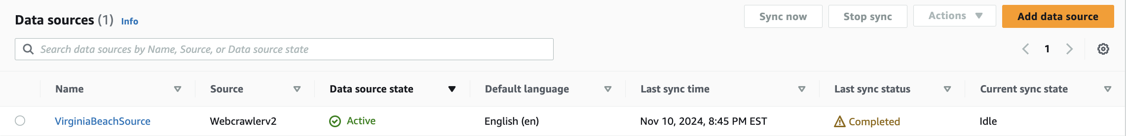

Figure : Data Collection using Webcrawlerv2.

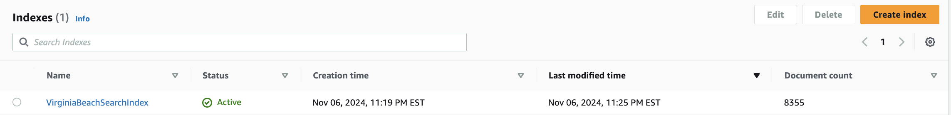

Figure : Count of crawled documents.

Key documents and pages are continually updated by city officials to reflect the most recent changes in city policies, community events, and critical deadlines. These updates are captured in real-time, ensuring the chatbot's responses are both current and contextually relevant. Each piece of content is tagged with metadata like publication dates, relevant tags, and links to related information, which helps in maintaining a structured dataset. The storage size for this crawled documents is around 56 MB. This automated data collection setup ensures that the chatbot is equipped with the latest information, allowing it to provide reliable and timely responses to citizen inquiries.

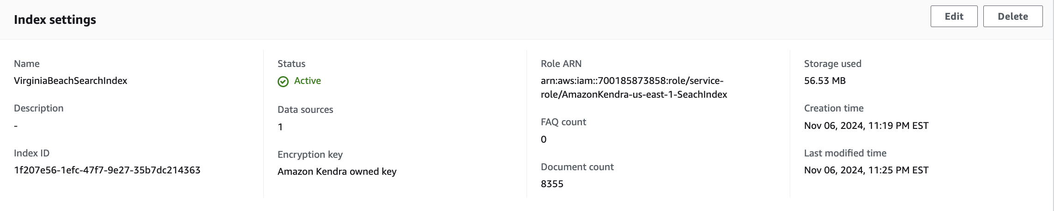

Figure : Storage used for crawled documents.

3.3.3 Data Description

The Virginia Beach Government website data is organized into sections that include articles, public announcements, and different city services and rules. There are also links to more information, related documents, and downloadable files. [12]

This website makes sure that residents of Virginia Beach can always find clear and current information about city services. The data helps the Virginia Beach Government website chatbot give accurate and helpful answers to people’s questions, making it easier for everyone to interact with the city and access the services they need.

## Data Conditioning

For our Virginia Beach Government website chatbot project, we use Amazon Kendra to handle data conditioning. Kendra crawls the website and organizes the information it finds. This includes various types of content like city policy documents, FAQs, and services which are crucial for the chatbot to function properly.

By using Kendra, the data is sorted using existing website details like when the content was published, tags, and categories. This helps make sure that the chatbot can easily search for and find the information it needs to answer questions for Virginia Beach residents. Since Kendra directly indexes data from the website, we don't have to spend extra time cleaning or organizing the data ourselves. This makes the process more straightforward and ensures that the chatbot always has the latest and most organized information available. This helps the chatbot provide quick and accurate support to users, improving how city services are delivered.

The QnABot is implemented using the following AWS tools and frameworks:

1. QnABot-VirginiaBeach Stack: Provides the foundational chatbot infrastructure.
2. QNABOTPLUGIN-BEDROCK-EMBEDDINGS-AND-LLM: Enhances NLP capabilities with embeddings and Bedrock-supported language models.

### QnABot-Virginia Beach Stack:

The **QnABot-Virginia Beach Stack** integrates advanced embedding and LLM capabilities by sourcing Lambda functions from the **QNABOTPLUGIN-BEDROCK-EMBEDDINGS-AND-LLM stack**. The **EmbeddingsLambdaArn** (arn:aws:lambda:us-east-1:700185873858:function:QNABOTPLUGIN-BEDROCK-EMBE-EMBEDDINGSLambdaFunction-5YgL7qepD22Y) handles text embedding operations using the **Amazon Titan-Embed-Text-v1** model, enabling the generation of high-dimensional embeddings for precise semantic search. Similarly, the **LLMLambdaArn** (arn:aws:lambda:us-east-1:700185873858:function:QNABOTPLUGIN-BEDROCK-EMBEDDINGS--LLMLambdaFunction-kQydnJ78VFpu) powers the chatbot’s integration with AWS Bedrock to leverage the **Claude-Instant-v1** model, ensuring fast, context-aware responses for user queries. By utilizing these Lambda functions, the stack achieves seamless performance, dynamic retrieval capabilities, and improved accuracy, enhancing the overall user experience for the Virginia Beach chatbot deployment.

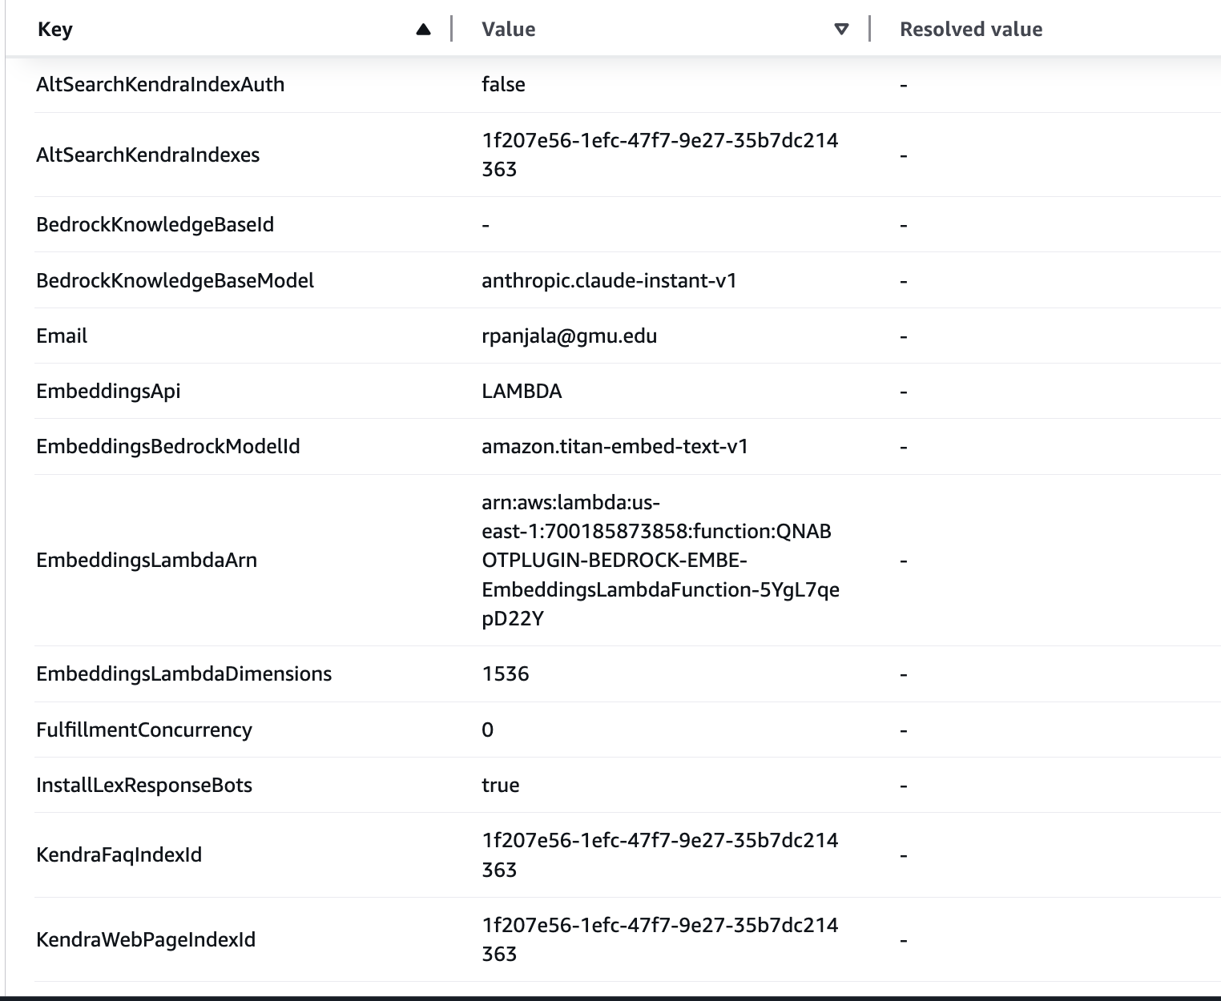

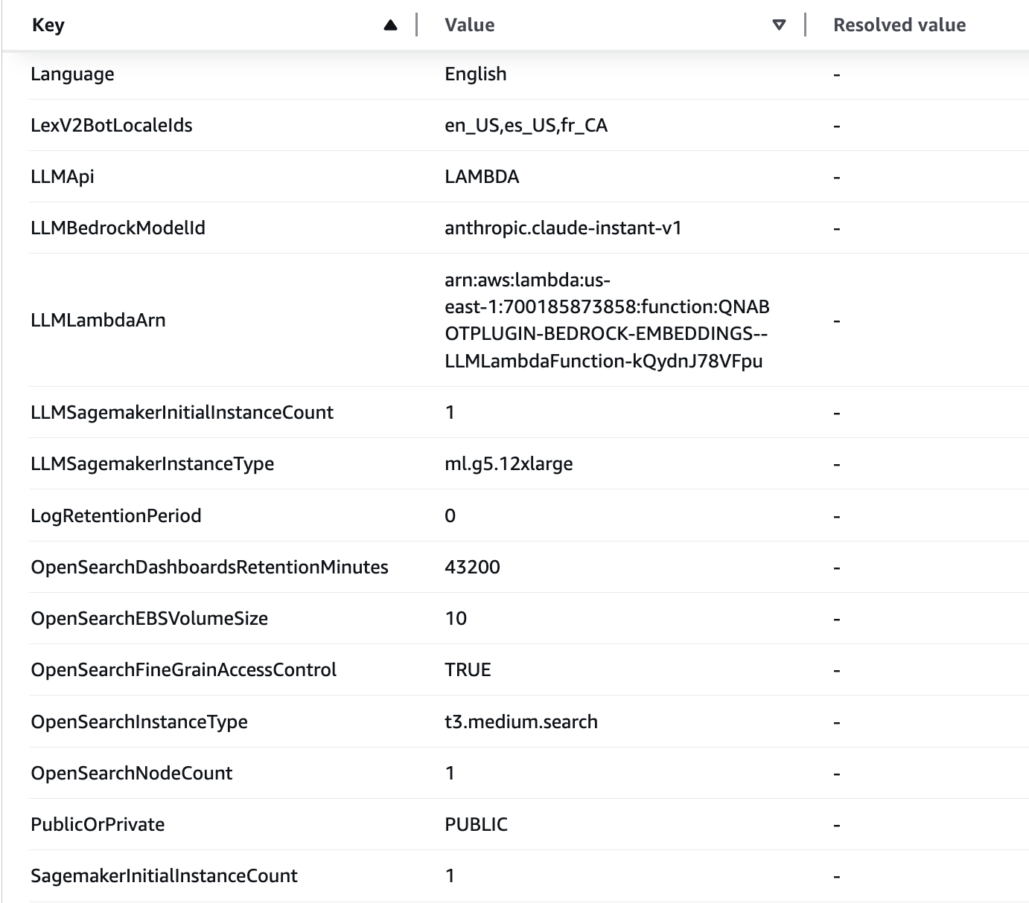 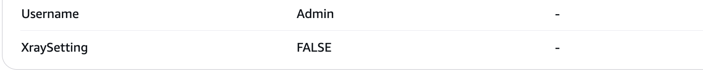

The **QnABot-VirginiaBeach Stack** brings together all the tools and resources needed to run and manage the chatbot seamlessly. At its core, the Lex V2 bot named **QnABot-VirginiaBeach_QnaBot** supports multiple languages, including English, Spanish, and French, with smart handling of queries through **QnaIntent** and fallback responses. Data and performance metrics are stored in dedicated S3 buckets, while OpenSearch powers the search capabilities with its configured endpoint and index. You can access the chatbot through the **ClientURL**, manage its content via the **ContentDesignerURL**, and monitor its performance using the **DashboardURL** in CloudWatch. User authentication is handled by Amazon Cognito through the **UserPoolURL**, ensuring secure access. Key integrations, like Lambda functions for search and feedback, ensure everything works smoothly behind the scenes. Overall, this stack provides a robust, user-friendly chatbot that’s ready to support Virginia Beach residents and deliver real-time, accurate information.

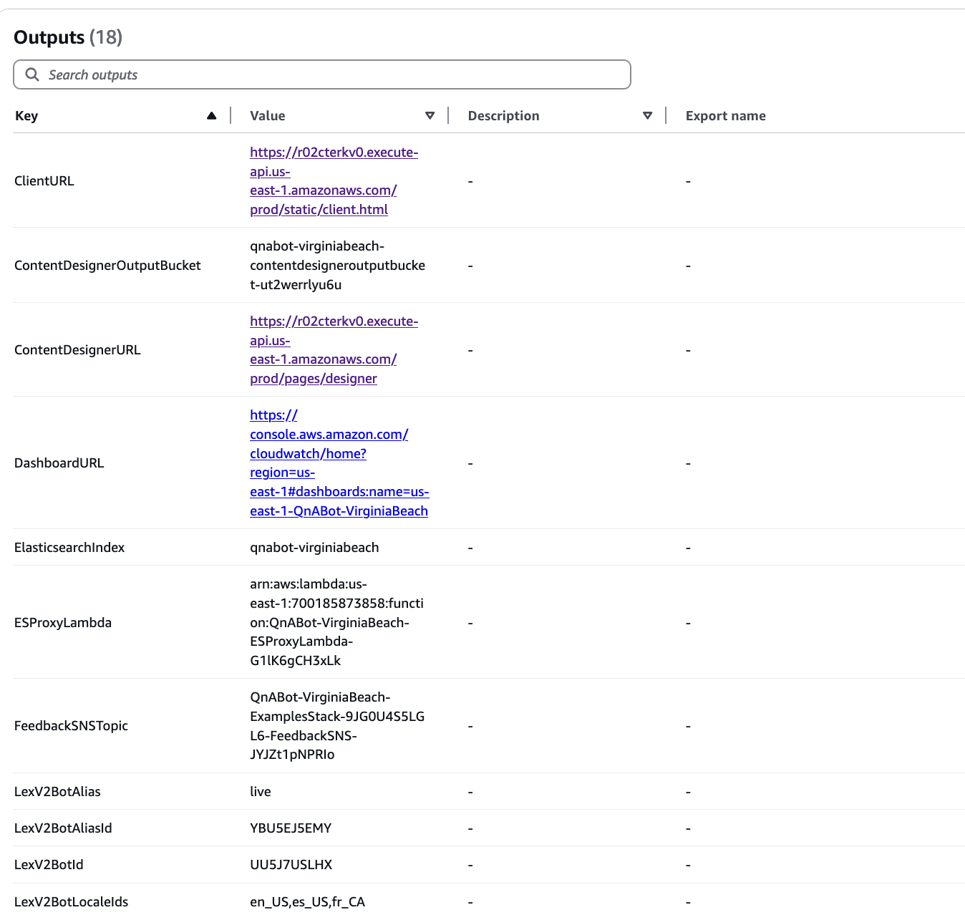

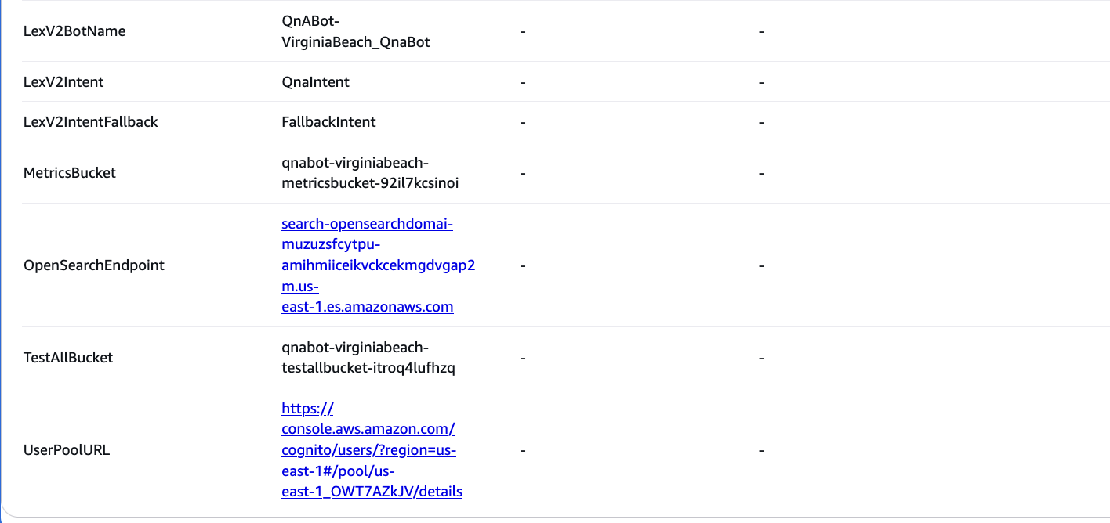

We have successfully deployed the **Virginia Beach QnABot** and set up its core components. You can access the chatbot through the **ClientURL** to interact with it and test its real-time capabilities. Additionally, the **Content Designer** can be accessed using the **ContentDesignerURL**, where we have configured and managed the chatbot’s knowledge base, intents, and responses. This deployment ensures a user-friendly experience for citizens while enabling seamless administrative control for content updates and improvements.

**QnABot Client Page**

The QnABot Client Page has a clean and simple user interface designed for easy interaction. At the top, there’s a header with the chatbot's name and a button labeled "Ask a Question", which prompts users to start engaging with the bot. The main area features a conversation-style layout where user questions appear on the right in a subtle blue bubble, while the bot’s responses are displayed on the left with a light pink background for readability.

The responses are well-organized with clear headings, such as "Answer" and "Confidence Score", and include additional details like response timing and source links. Below the response, the interface seamlessly allows users to continue the conversation by typing their next query in a text box at the bottom. The overall design is clean, intuitive, and user-friendly, making it easy to interact with the chatbot without distractions.

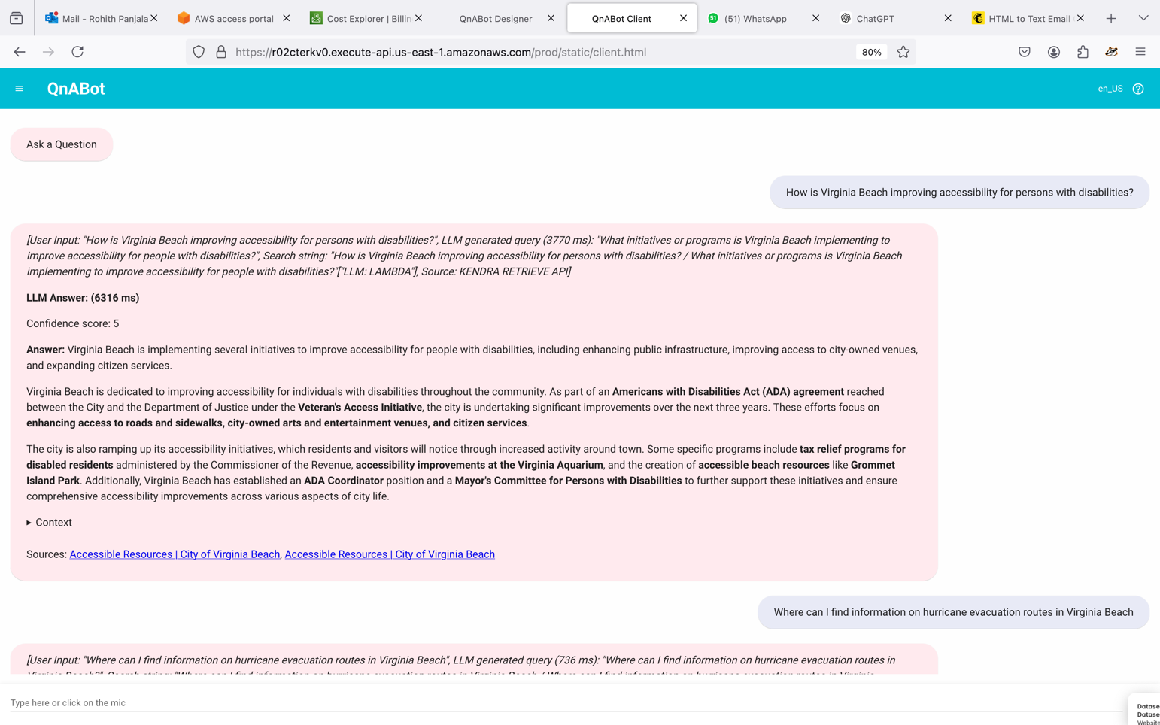

**Content Designer:**

The Content Designer landing page provides an easy-to-use interface for managing the QnABot's content. At the top, you’ll see tabs for QUESTIONS, TEST, and TEST ALL, allowing you to navigate between creating/editing content and testing the bot’s responses.

In the QUESTIONS section, you can view a list of existing question-and-answer pairs, each with an ID, Type (qna), and the associated content or response. For example, entries like CustomError and CustomNoMatches handle errors and unmatched responses, while others like Feedback.001 and Feedback.002 manage thumbs-down or thumbs-up feedback.

Each entry has options to edit (pencil icon) or delete (trash icon) for easy content management. You can also add new QnA pairs using the ADD button or refresh the list with the REFRESH button. The clean and structured layout makes it simple to manage, update, and test the chatbot’s content efficiently.

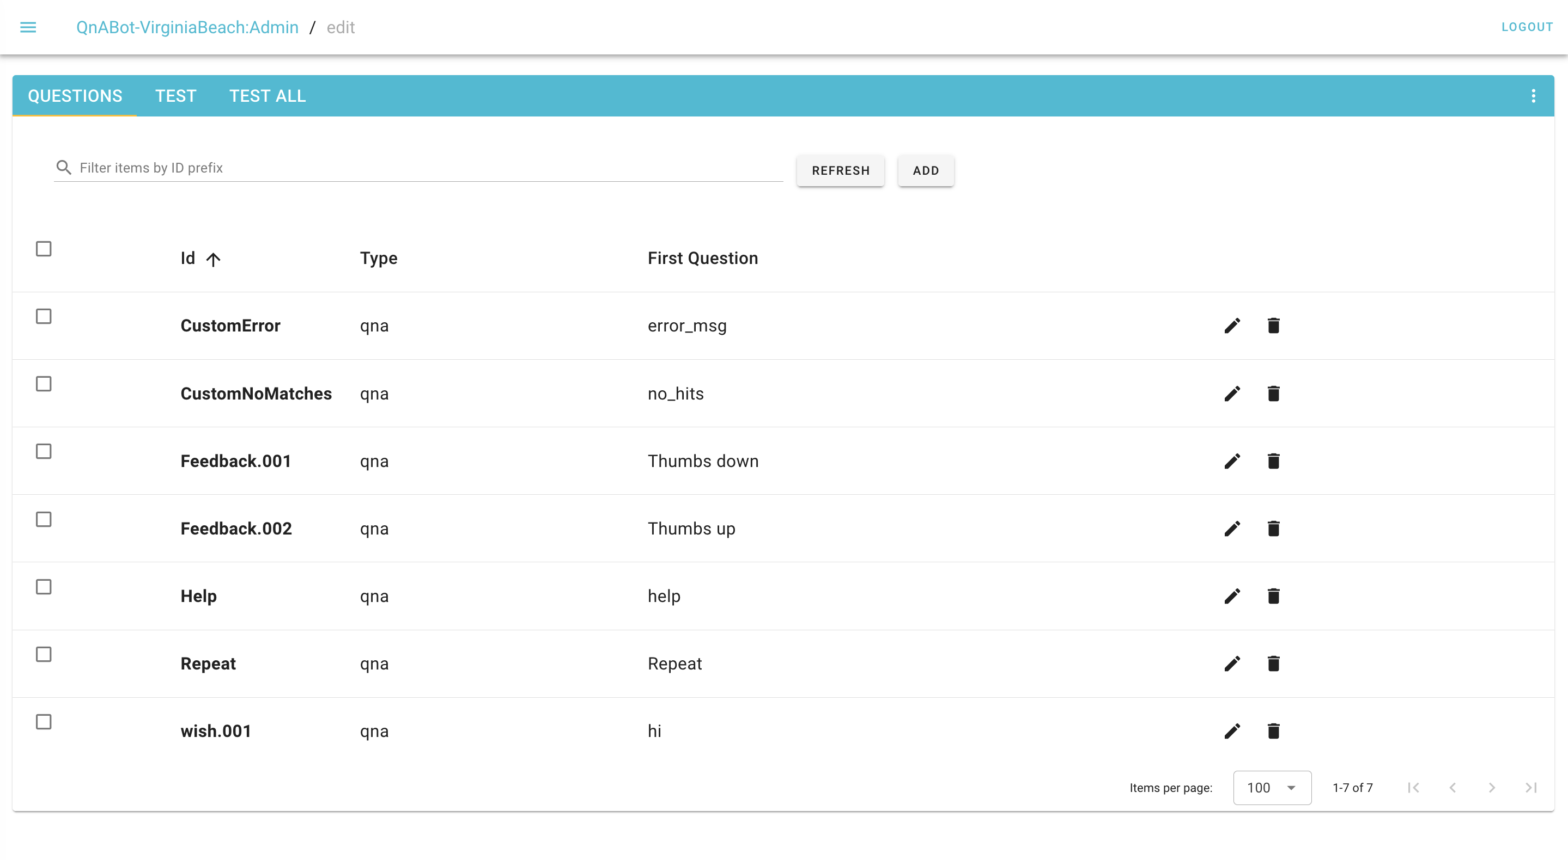

The Content Designer Settings page provides a comprehensive suite of options to configure and fine-tune the QnABot for optimal performance. The Base Chatbot Settings allow enabling debug responses and logging for troubleshooting, while Language Identification sets confidence scores to detect user language. The OpenSearch Configuration fine-tunes search behavior, confidence thresholds, and fallback options, with customizable error and empty-response messages. In the Security and Privacy section, settings for identity verification, sensitive data redaction (e.g., SSNs, emails, and bank details), and PII rejection using regex ensure data protection. The Query Matching options enable semantic search using embeddings, configure score thresholds, and support query disambiguation for better accuracy. Advanced configurations allow for keyword matching, phrase boosting, and sentiment analysis, while the Kendra Indexer section controls web crawling behavior, such as depth, scheduling, and supported languages. Finally, the General Settings enable generative AI responses using models like Claude, manage query prompts, display context and source links, and define the chat history length. These settings collectively ensure the chatbot is accurate, secure, and adaptable to various use cases, enhancing user experience and performance.

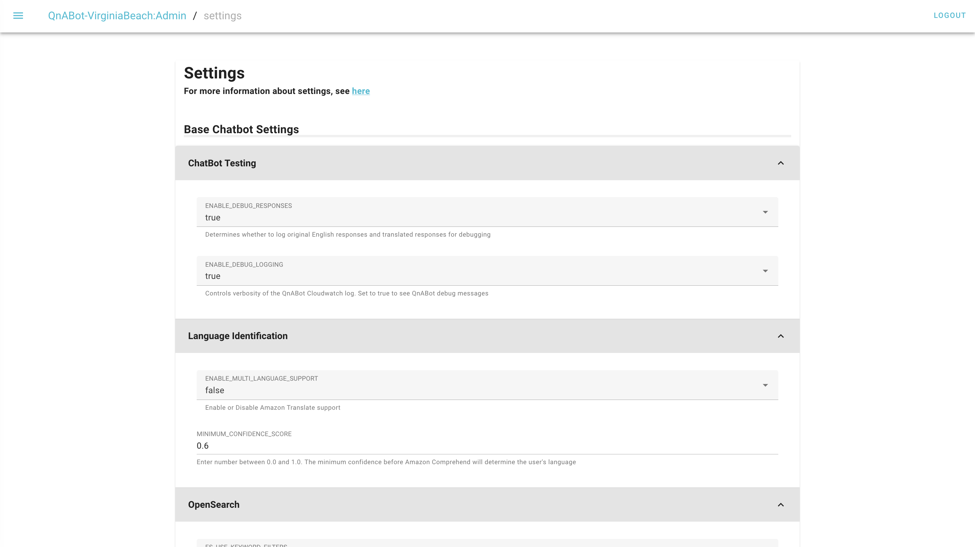

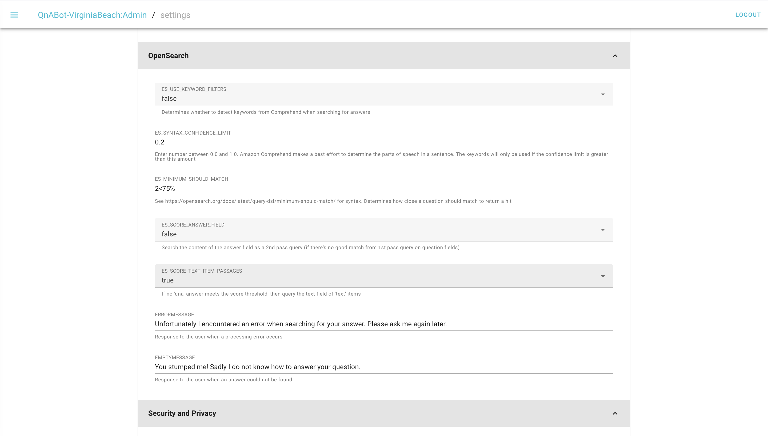 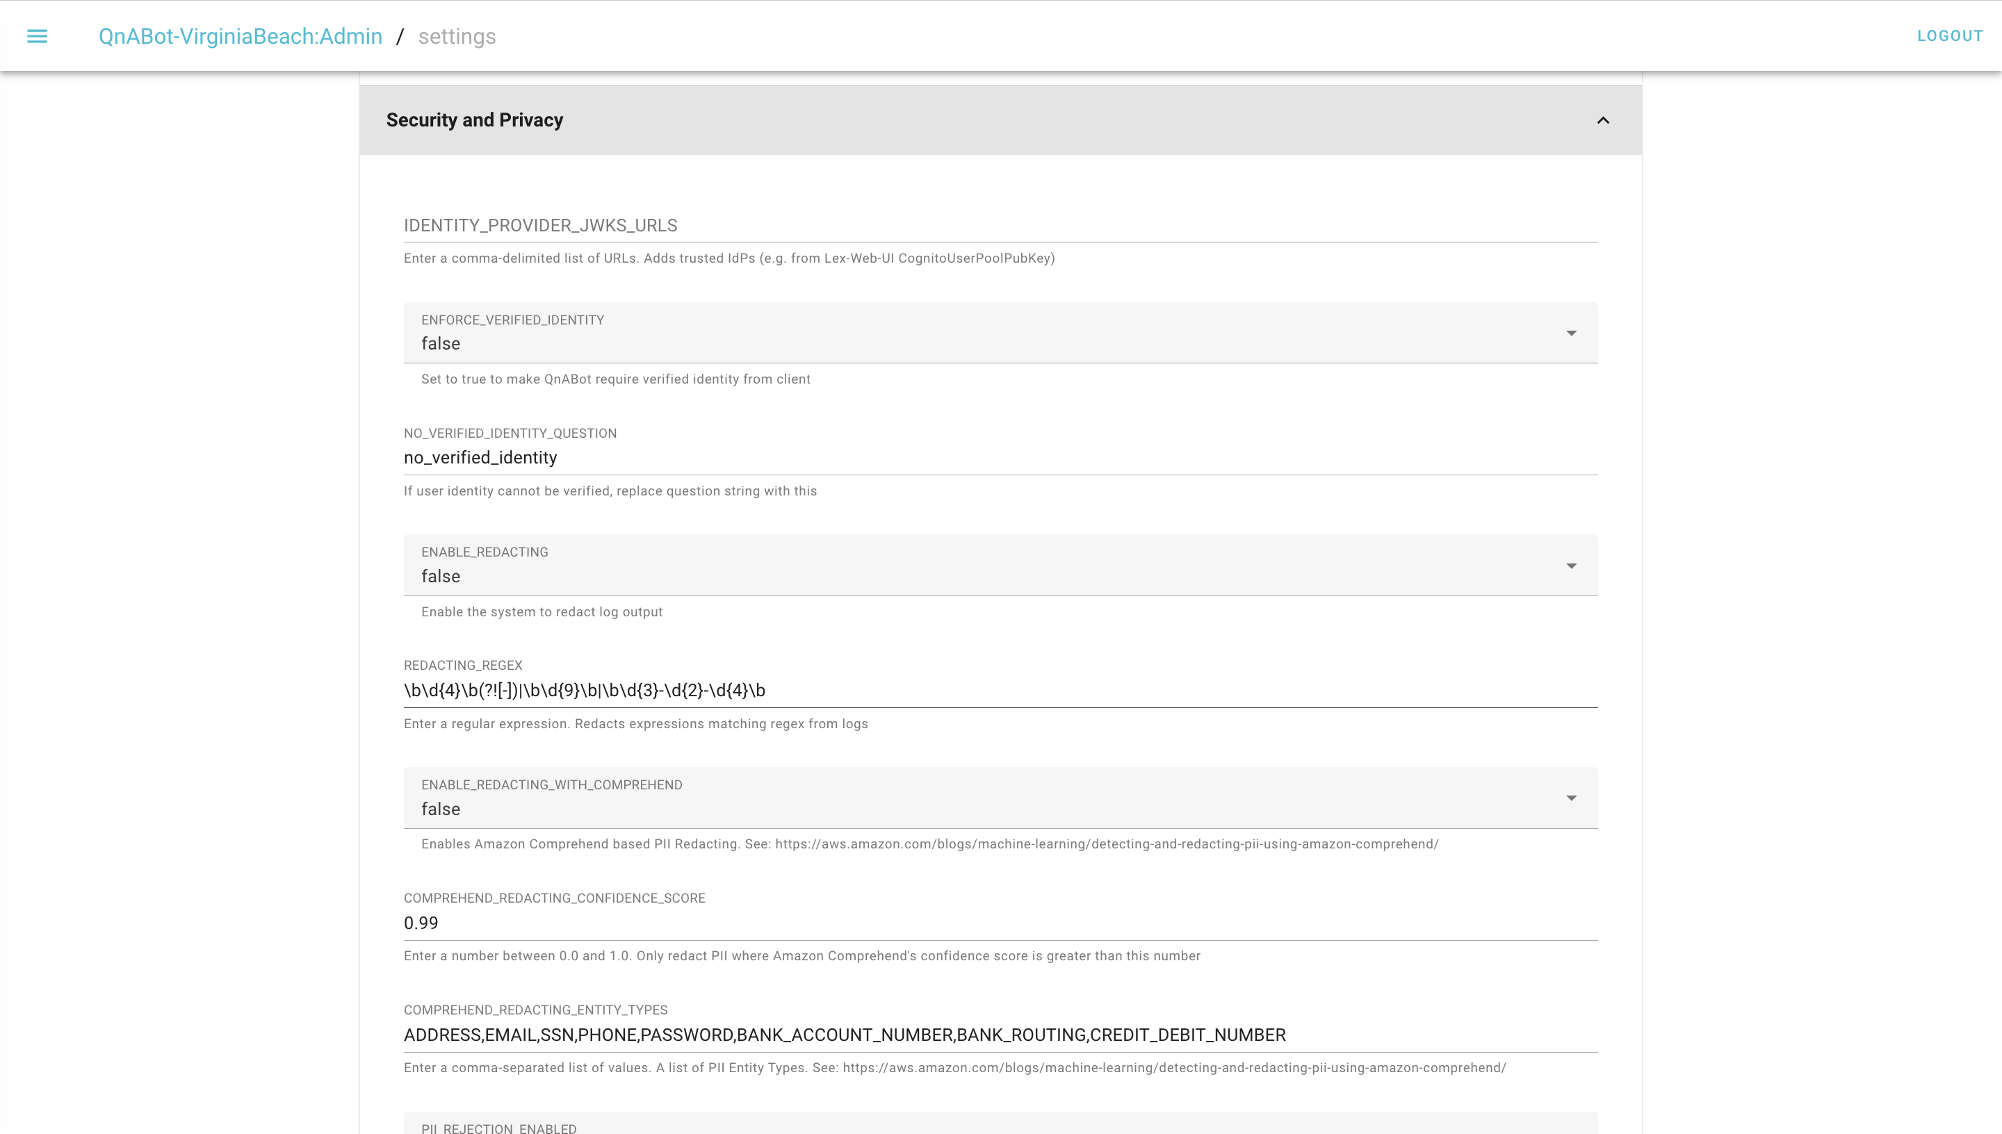

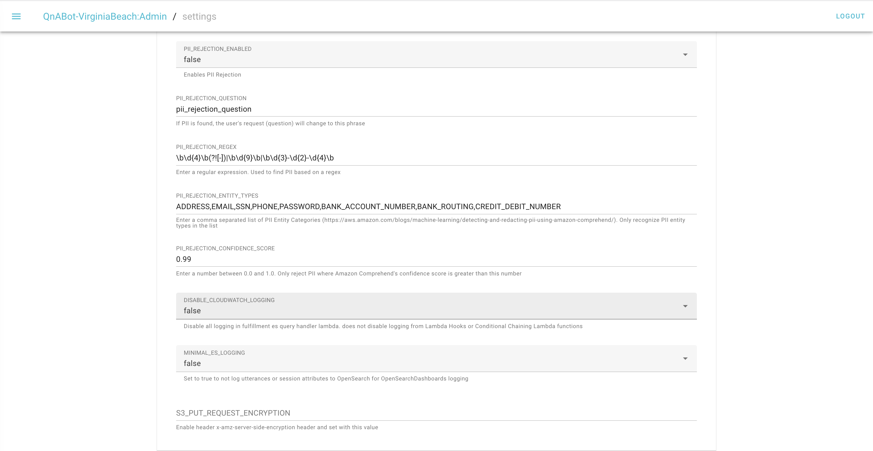 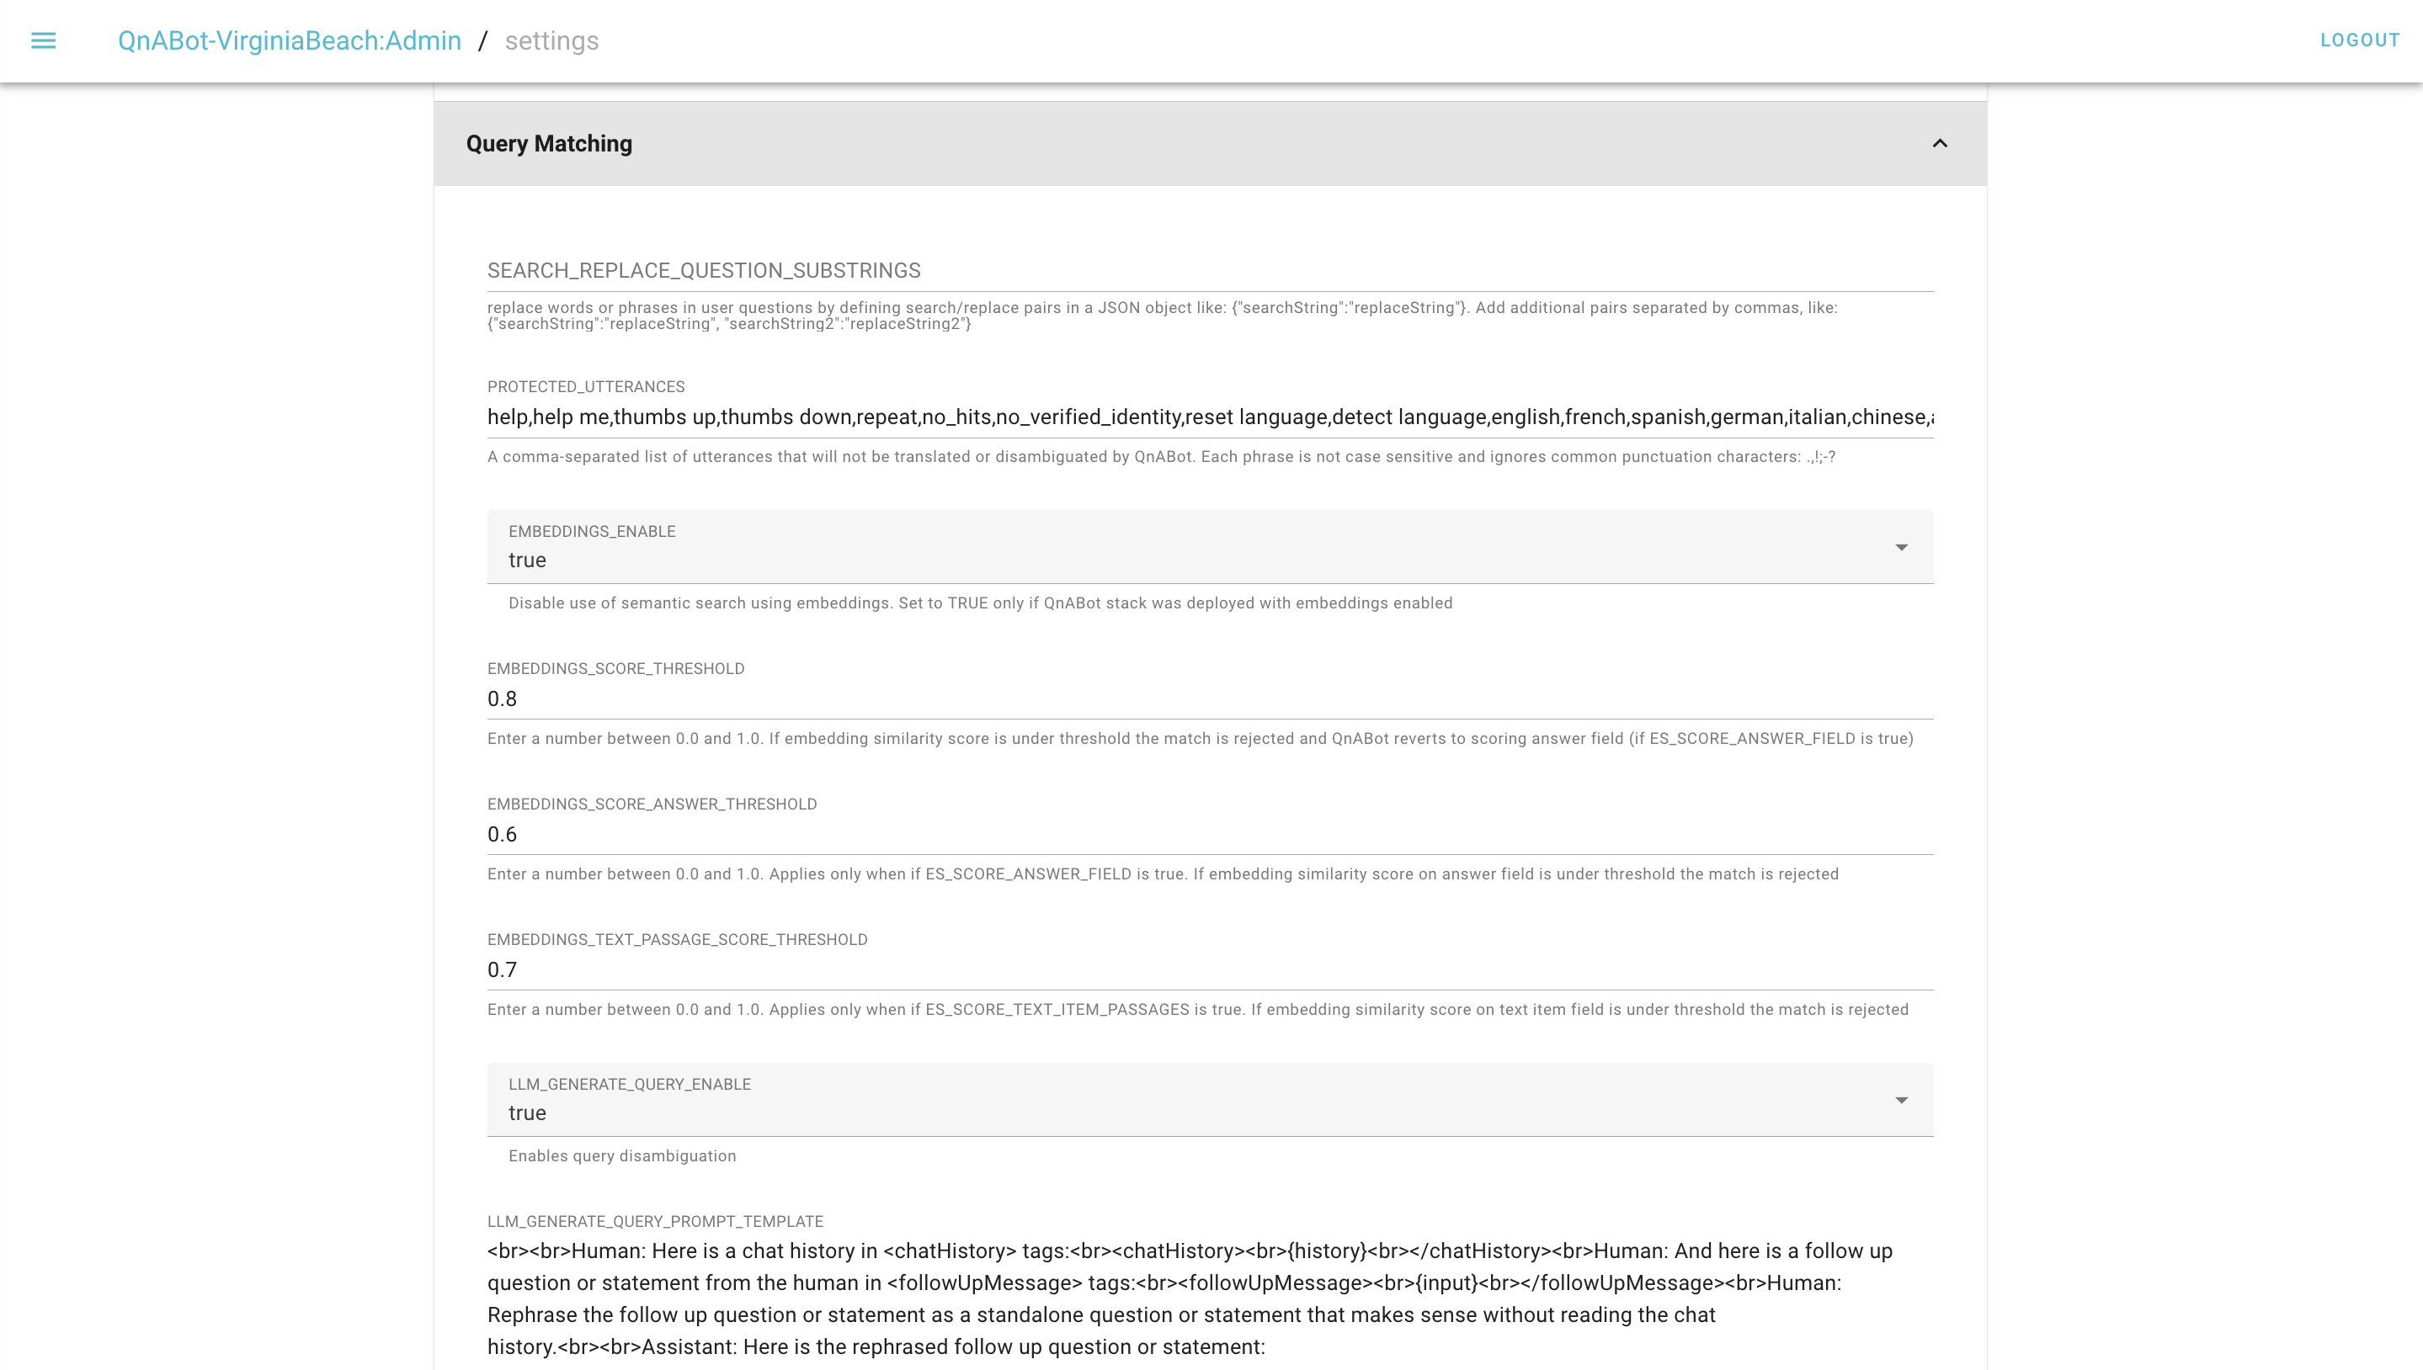

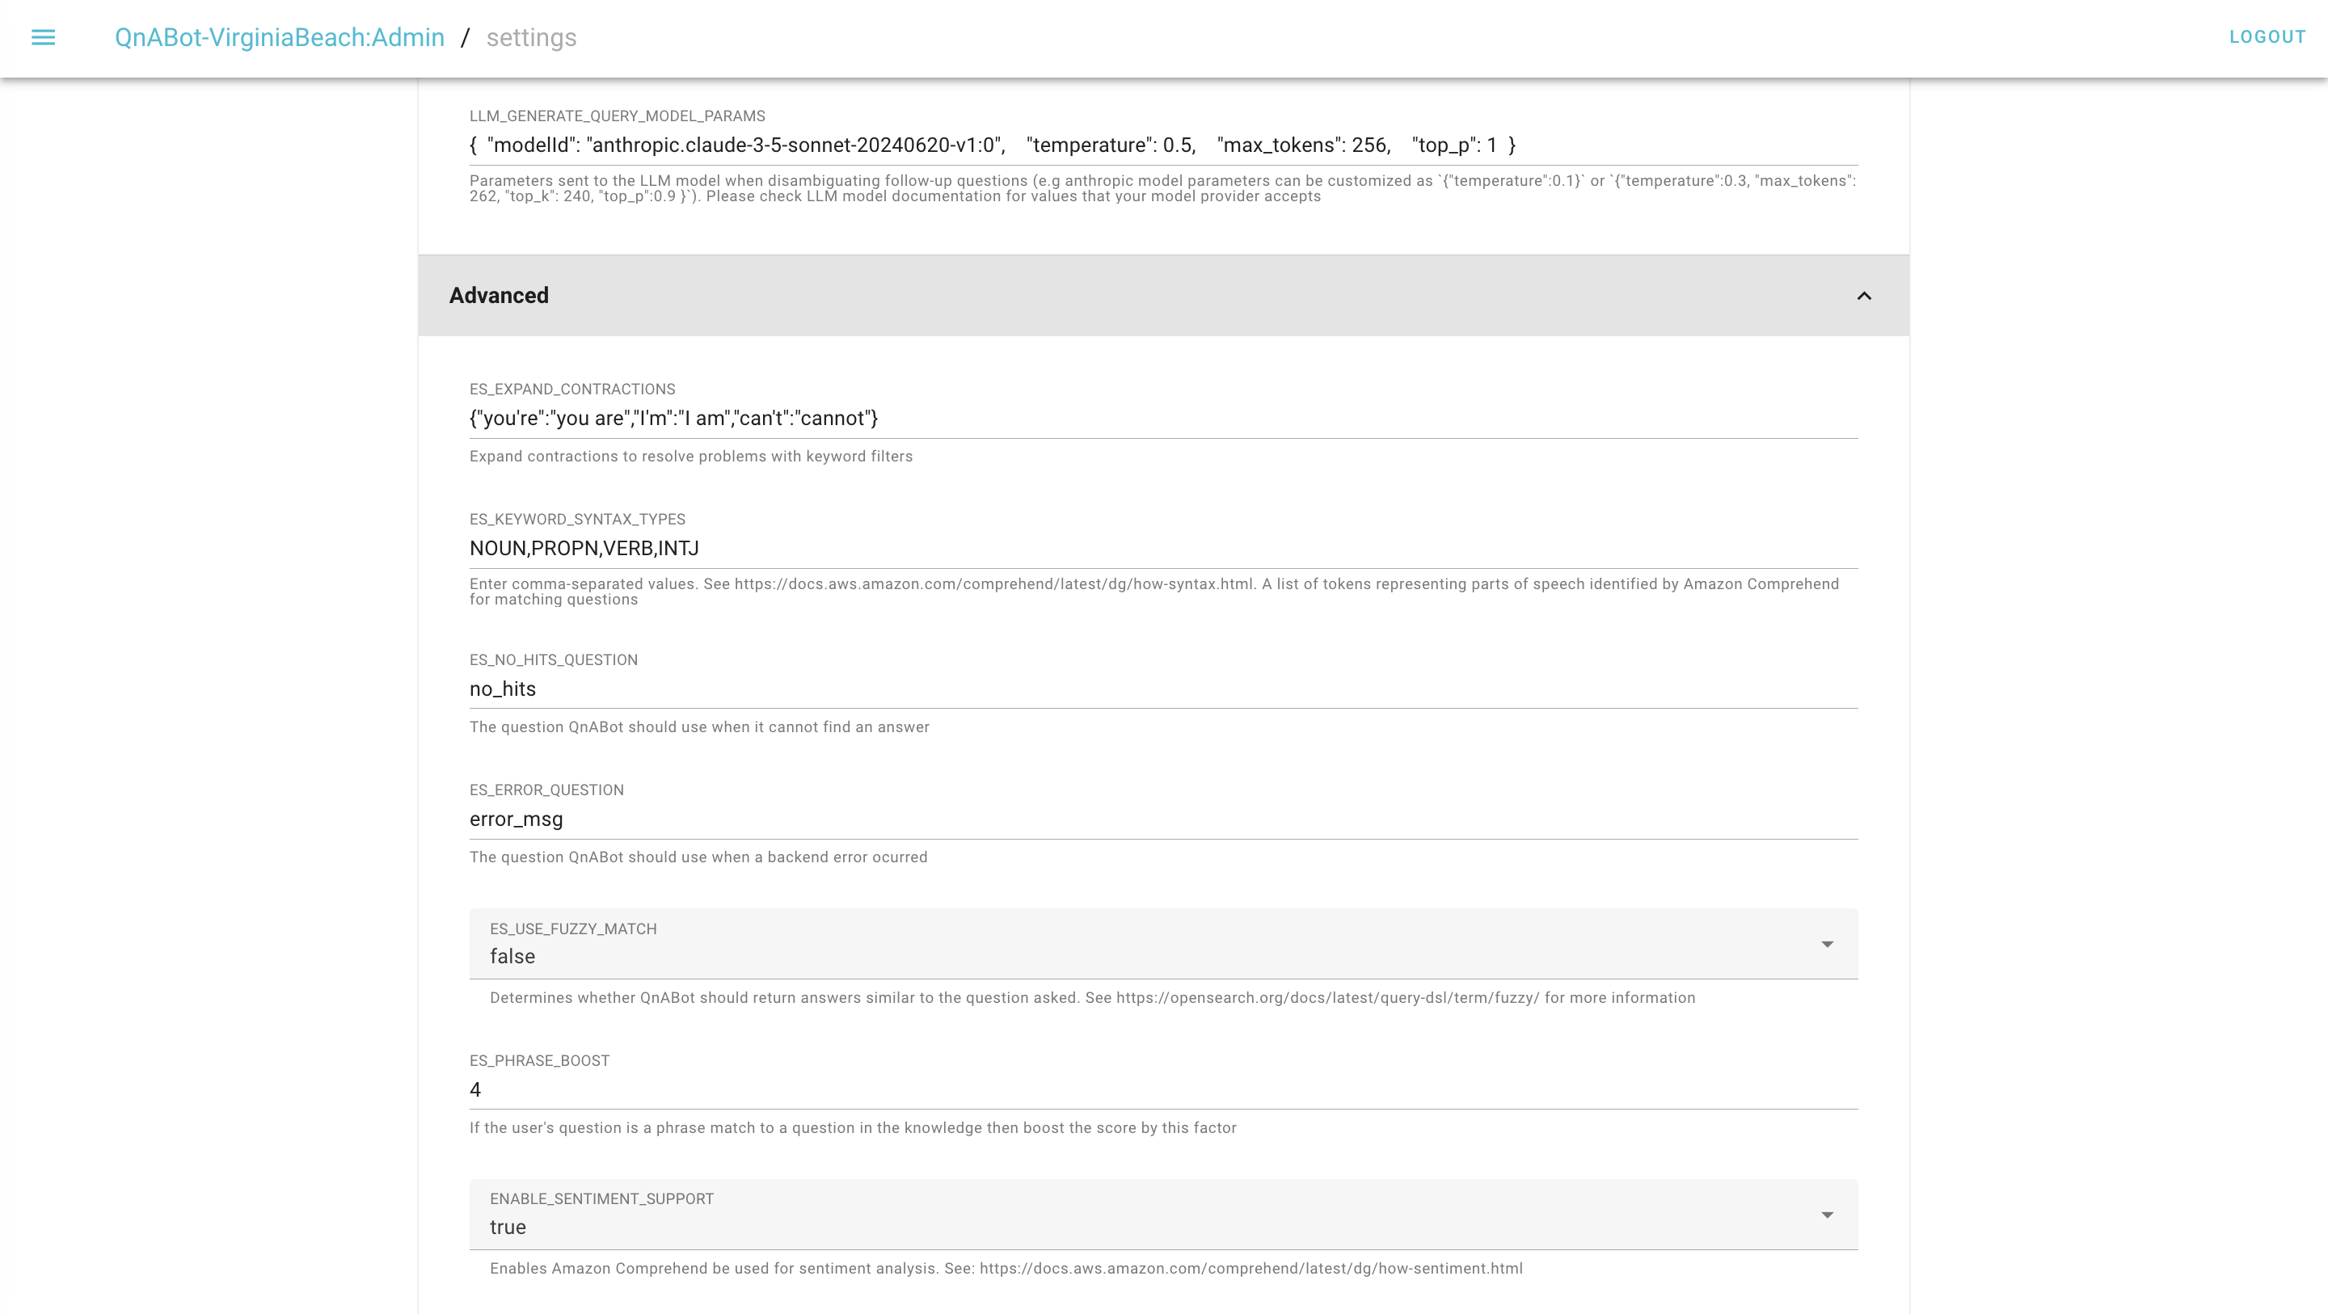

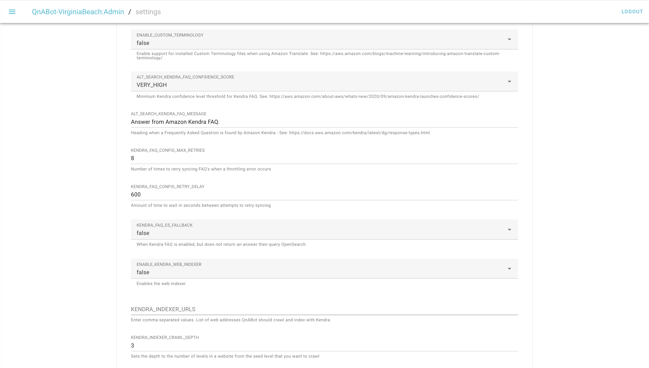

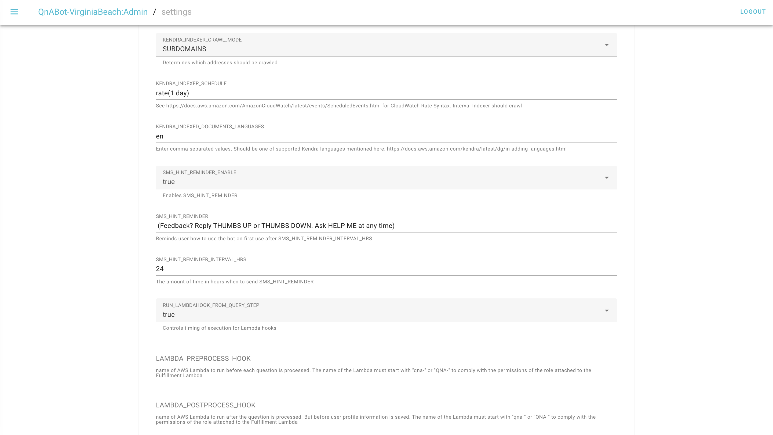 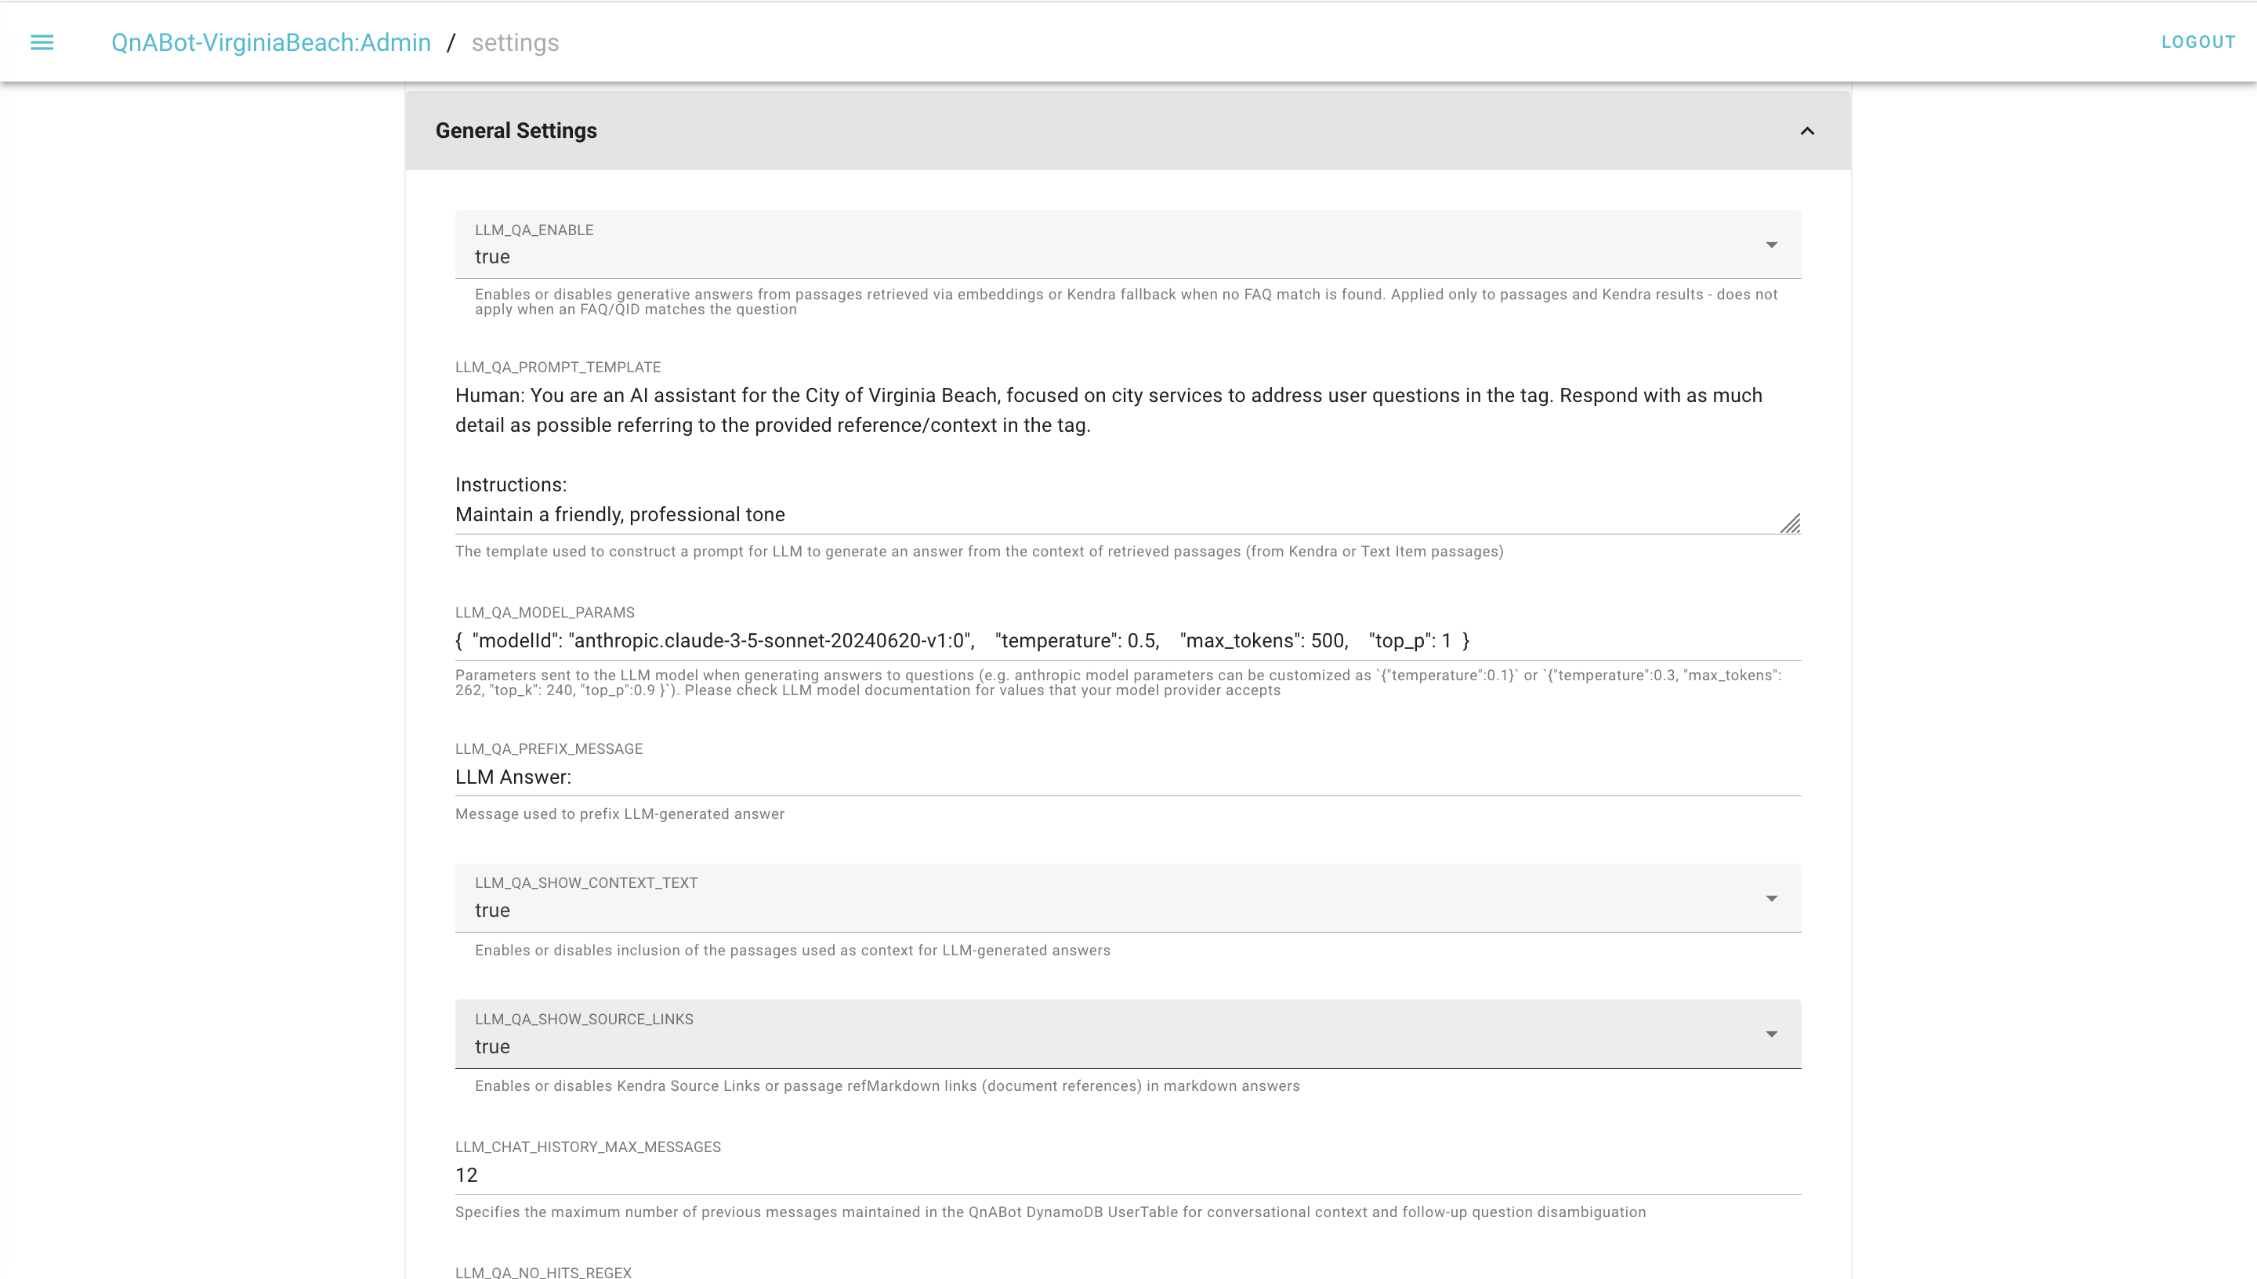

**Lambda Function:**

The AWS Lambda function developed for the project seamlessly integrates with AWS Bedrock to enable text generation using multiple large language models (LLMs) from providers such as Anthropic, AI21, Amazon, Cohere, and Meta. The function dynamically constructs the request body based on the selected provider, ensuring compatibility with provider-specific APIs. For instance, it supports both Claude-2 and Claude-3 message formats for Anthropic models, while handling response structures uniquely defined by each provider. Additionally, the function enhances user prompts by dynamically embedding contextual details such as the current date, time, and day in the prompt, ensuring responses remain relevant and time sensitive. By leveraging a reusable Bedrock client, the solution minimizes latency and optimizes resource usage. Furthermore, the function includes the flexibility to pass parameters like temperature or system prompts, enabling fine-tuning of model behavior. With robust design and support for multiple providers, this Lambda function serves as a core component of the chatbot’s architecture, ensuring scalable, accurate, and contextually aware responses to user inquiries.

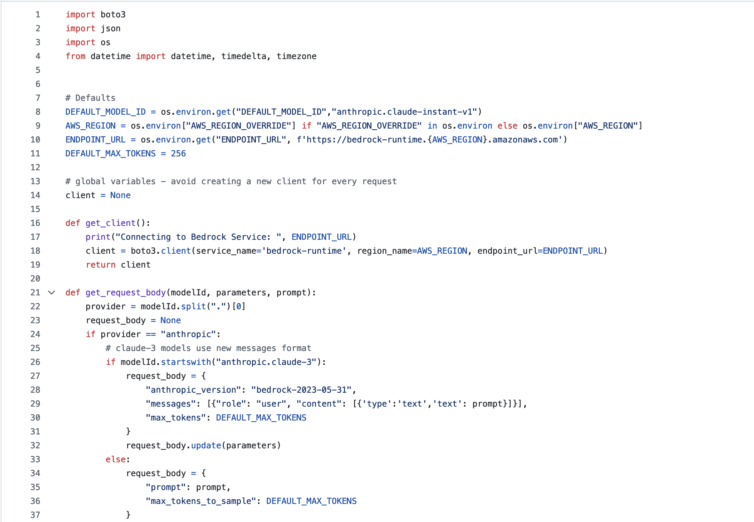

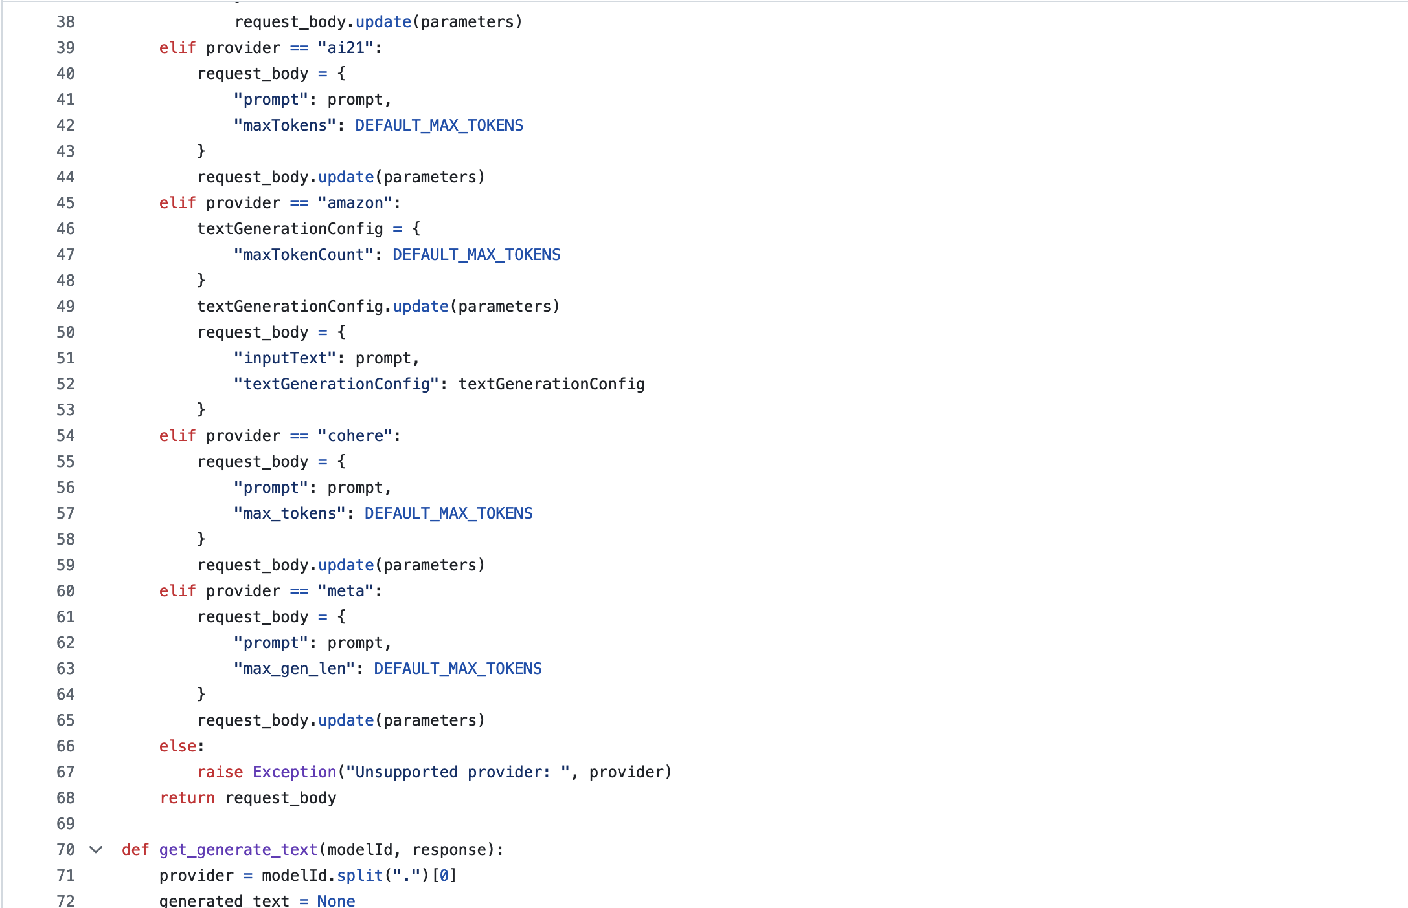

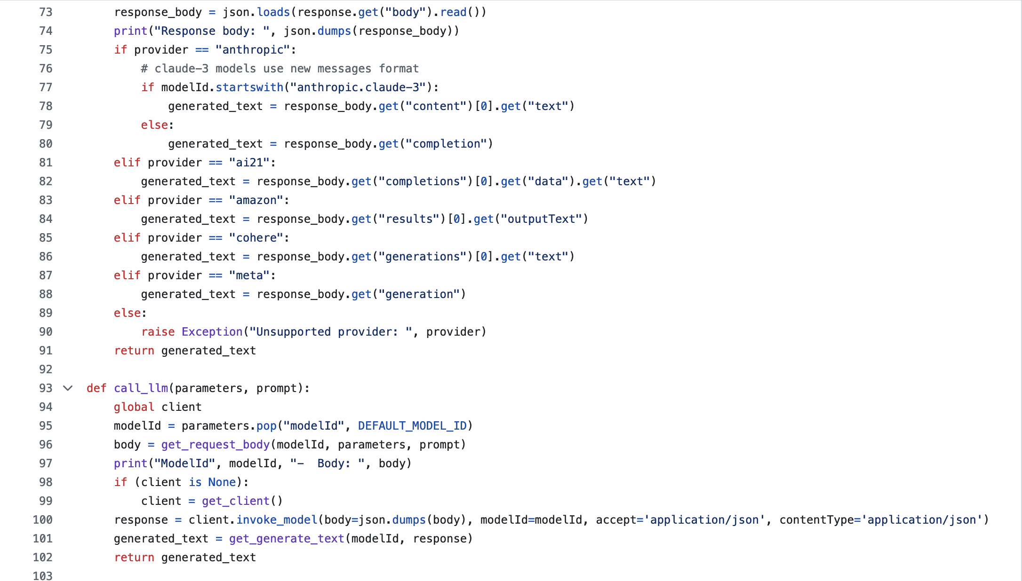 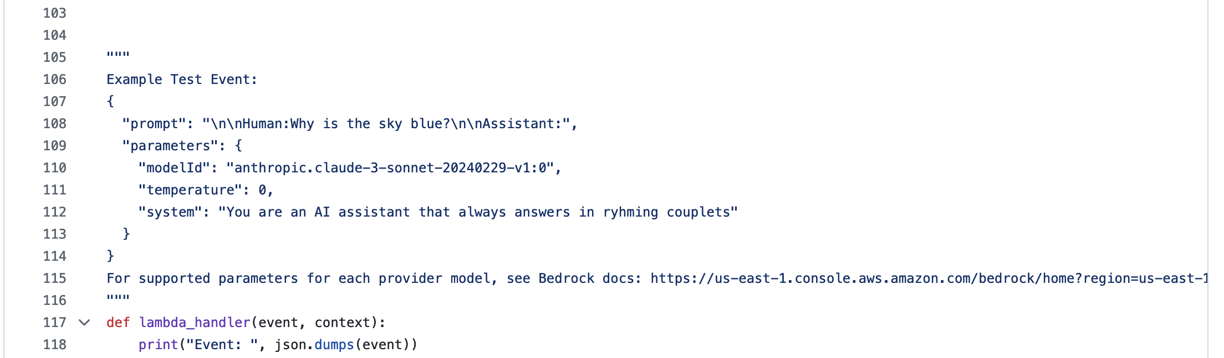

## Data Quality Assessment

Assessing the quality of the data from the “Virginia Beach knowledge base” is critical to ensuring the effectiveness of the chatbot’s responses. Below is evaluation of the dataset using key data quality attributes:

1. Completeness: It means ensuring all required data is present. For our chatbot to function properly, all relevant pages, documents, including text, links, and downloadable resources must be checked if is fully captured by Amazon Kendra. Missing sections or partially crawled data can affect completeness.

2. Uniqueness: All the data on the website is unique, it means not duplicate data is present.

3. Accuracy: The data must accurately reflect the content from the Virginia Beach government website, with no errors introduced during the collection process. Also, the data must be evaluated regularly to ensure that any changes in government policies are accurately reflected in the knowledge base.

4. Atomicity: It refers to the extent to which data is broken down into the smallest meaningful units. For this chatbot, it means organize the data into small, meaningful chunks that can be accurately indexed and retrieved by Amazon Kendra, making it easier to perform relevant queries.

5. Conformity: It means data complies with a predefined format. Ensuring that the collected data follows a consistent structure such as consistent date formats and URL’s. This will help in ensuring easy retrieval and processing by the RAG system.

6. Overall Quality: It is completely depending on chatbot providing accurate, relevant, and up-to-date responses to citizen queries. This includes ensuring timely updates to reflect any changes or new information added to the Virginia Beach website.

## Other Data Sources

This project only uses only data obtained from the City of Virginia Beach government website and does not incorporate any other external data sources. The focus is on ensuring that the chatbot provides answers strictly based on information available from the official city website. By relying only on this source, we aim to keep the project aligned with the city's requirements and ensure that the chatbot delivers accurate, relevant, and context-specific information to users based on publicly available Virginia Beach data.

## Storage Medium

For storing, the data collected from the City of Virginia Beach government website we will be using Amazon S3, a secure and scalable cloud storage service. [9] Amazon S3 is ideal because it can easily handle vast amounts of data and offers strong security features like encryption and ensures that the data is always available, protected from loss. It also integrates well with other AWS services like Amazon Kendra and Amazon Bedrock, which are important for this RAG chatbot. By choosing Amazon S3, we ensure that the data is stored in a reliable, secure, and flexible environment that supports the project’s needs now and in the future.

## Storage Security

For this Virginia Beach website data storage security is an important component to ensure the safety. [10] Amazon S3 provides multi-layer security with encryption both while it's stored and when it's being transferred. Data in S3 is encrypted using server-side encryption and data in transit is encrypted using HTTPS to prevent unauthorized access while transferring the data. Access to the stored data is managed through a set of policies, instead of relying on Access Control Lists (ACL). By disabling ACL, accessing the data is controlled by a combination of AWS Identity and Access Management(IAM), S3 bucket policies, Virtual Private Cloud(VPC), and AWS Organization Service Control Policies. These policies correctly define who can access and modify the data. For this Virginia Beach website data, security policies are configured and managed by the GMU CEC Information Technology(IT) help desk, ensuring that only authorized users can access the data through specific user roles and permissions. This multi-layer approach helps to protect data from unauthorized access and ensures its confidentiality and integrity throughout the project.

## Storage Costs

Based on Amazon S3 pricing, cost of storing the data from the City of Virginia Beach website depends on how much data we store, how frequently we access it, and on other factors. [11] The basic cost for S3 Standard storage is $0.023 per GB for first 50TB per month. Accessing data stored in S3(GET) incurs a minimal charge of about $0.0004 per 1,000 requests. While transfers within AWS are generally free, downloading data to local systems is charged at $0.09 per GB for the first 10 TB. Additionally, there are fees for uploading and modifying data (PUT), typically $0.005 per 1,000 requests.

For example, storing 50Gb of data in Amazon S3 costs $1.15 per month. Assuming daily updates, having 30 PUT and 100 GET request per month costs around $0.00015 and $0.00004 respectively. For data transfer if 1GB is assumed, then it cost $0.09. So, the total estimated monthly cost for using Amazon S3 to store and minimally access/transfer 50GB of data would be around $1.24. By carefully controlling how we store and access the data, we ensure that costs remain low while maintaining easy and reliable access to our data.

After crawling Virginia Beach website data “<https://virginiabeach.gov/>” with Kendra we got around 8350 documents and size of stored data is 56 MB. The cost for Kendra and Open Search for crawling and index this documents is around $31 for 24 hours.

## IAM Roles

In the implementation of our project, we established the IAM role " AmazonKendra-VBSourceData" to enable Amazon Kendra to securely access and process the necessary data sources. This role is specifically designed with a maximum session duration of one hour, enhancing security by limiting the time frame within which the permissions can be utilized. It is equipped with tailored permissions policies that allow Kendra to perform essential actions, such as reading data from AWS services integral to our data pipeline. The role also includes a trust relationship setup, granting Kendra the authority to assume this role, thereby ensuring it has the appropriate access to manage data efficiently and securely according to AWS best practices. This IAM role is crucial for maintaining the integrity and security of our data interactions within the AWS cloud environment.

## Cost Optimization Approach

To reduce the high daily costs associated with AWS Kendra and OpenSearch services used by our RAG Generative AI chatbot, we have developed a cost optimization strategy that involves creating backups of the indexed data. The process begins by extracting data from Kendra, which we then serialized and stored in JSON format on local drives. This data is subsequently transferred and archived in Amazon S3 buckets, which offer secure and scalable cloud storage at a lower cost compared to Kendra. Additionally, we've set up a fallback mechanism where S3 is used as an alternative data source to Kendra. This not only decreases our dependence on Kendra, reducing operational costs, but also ensures that data remains accessible and secure in the cloud, enhancing the reliability and efficiency of our chatbot service.

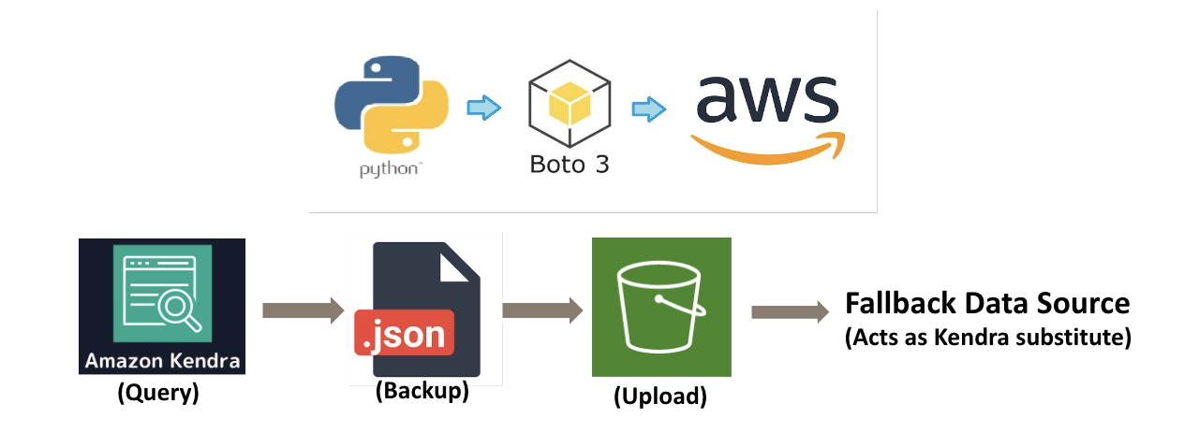

Figure : Cost Optimization with Data Backup

However, upon further evaluation, we've realized that this method, although cost-effective, is not straightforward and introduces complexities in maintaining data consistency and retrieval efficiency. Due to the complexity and extra effort required to manage the proposed backup method, we have decided not to use it. Instead, we'll keep using Kendra, focusing on making the most of its advanced search and AI features to ensure our chatbot performs well, remains reliable, and provides a good user experience.

But to reduce costs associated with OpenSearch, we selected the "t3.medium.search" instance from AWS to run our OpenSearch service, which is optimized for handling search functionalities effectively. This type of server is a part of AWS's T3 series, known for its balance of performance and cost-effectiveness. Each t3.medium instance is equipped with 2 virtual CPUs and 4 GB of RAM, making it well-suited to manage our project's moderate data processing and search query needs. The defining feature of the T3 series is its burstable performance, which allows the server to handle increases in load by using accumulated CPU credits. This flexibility is perfect for our project's requirements, where workload levels aren't constant and can vary significantly. By deploying the "t3.medium.search" instance, we've managed to cut our OpenSearch-related costs by nearly 50%, achieving significant savings without compromising on the efficiency needed for our search tasks. This makes the T3 medium instance an ideal choice for our development of prototype that require adaptable performance at a lower cost.

# Implementation

## Solution Approach

After carefully considering the feedback from the Allwyn Corporation, our team has updated a strategy for developing the chatbot. Our main goal is to make the chatbot respond more precisely and relevantly, providing specifically to the needs of residents, visitors, and business owners. We plan to use AWS Bedrock models to improve the chatbot's ability to search information and understand questions more naturally. Additionally, we're integrating AWS Cognito on the content designer end to manage developer authentication securely, ensuring that each developer interaction is both private and personalized. The strategy involves continuously refining the chatbot by incorporating feedback from initial tests and ongoing discussions with Allwyn Corporation. This approach helps us make sure the chatbot becomes easier to use and more helpful over time, aligning closely with the evolving needs of Virginia Beach’s online community. By focusing on test feedback, we aim to continually enhance the chatbot, making it an important part of the city’s digital services.

### Systems Architecture



Figure : System Architecture

This architecture diagram shows the setup of a chatbot system designed for the City of Virginia Beach, hosted on AWS Cloud. The system includes various AWS services to function efficiently and securely. At its core, an S3 bucket is used for storing the data files, related to Virginia Beach website data. An API Gateway manages incoming requests, directing them to appropriate services for processing. AWS Lambda functions are employed for executing specific tasks such as data retrieval from the S3 bucket and performing necessary answers for responses. For security and user management, Amazon Cognito is utilized to handle authentication and authorization, ensuring Content designers are securely managed and have appropriate access. System Manager Parameter Store is used for securely managing configuration data. Amazon QnABot processes user queries and determines responses by leveraging Virginia Beach website data and Bedrock models. The system's intelligence is further enhanced by Amazon Kendra, which provides advanced search capabilities across the provided documents and data, ensuring the chatbot can access and retrieve the most relevant information. Bedrock supports the chatbot by providing a strong foundation with additional data. Together, these components integrate to deliver a responsive and effective chatbot service that improves user engagement and access to city-related information.

### Systems Security

We have put several security measures in place to protect the system, following guidelines from the "QnABot on AWS" implementation guide. [13] First, we use Amazon Cognito to make sure content designer is properly verified before they can access the system, keeping configurations secure. We protect all data, whether it's stored or being sent to and from the cloud, by encrypting it with service like AWS S3. We also use AWS Identity and Access Management (IAM) to strictly control who can access what within the system, ensuring that only those who really need access can get it. The API Gateway helps keep the system safe by checking all incoming data requests and stopping any that don't look right before they reach the more sensitive parts of the system. Lastly, we securely manage sensitive information such as API keys and database credentials using AWS System Manager Parameter Store, which keeps this information encrypted and safe from unauthorized access. All these steps work together to create a secure environment for the chatbot on the AWS cloud.

### Systems Data Flows

In our chatbot system, a user starts an interaction by asking a question through the website interface. Amazon QnABot sends this question to corresponding AWS Lambda function. This function uses Amazon Kendra to search for relevant documents, which are then provided to Amazon Bedrock. Bedrock uses this information to enable a Large Language Model (LLM) to generate an appropriate response based on the query and context from Kendra. Here we are using Anthropic Claude Sonnet 3.5 model in Amazon Bedrock. The response is created in natural language and sent back to the web interface, ensuring that the user receives a precise and contextually relevant answer. This streamlined process enhances user experience by providing quick and accurate responses.

### Bedrock Models and Our Selected Implementations

In our project, we are leveraging Amazon Bedrock to enhance our chatbot with advanced foundation models. Amazon Bedrock offers a range of high-performing foundation models from leading AI companies such as AI21 Labs, Anthropic, Cohere, Meta, Mistral AI, Stability AI, and Amazon itself. For our specific needs, we are integrating Claude 3.5 Sonnet from Anthropic. This model excels in natural language processing(NLP) tasks and enable our chatbot to generate precise, contextually relevant responses for users engaging with the Virginia Beach city government services. This choice of model ensures our chatbot providing reliable and effective communication assistance.

Claude 3.5 Sonnet from Anthropic is the new version of an advanced Artificial Intelligence(AI). This AI is smarter and better at solving problems than its previous versions. It is also faster and cheaper to use, making it accessible for various tasks. Claude 3.5 Sonnet is greater for complex tasks like customer support need to understand content, managing multi-step workflow, translating code, and creating user-friendly applications. It shows near-human levels of understanding and fluency, making it excellent at grasping complex instructions. It responds with high-quality, natural sounding content. [14] Claude 3.5 Sonnet can write and edit code on its own, with strong reasoning and troubleshooting skills. This model has best vision capabilities, it can read charts, graphs and transcribe text from imperfect images.

Next, the costs for using the Claude 3.5 Sonnet model from Anthropic on AWS Bedrock in North Virginia region are divided into two types: on-demand and batch processing. [15] For on-demand, where responses are needed quickly, it costs $0.003 for every 1,000 input tokens and $0.015 for every 1,000 output tokens. On the other hand, for batch processing which is good for handling huge amount of data without the need for instant responses, is cheaper. It costs $0.0015 for every 1,000 input tokens and $0.0075 for every 1,000 output tokens. This makes batch processing more affordable option for projects that need to process large amounts of data cost-effectively.

### Default Chatbot

We developed a chatbot for the City of Virginia Beach that uses Amazon Kendra as its main search and intelligence system. Kendra uses the city government's knowledge base as the primary source, which Kendra indexes directly, making it easy to search.

The chatbot uses Kendra’s powerful indexing to organize and make the knowledge base easily searchable. With Kendra's natural language understanding, the chatbot can understand queries without needing any Previous training. It uses Kendra’s advanced search capabilities to find the most relevant information for user queries. The integration of Kendra's search outcomes with the chatbot's response system ensures the delivery of precise answers within a 50-word limit and a polite deferral if information is lacking.

**Prompt Engineering for Default Chatbot:**

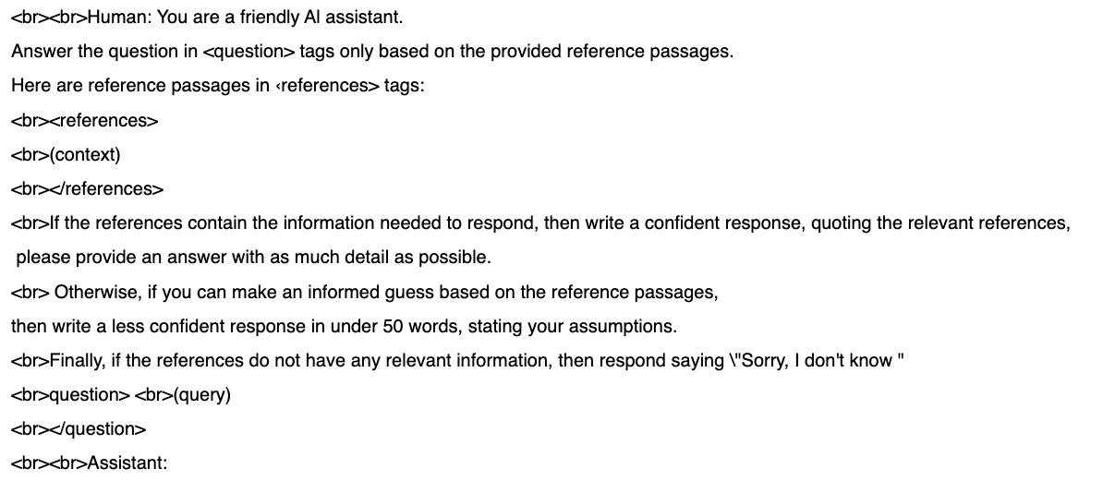

### Updated chatbot

For the Virginia Beach city government chatbot, we are enhancing the chatbot with prompt engineering focused on creating a friendly and professional communication style that is easy for everyone to understand. This includes designing prompts for relevant queries and providing clear, straight forward, and helpful answers to users to make information easy to read. It also encourages user to ask follow-up questions if they need more information. It recognizes its limits and can suggest customer support when it's unable to provide answers by itself.

Chatbot provides response by referring current date and time. We've also added a feature to measure the chatbot's confidence in its responses, ensuring the information it provides is reliable and pointing users to other resources when necessary. Additionally, we are handling conflicting information and incorporating reference-based responses and delivery of each answer will be short and direct response. This multifaceted approach is enhancing the way the city interacts with residents, using advanced technology to better serve the community's needs.

**Prompt Engineering for Updated Chatbot:**

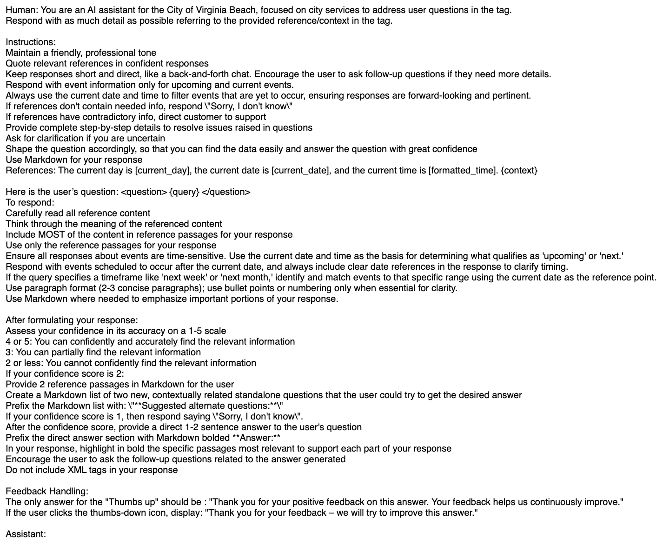

# Testing and Validation

## Testing

For testing the chatbot initially we considered Amazon Bedrock's in-built model evaluation, which helps compare and select the best-performing model based on various metrics, was not utilized. As this chatbot only uses the Claude 3.5 Sonnet model, conducting a comparative model evaluation was unnecessary.

As a result, we choose manual testing for the chatbot. The manual testing of our chatbot was strictly planned to evaluate its effectiveness in handling scenarios relevant to the City of Virginia Beach. This testing focused on few categories.

### Testing Categories

Functional Testing: The chatbot was tested with over 200 queries related to city services, including public safety, community programs, and operating hours. It performed well with straightforward queries but faced challenges with more complex and unclear questions.

Figure : Operating Hours Query

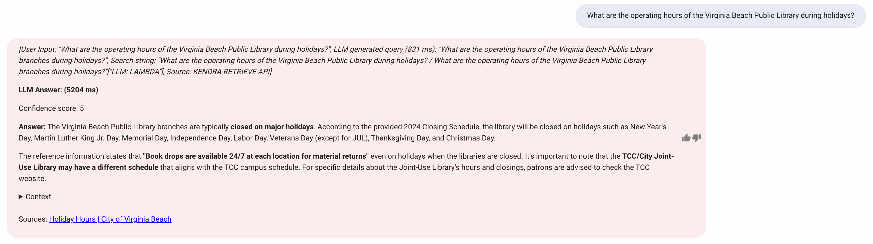

Figure : Library Hours Query

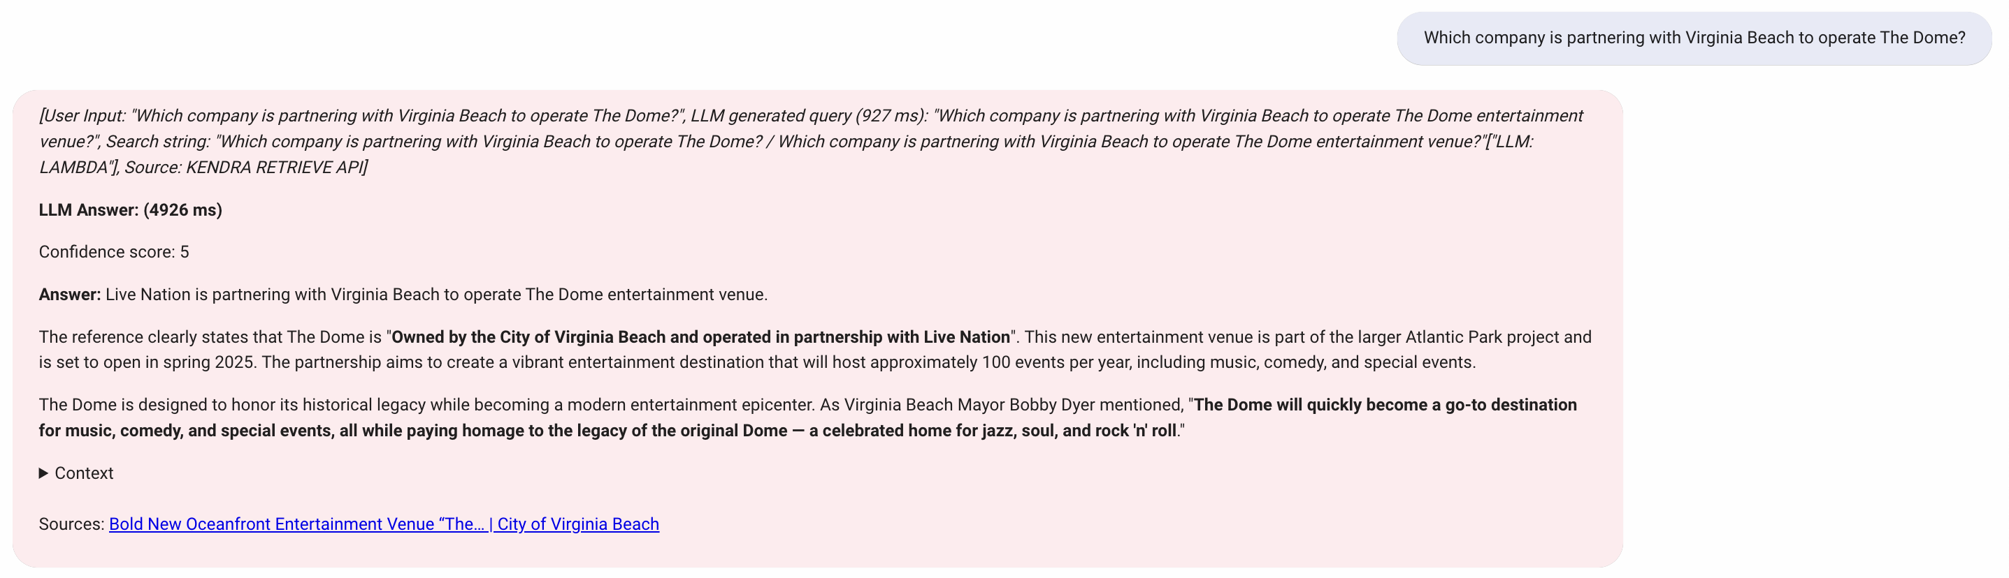

Figure : News Update Query-1

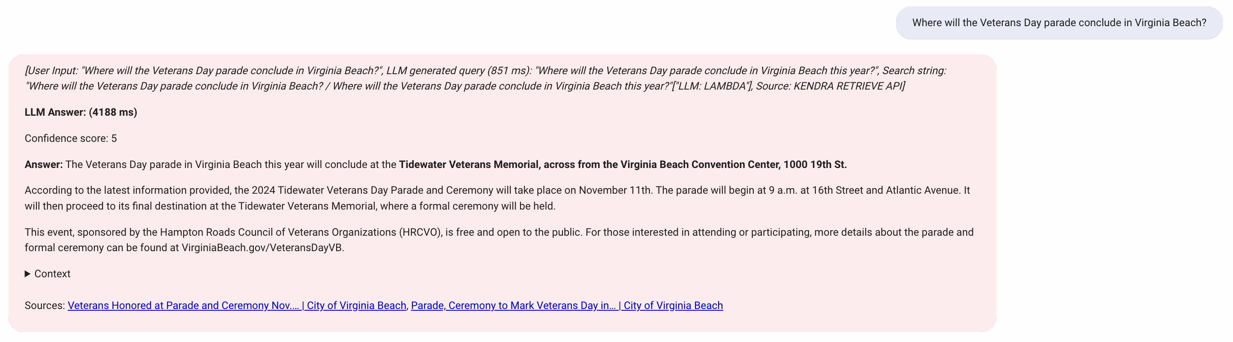

Figure : News Update Query -2

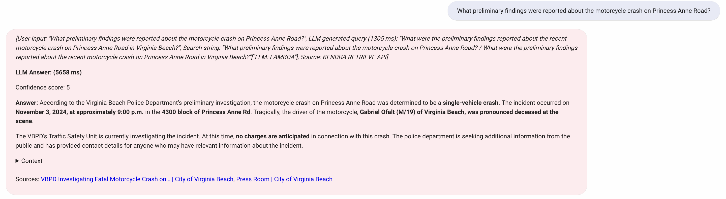

Figure : News Update Query -3

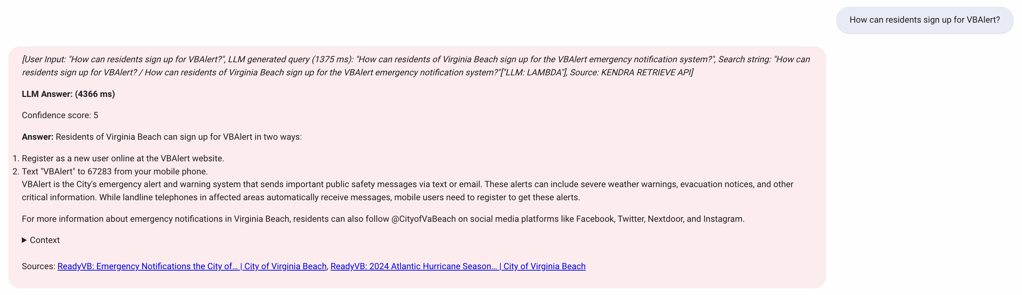

Figure : VB Update Query -1

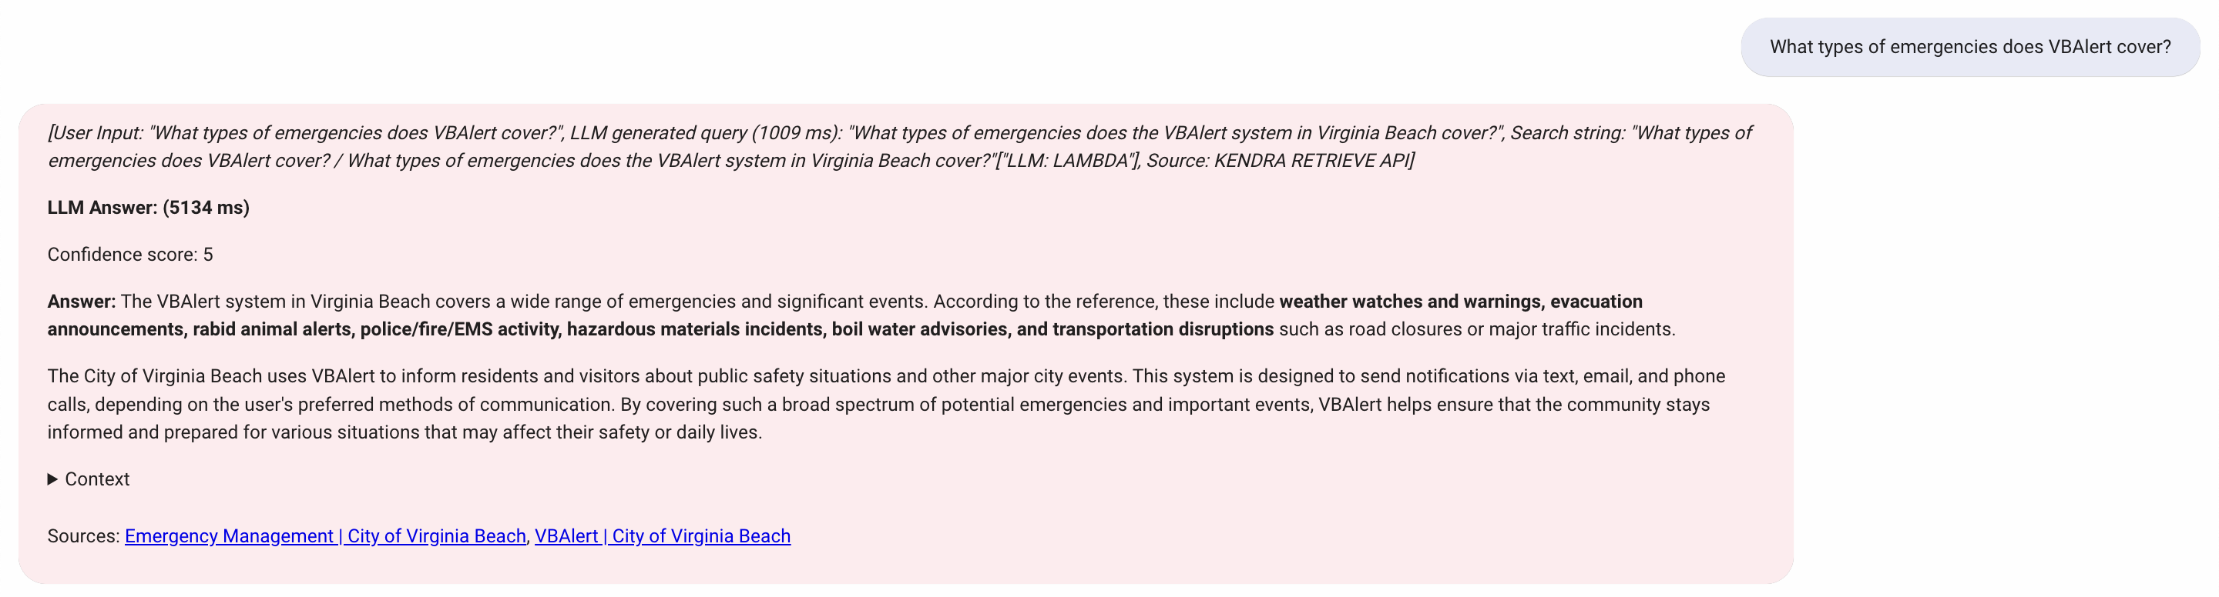

Figure : VB Update Query -2

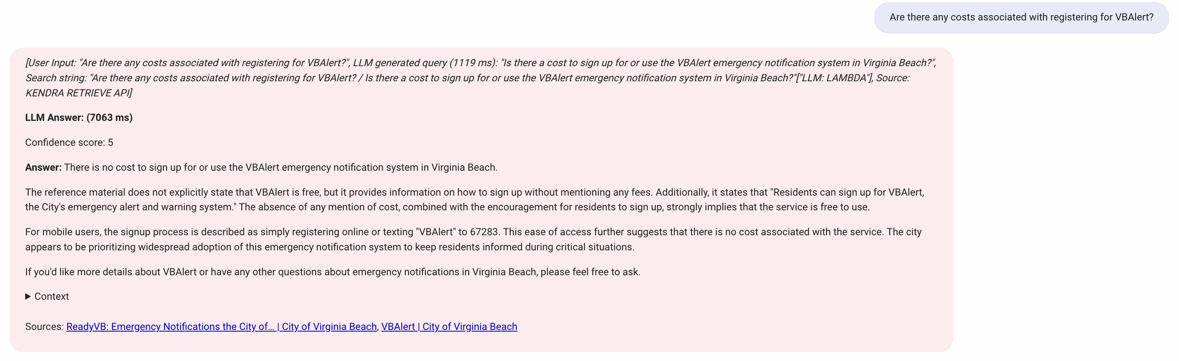

Figure : VB Update Query-3

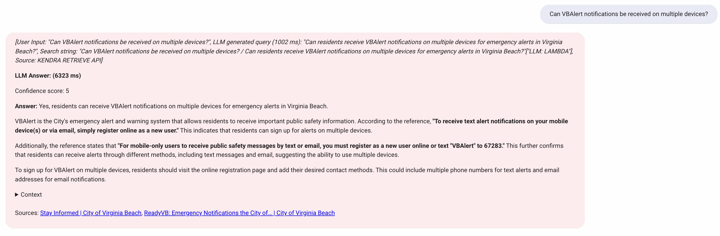

Figure : VB Update Query-4

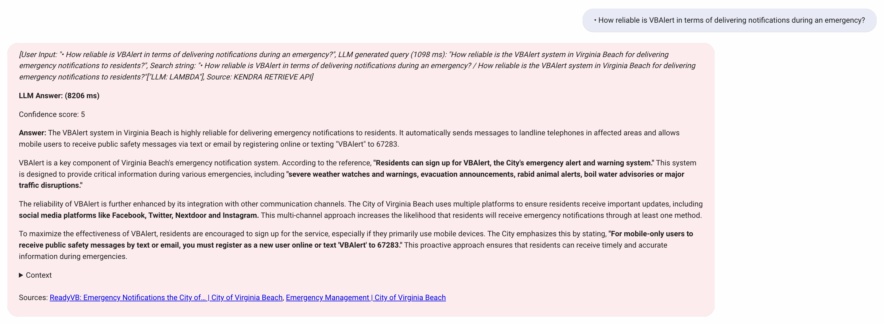

Figure : VB Update Query-5

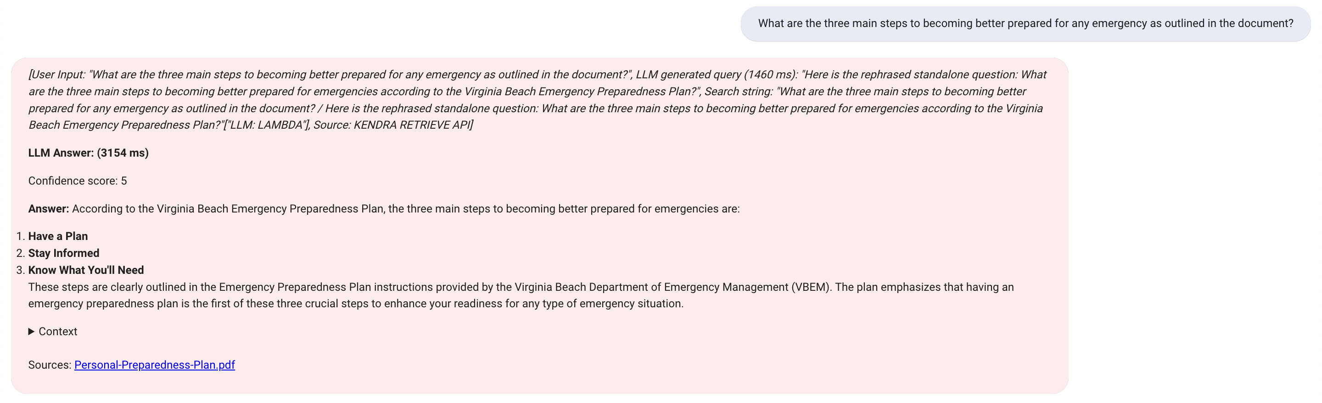

Figure : Emergency Update Query-1

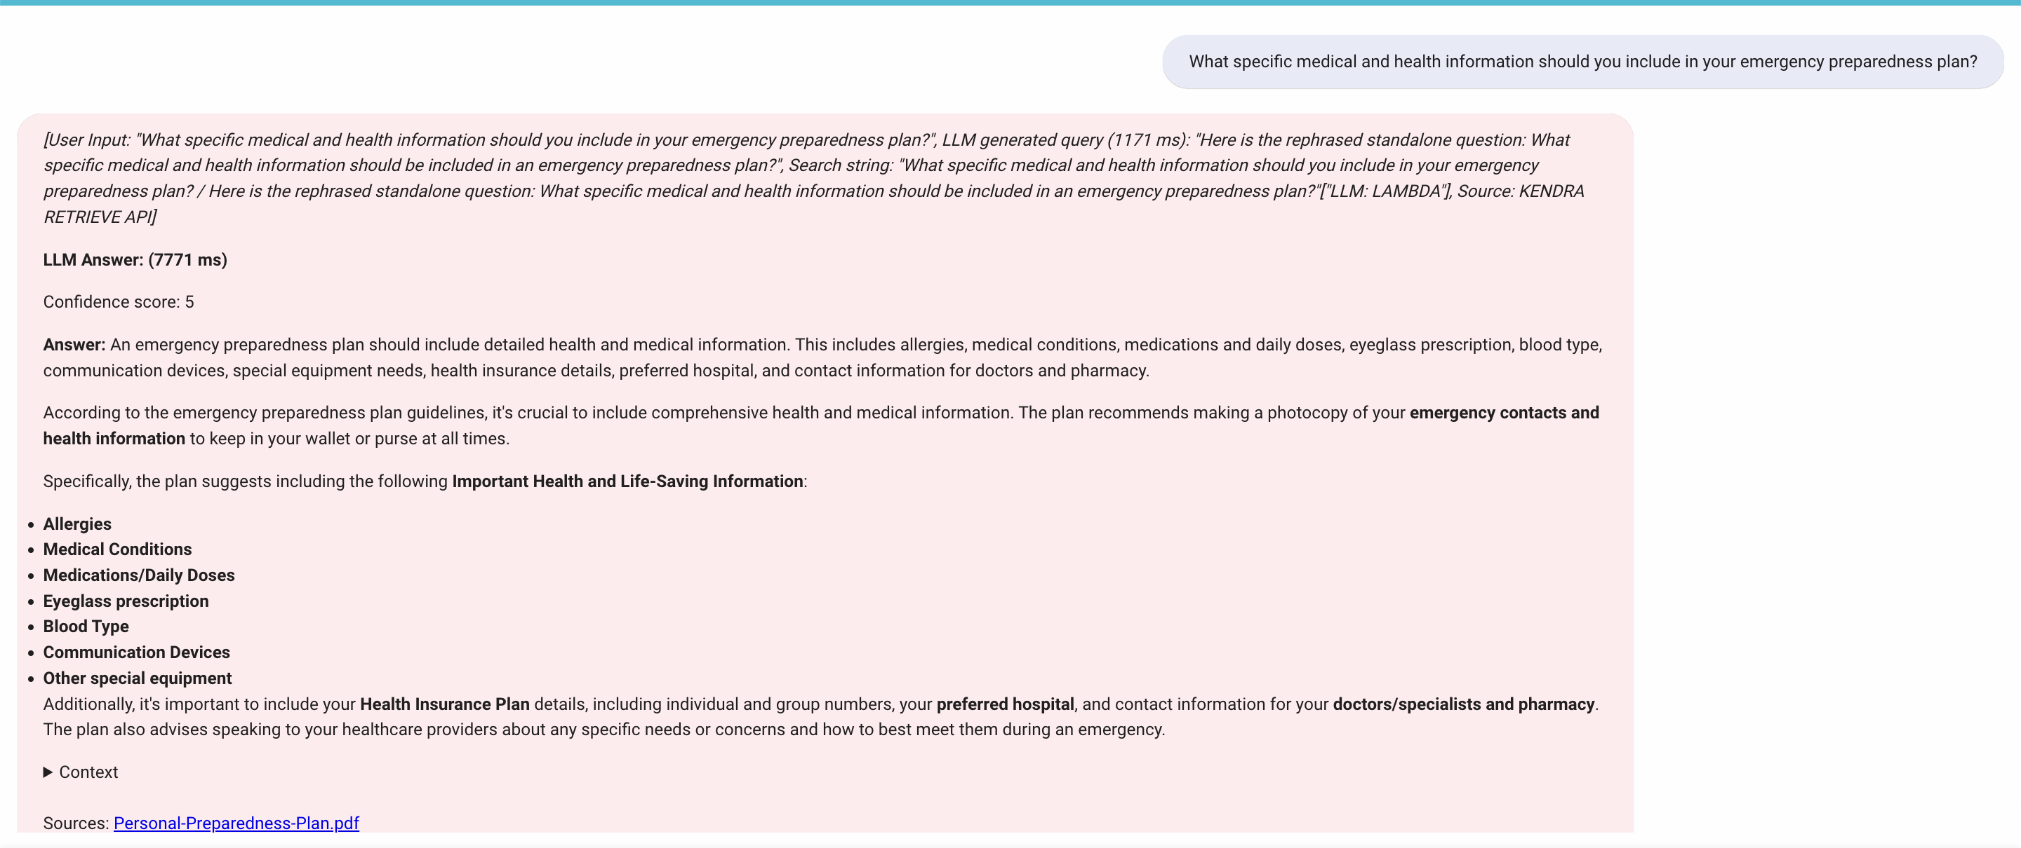

Figure : Emergency Update Query-2

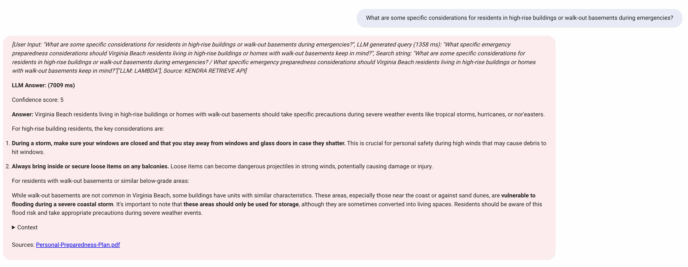

Figure : Emergency Update Query-3

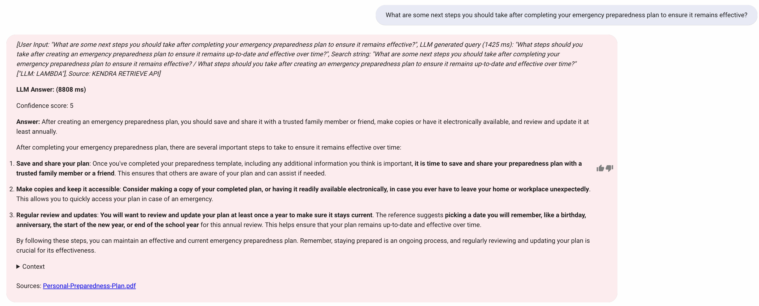

Figure : Emergency Update Query-4

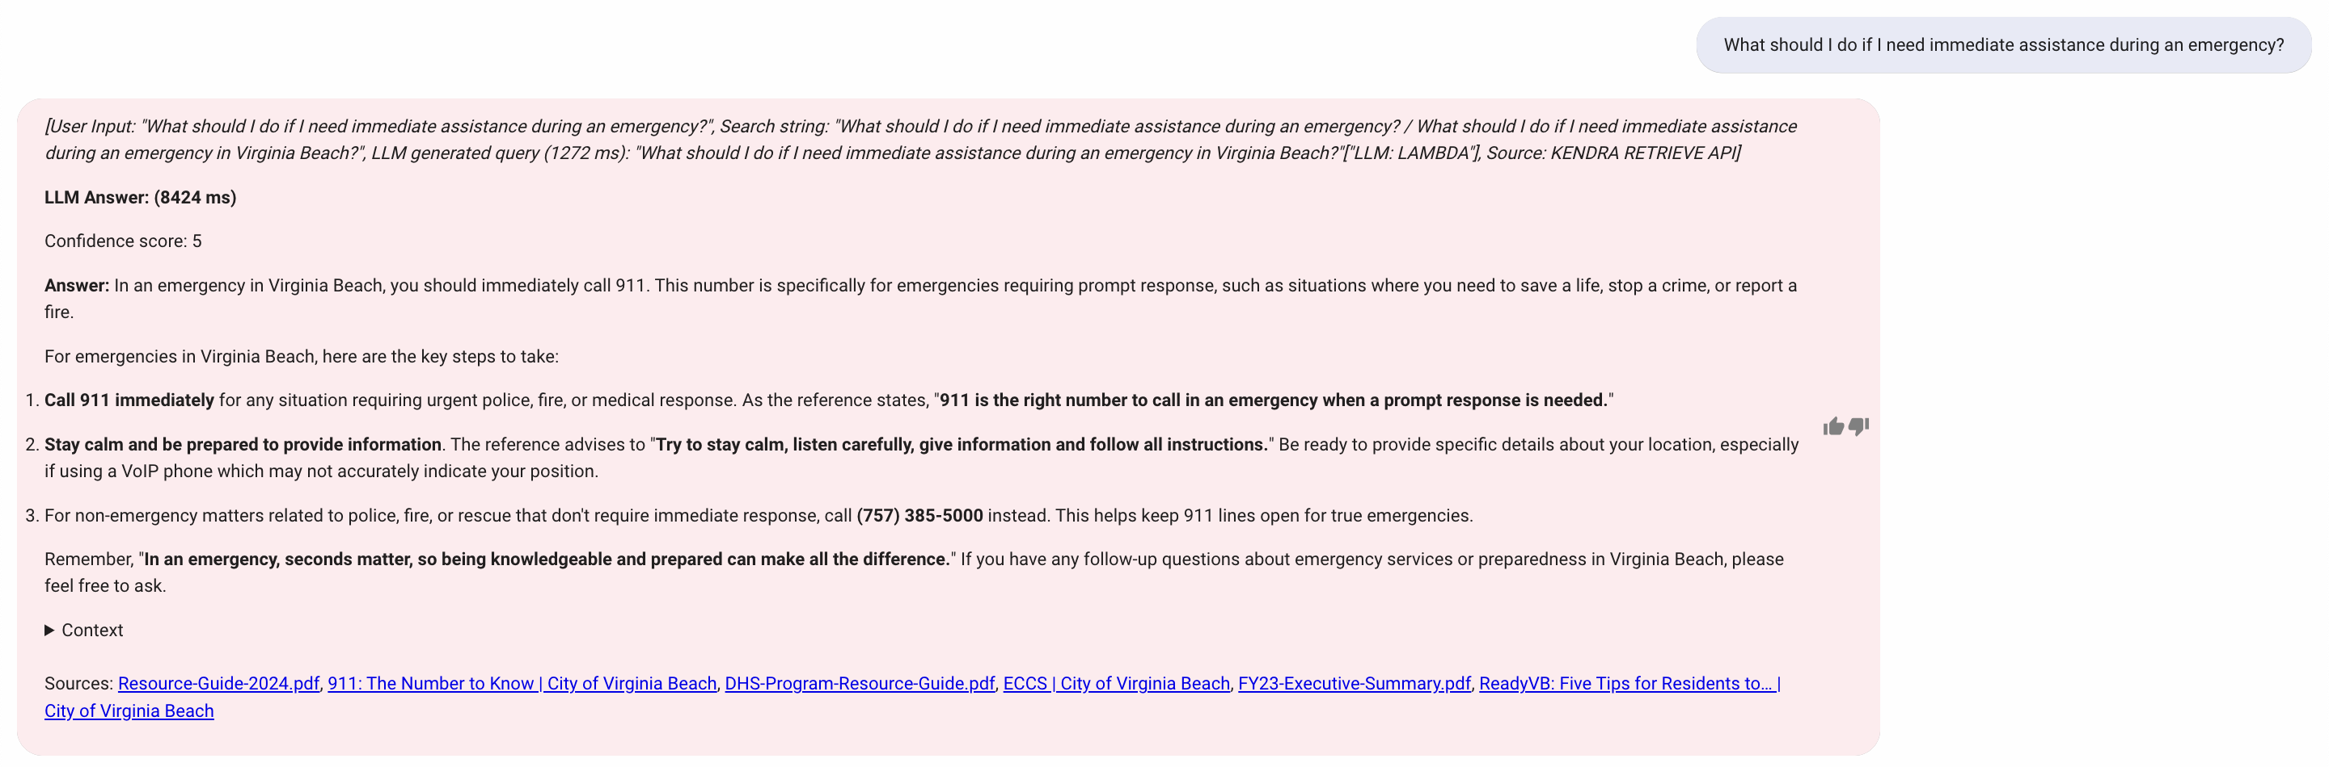

Figure : Emergency Update Query-5

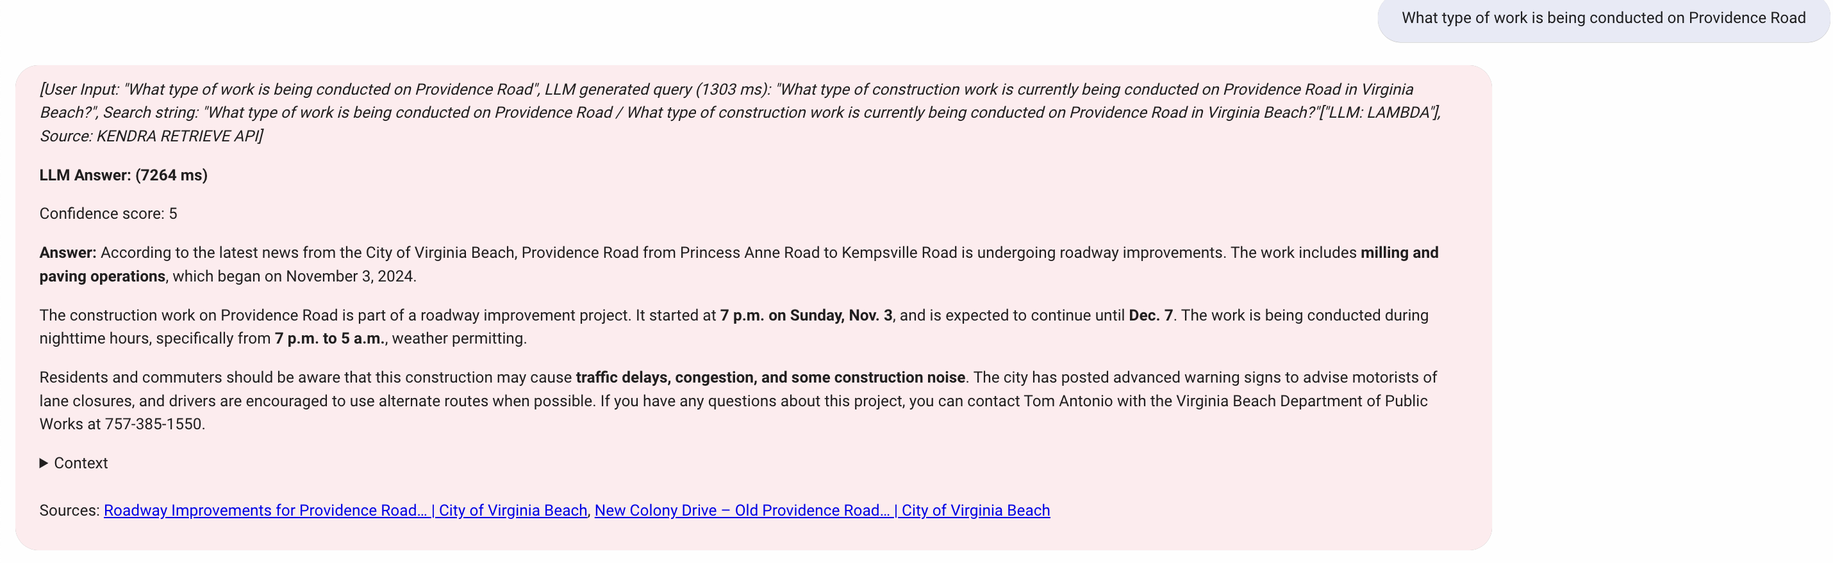

Figure : Road closures Query-1

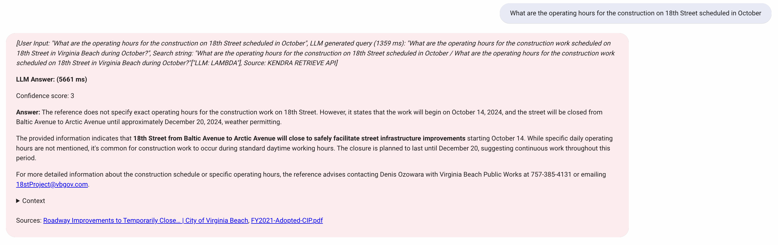

Figure : Road closures Query-2



Figure : Road closures Query-3

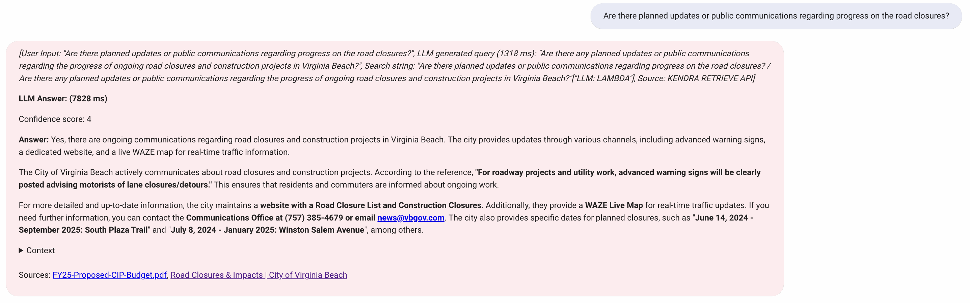

Figure : Road closures Query-4

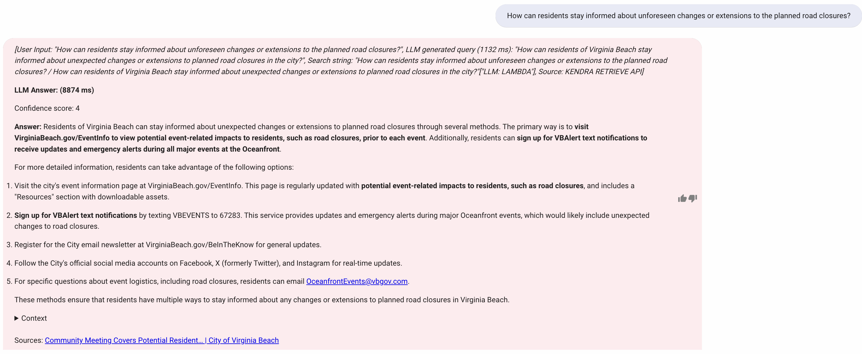

Figure : Road closures Query-5

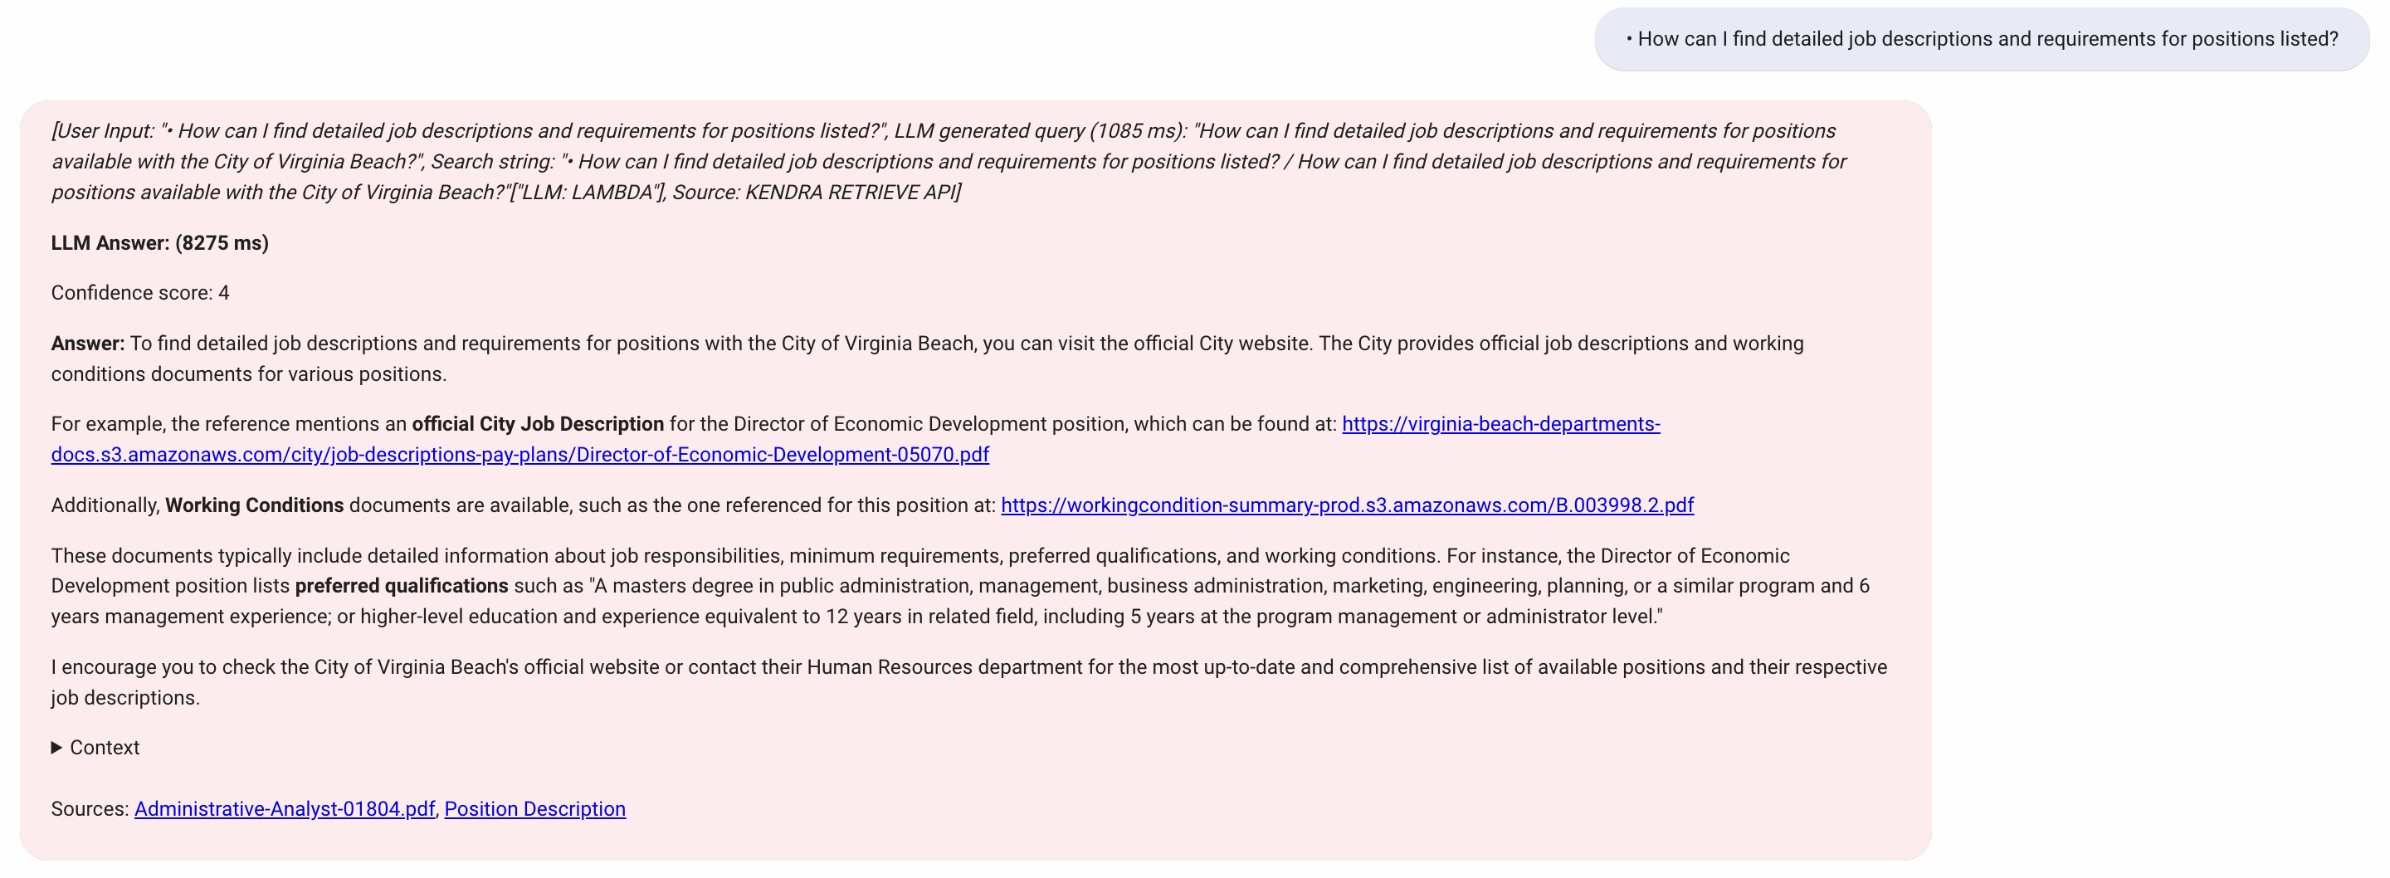

Figure : Career Opportunities Query-1

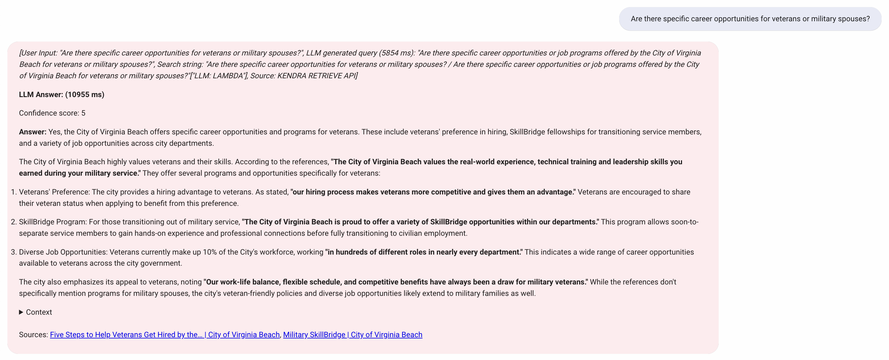

Figure : Career Opportunities Query-2

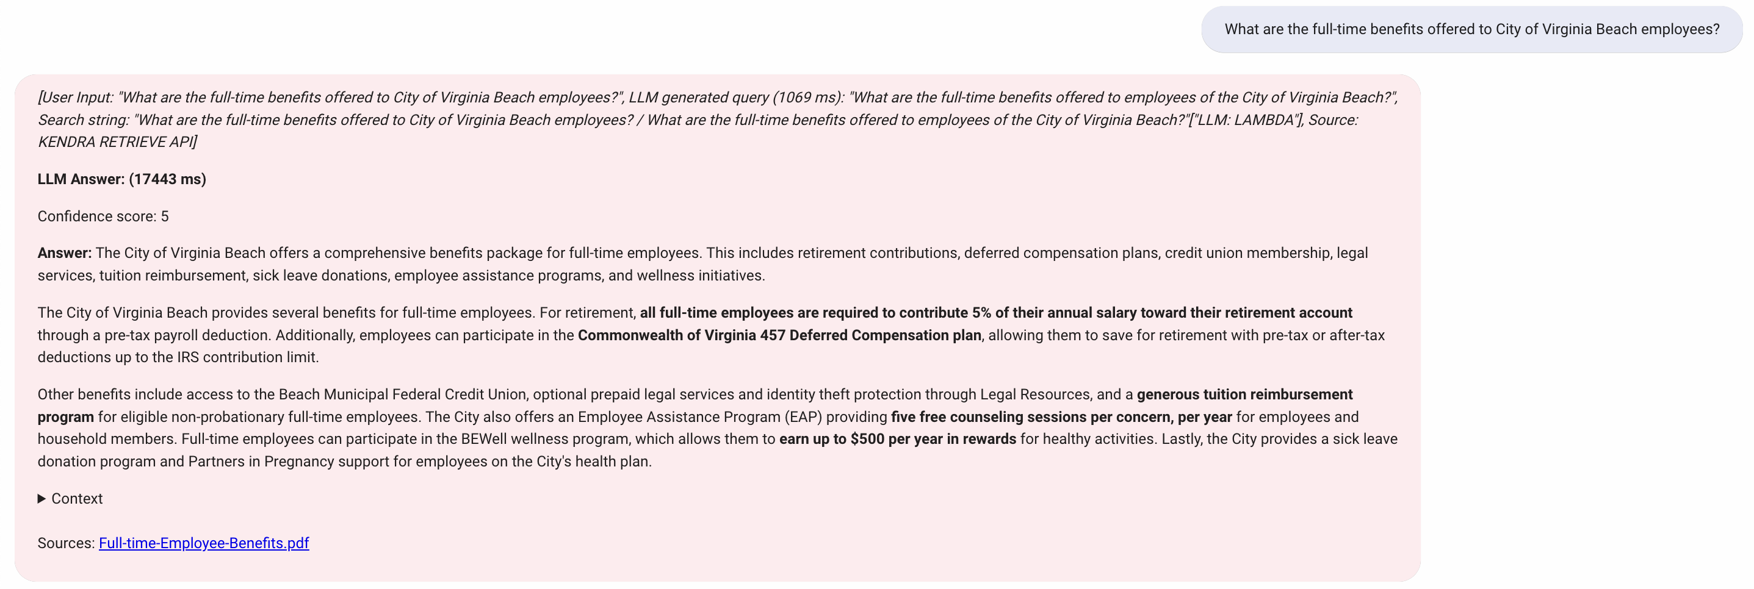

Figure : Career Opportunities Query-3

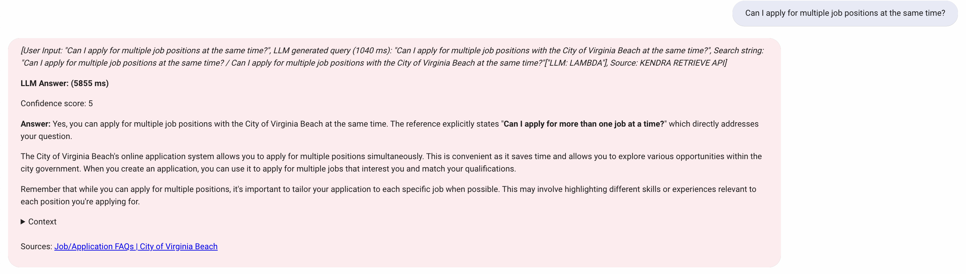

Figure : Career Opportunities Query-4

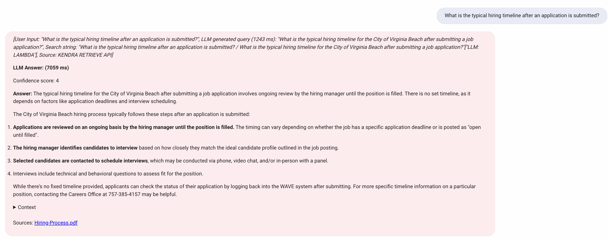

Figure : Career Opportunities Query-5

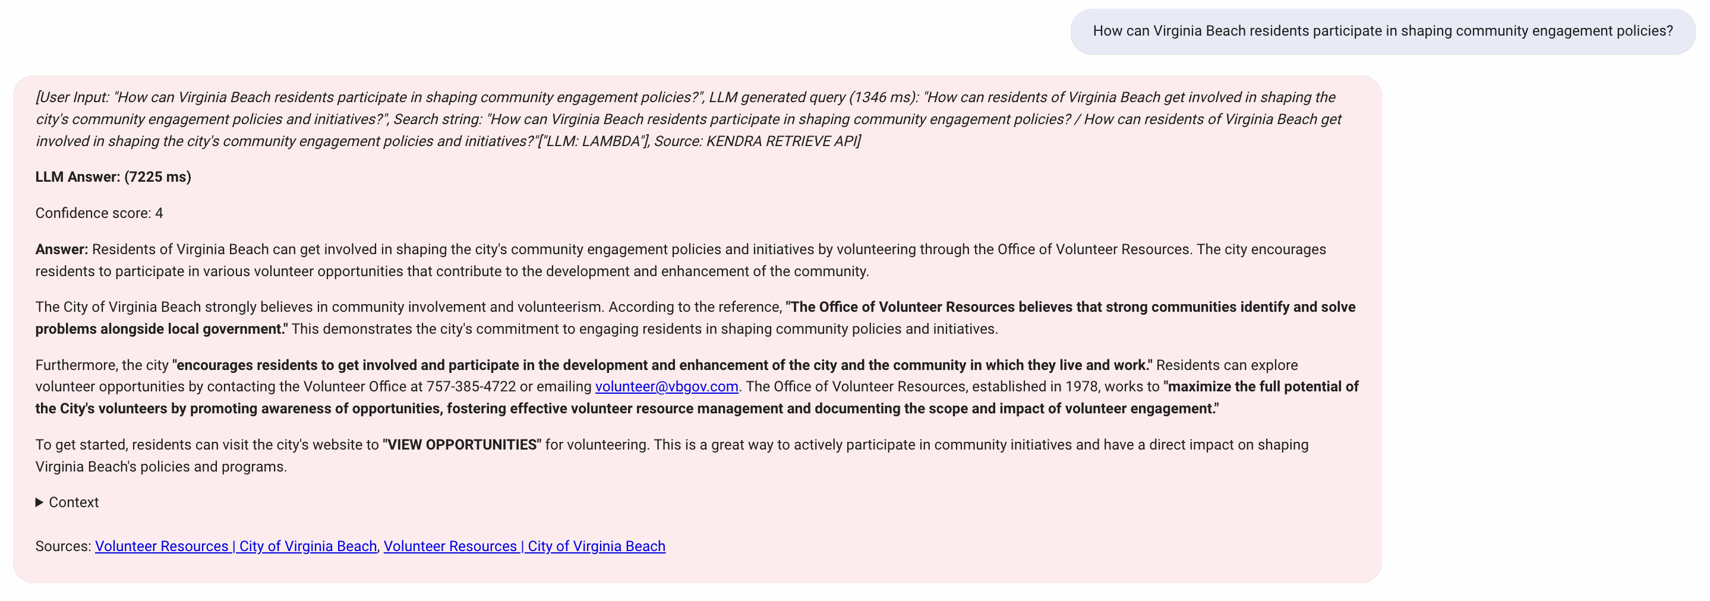

Figure :Community Engagement Query-1

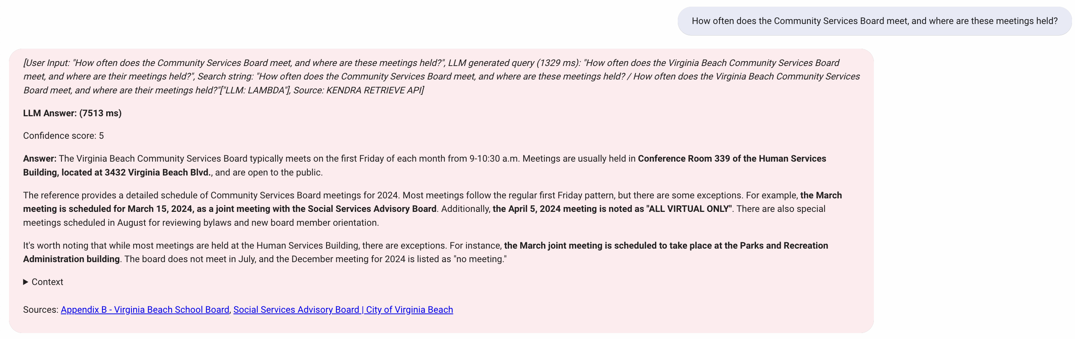

Figure : Community Engagement Query-2

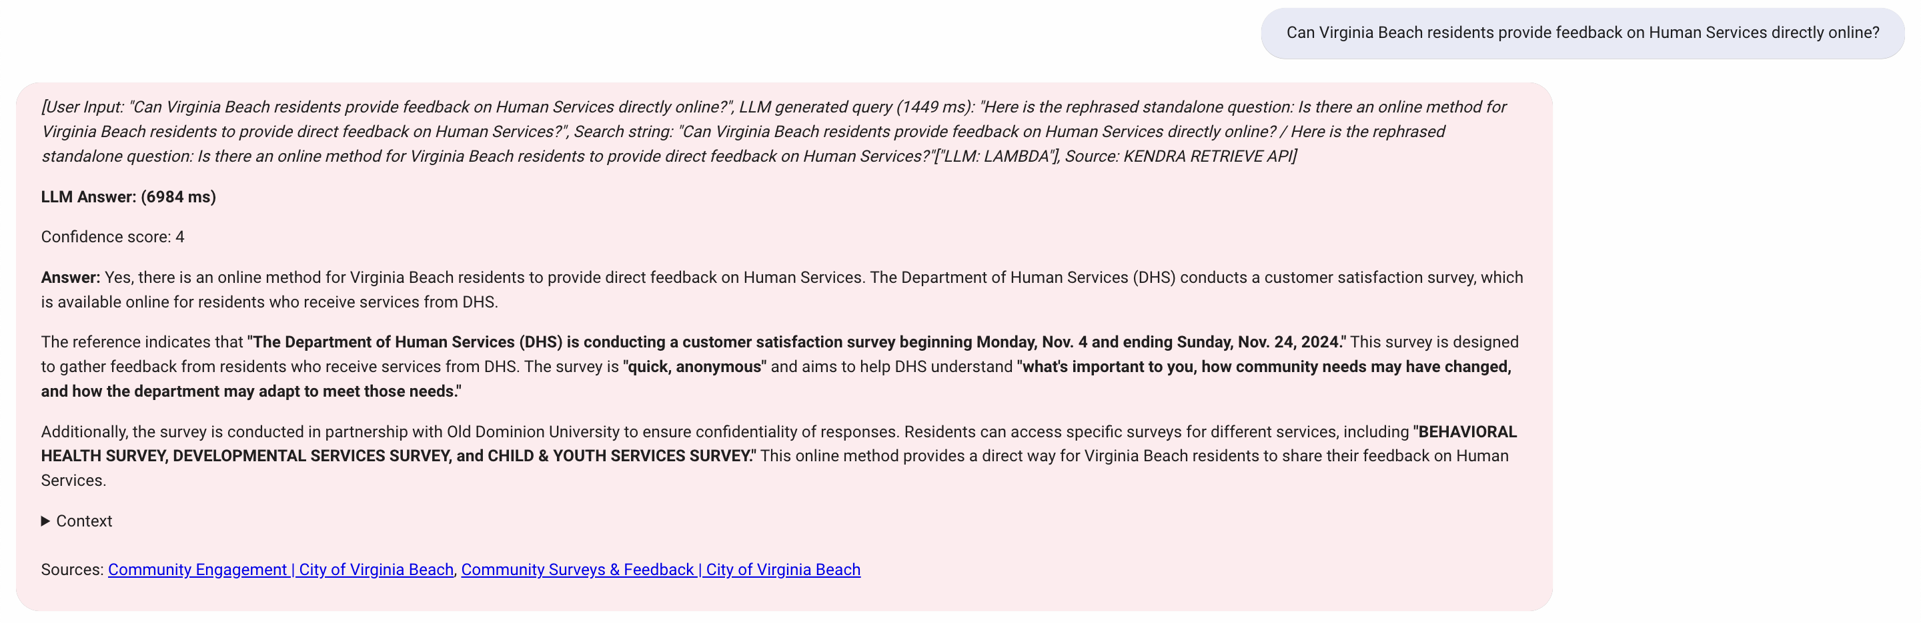

Figure : Community Engagement Query-3

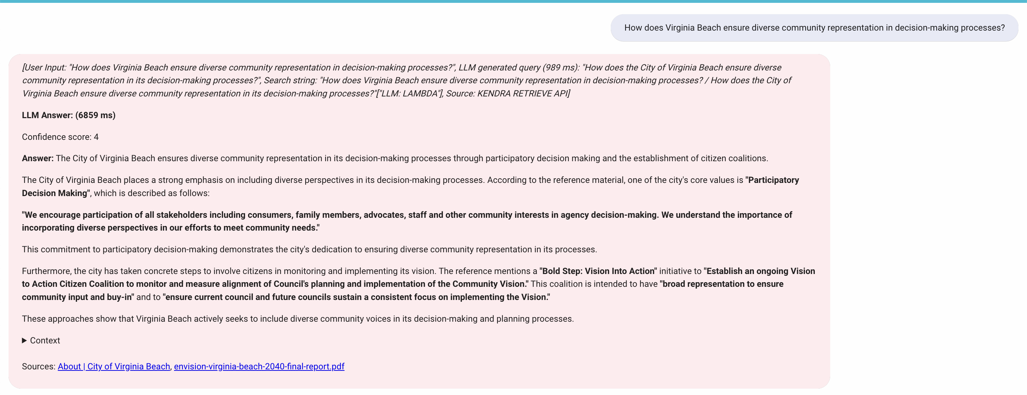

Figure : Community Engagement Query-4

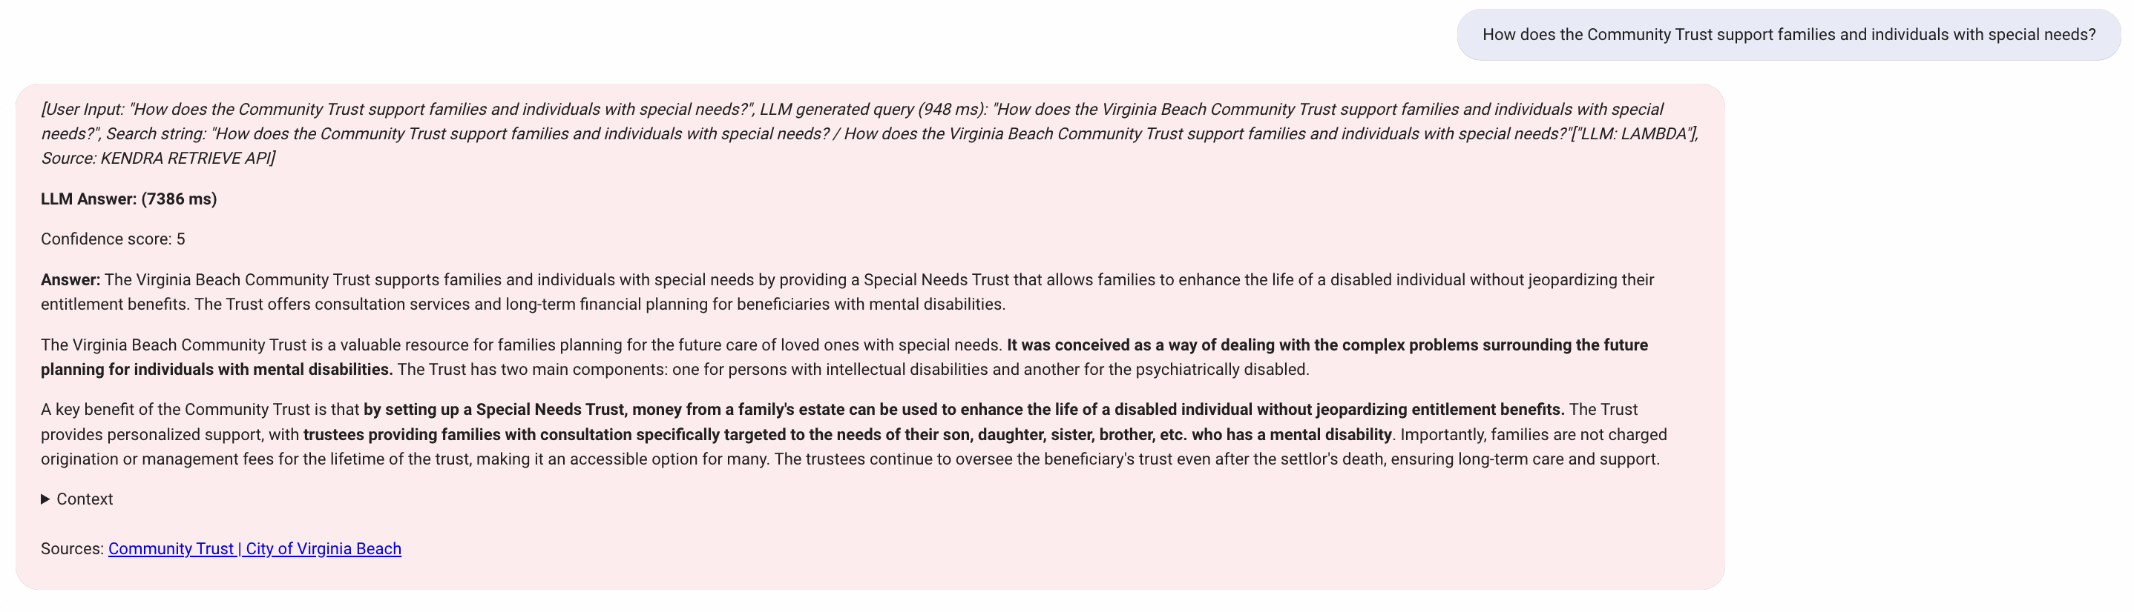

Figure : Community Engagement Query-5

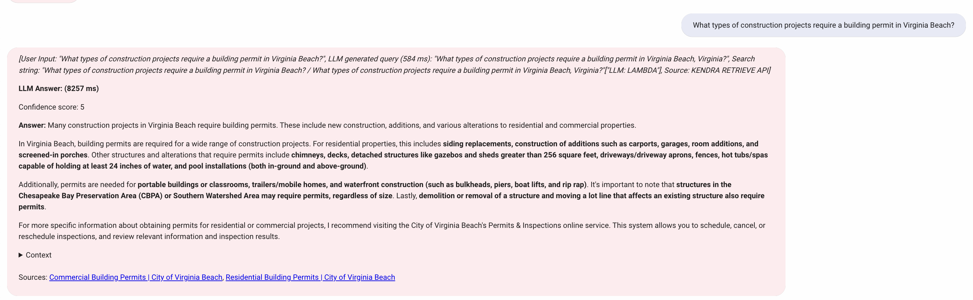

Figure : Permit Related Query-1



Figure : Permit Related Query-2

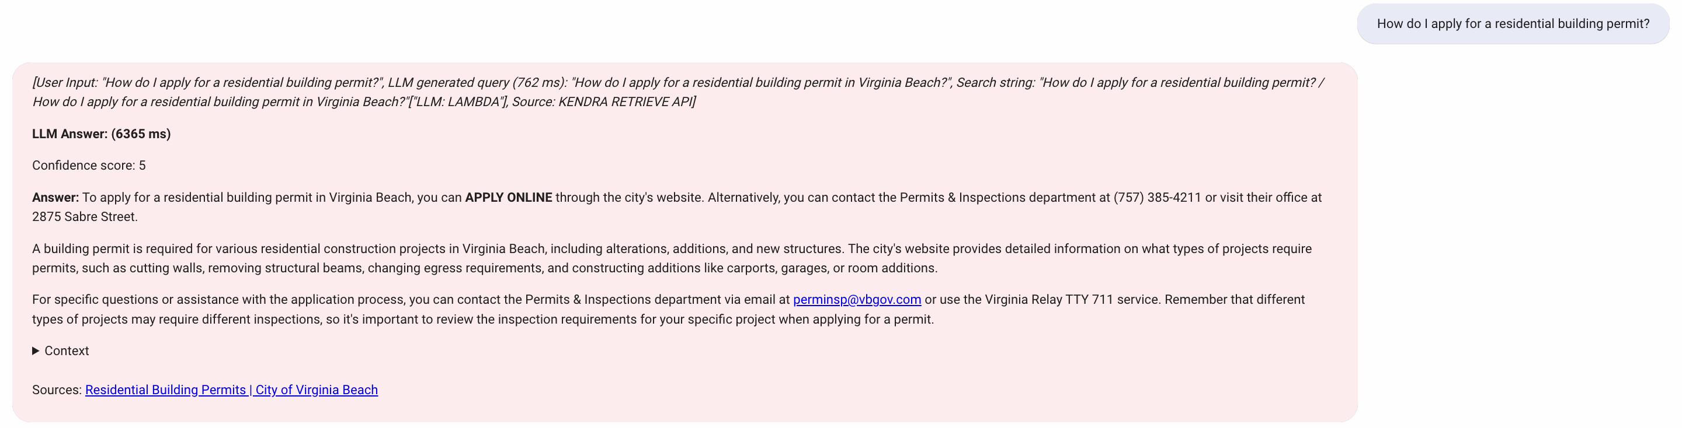

Figure : Permit Related Query-3

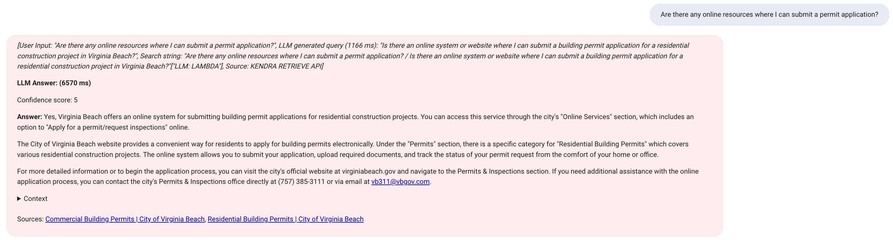

Figure : Permit Related Query-4

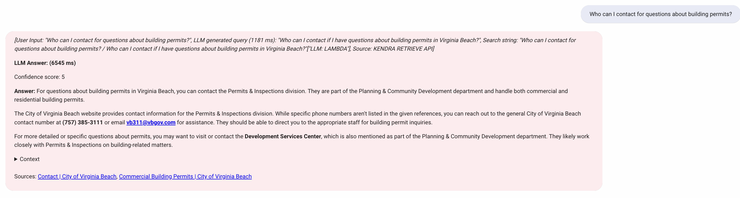

Figure : Permit Related Query-5

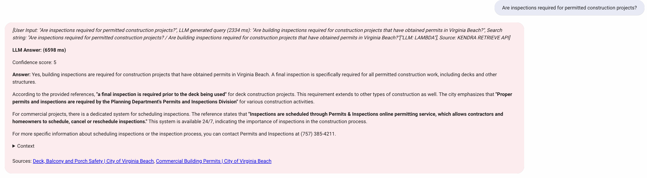

Figure : Permit Related Query- 6

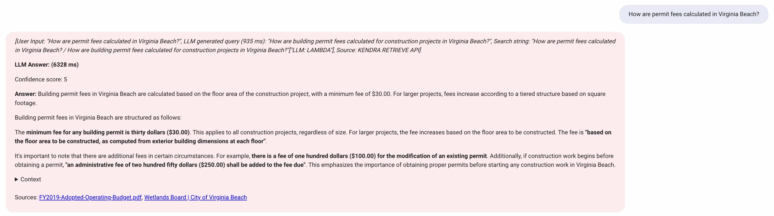

Figure : Permit Related Query-7

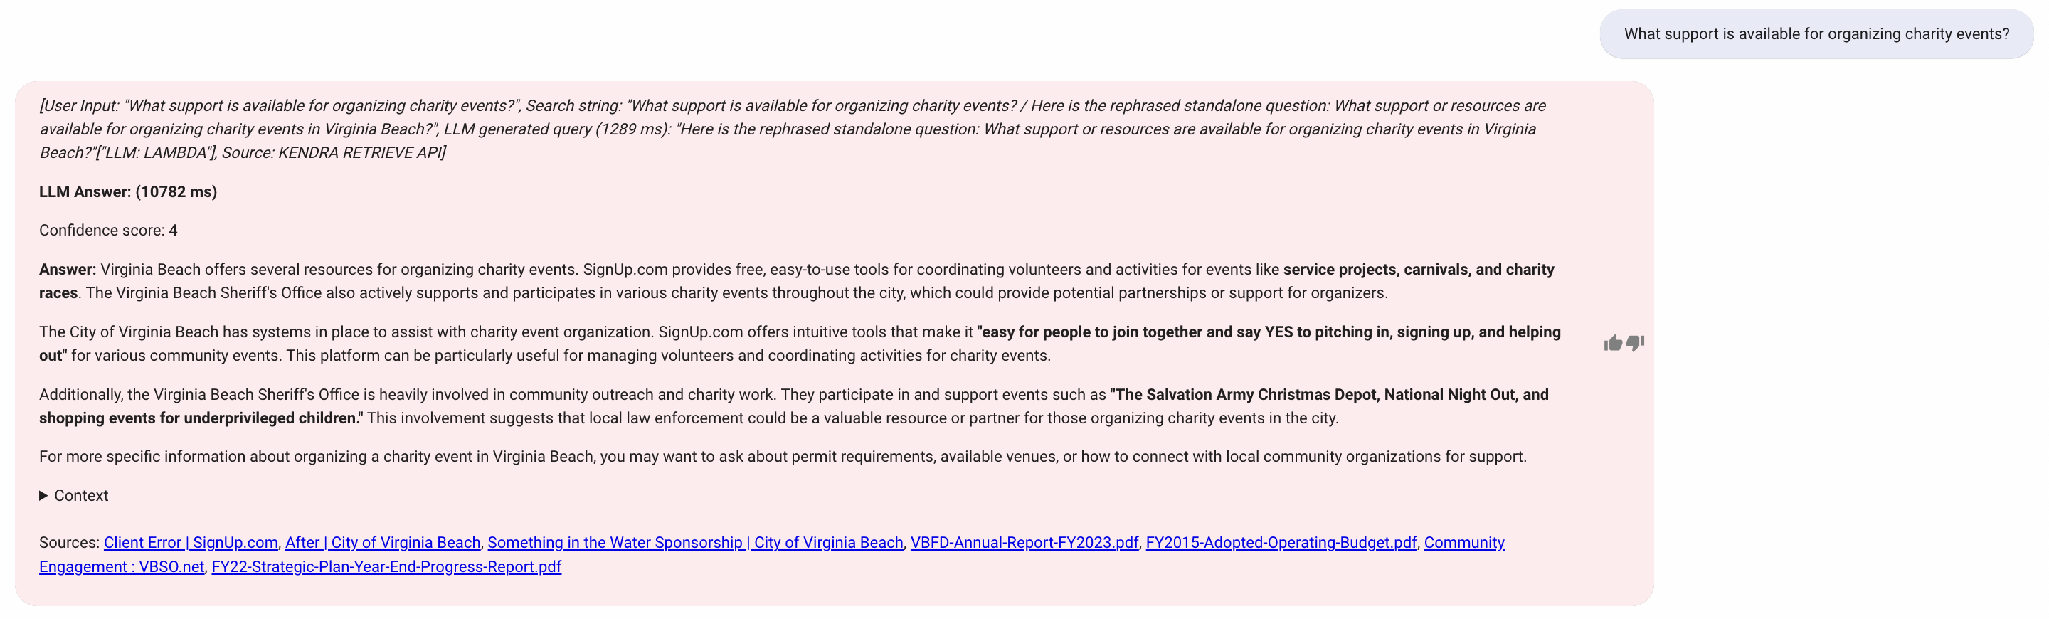

Figure : Permit Related Query-8

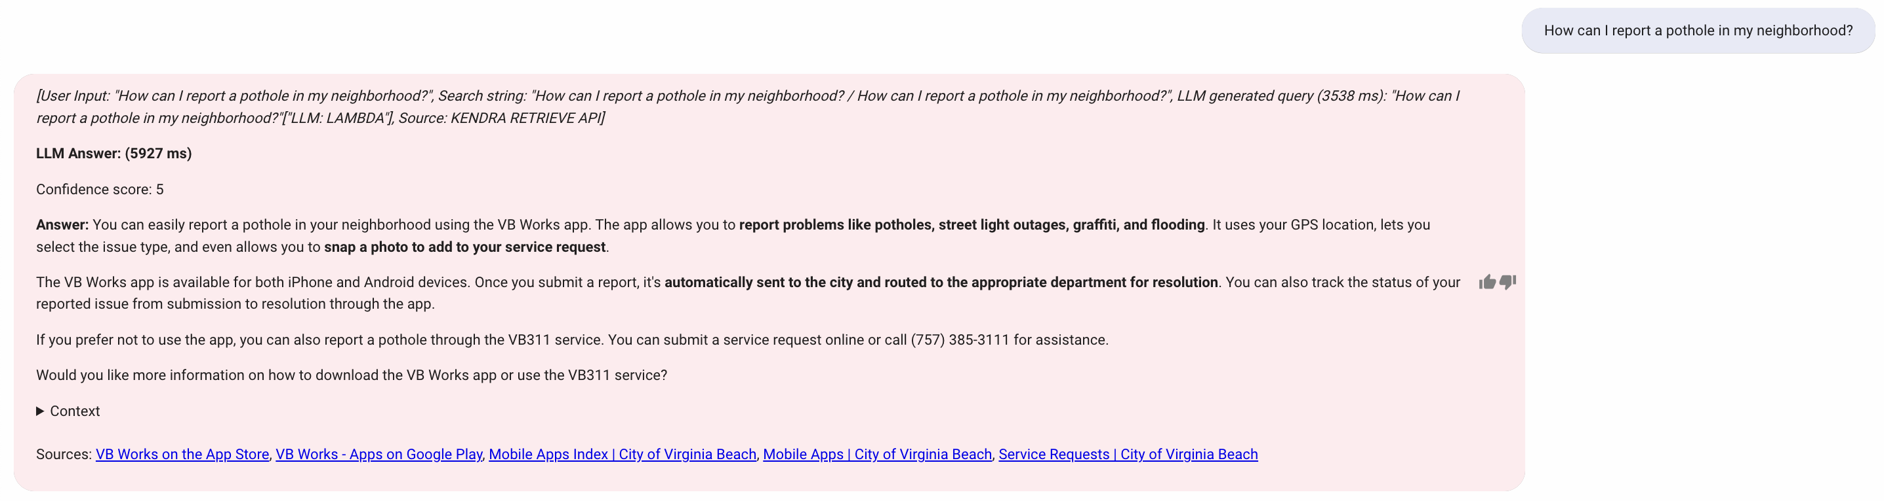

Figure : Report Related Query-1

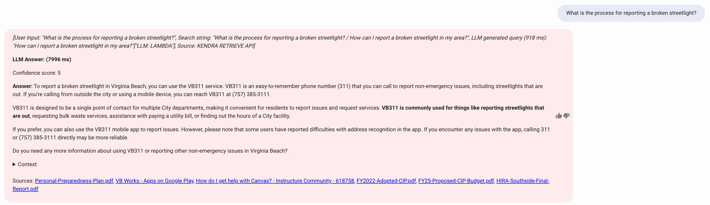

Figure : Report Related Query-2

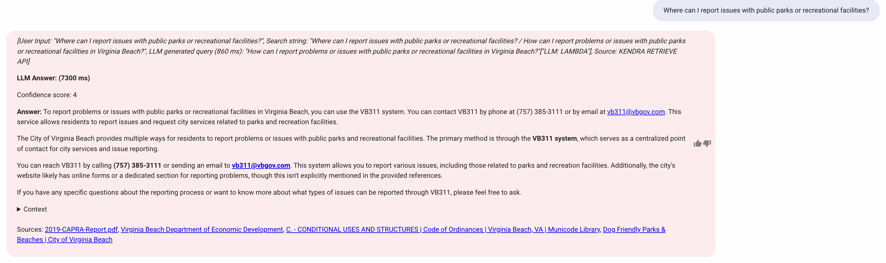

Figure : Report Related Query-3

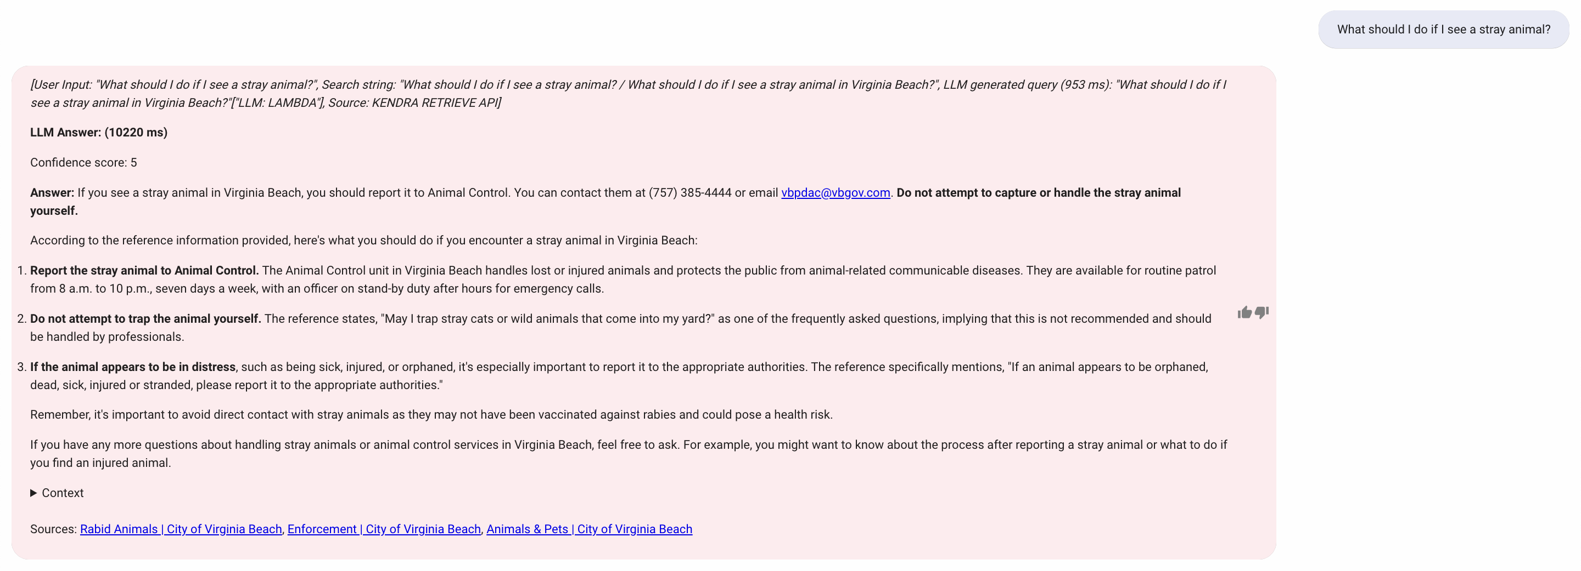

Figure : Report Related Query-4

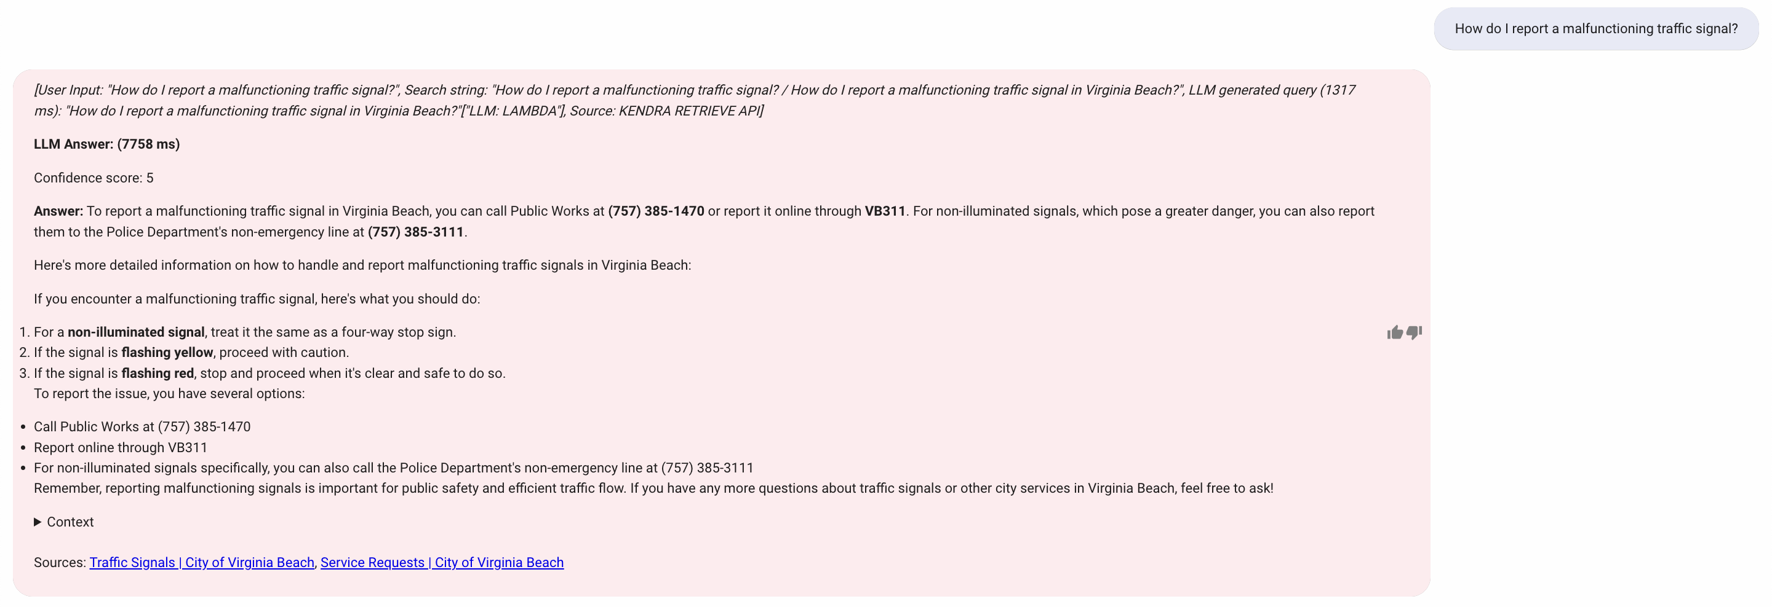

Figure : Report Related Query-5

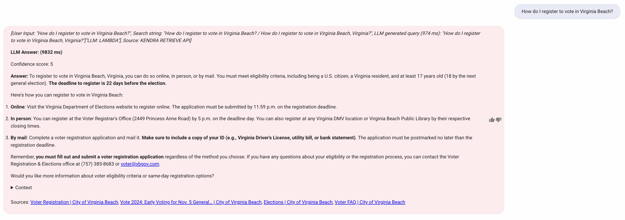

Figure : Voting Related Query-1

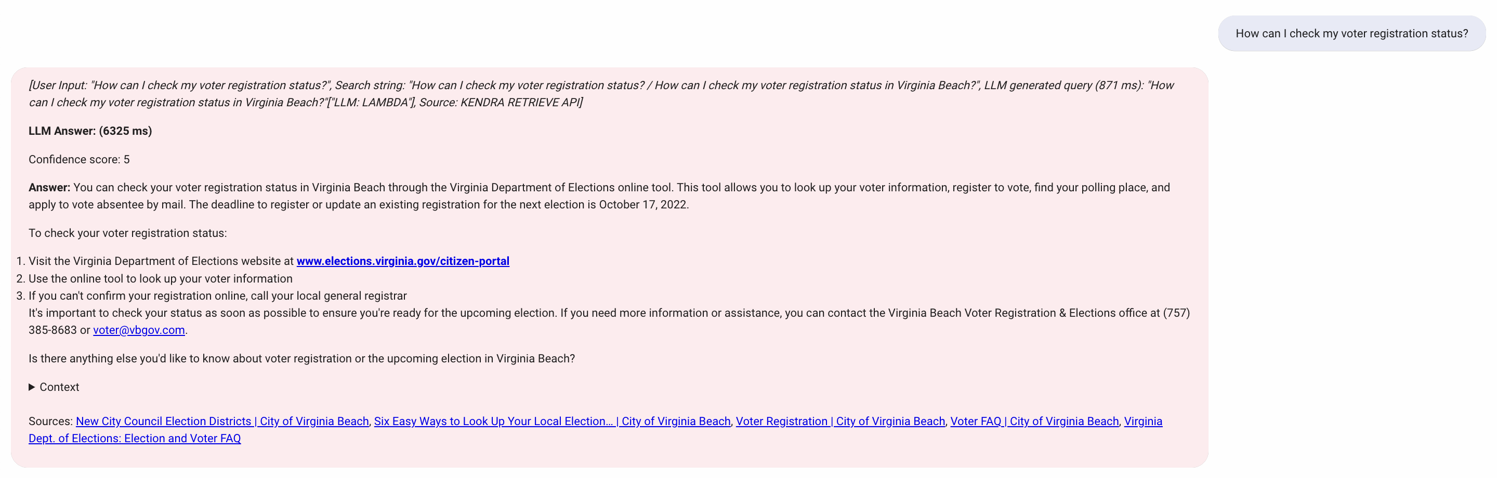

Figure : Voting Related Query-2

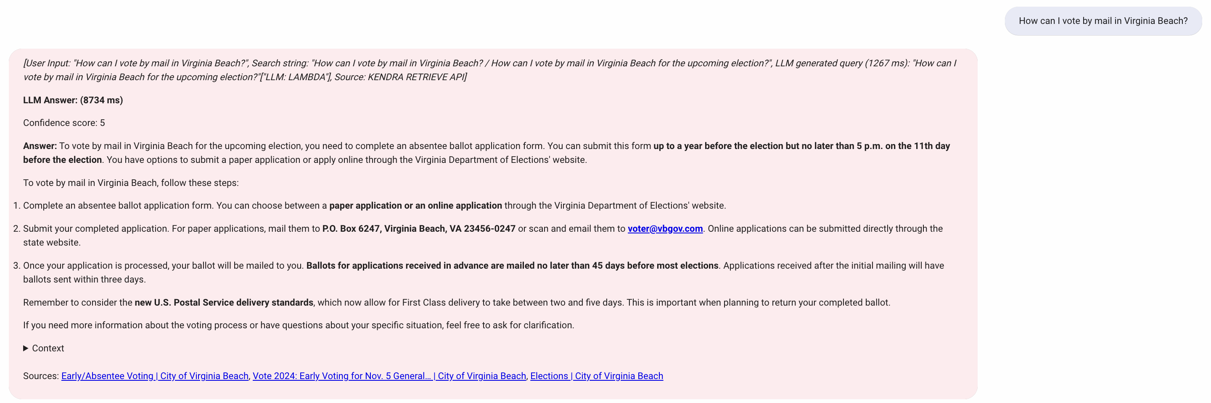

Figure : Voting Related Query-3

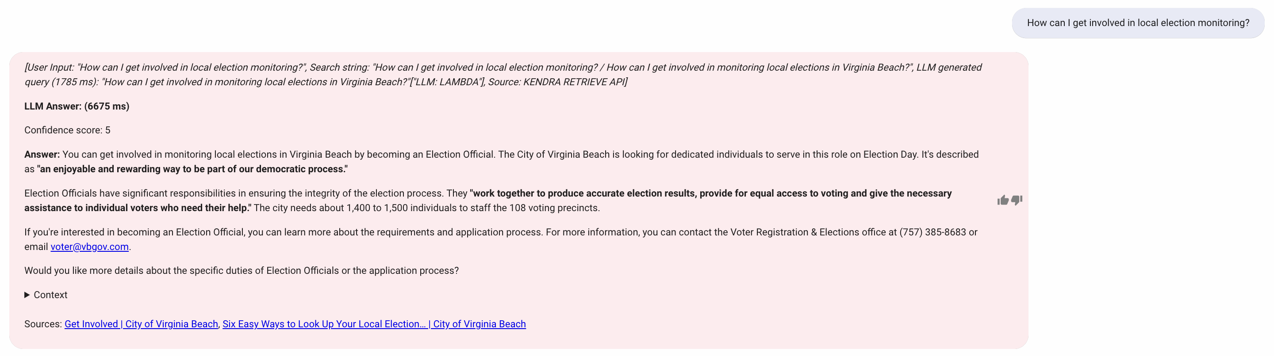

Figure : Voting Related Query-4

Query Variability Testing: It capably managed paraphrased and reformulated questions, proving its strength in recognizing user intent despite varied phrasing. However, context maintenance in multi-turn conversations was a noticed weak.

Error Handling Testing: The chatbot smoothly handled minor typos and grammatical mistakes, showing it could understand slightly mistaken inputs. However, it struggled with significantly misspelled or incomplete queries.

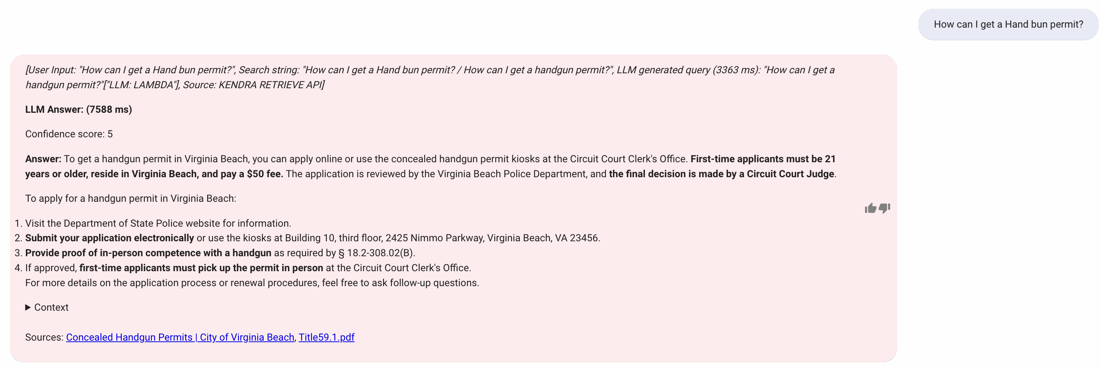

Figure : Typo Error in Query

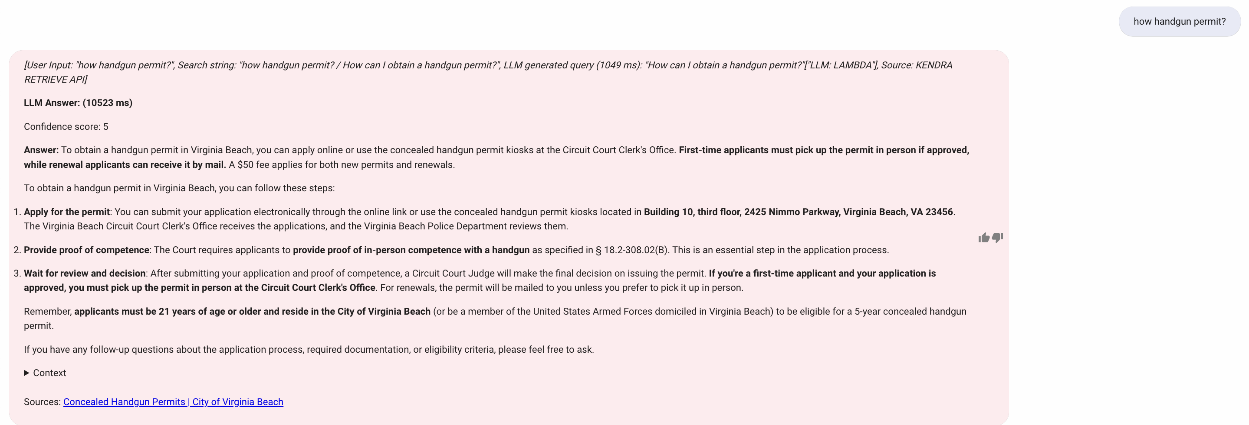

Figure : Grammatical Mistake in Query

Response Quality Testing: The chatbot consistently delivered accurate and relevant answers, supported by strong confidence scores and appropriate references. Although response times were satisfactory, the bot sometimes weak in maintaining continuity in conversations involving multiple topics.

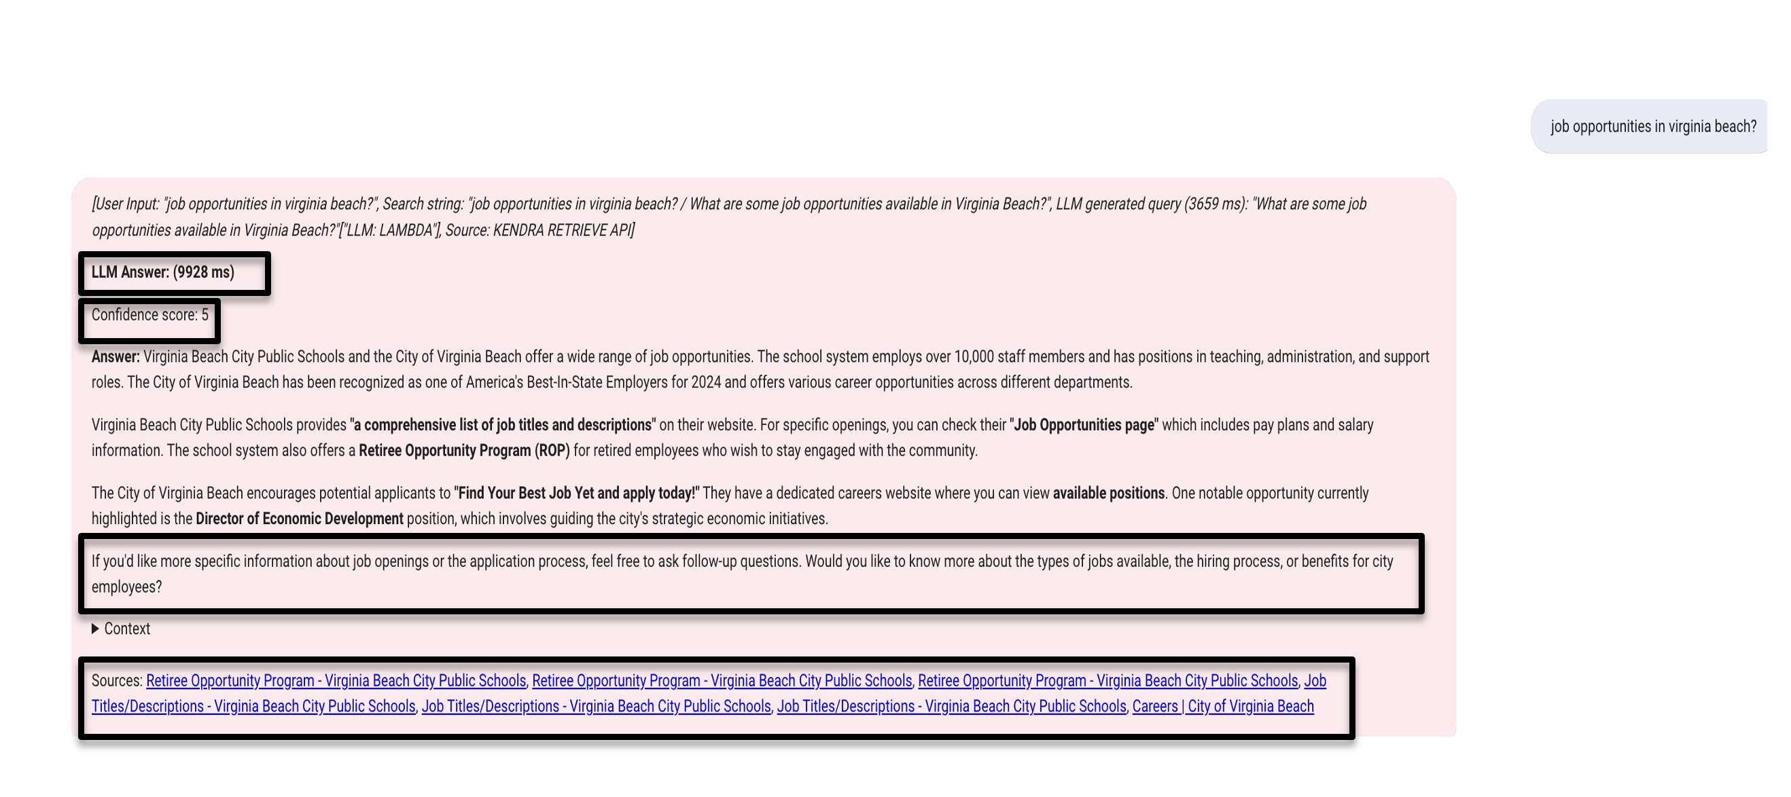

Figure : Response Quality

User Feedback Testing: Utilizing a thumbs up and thumbs down feedback system, we assessed user reactions to chatbot responses, which provided valuable insights into the chatbot's effectiveness and areas needing improvement.

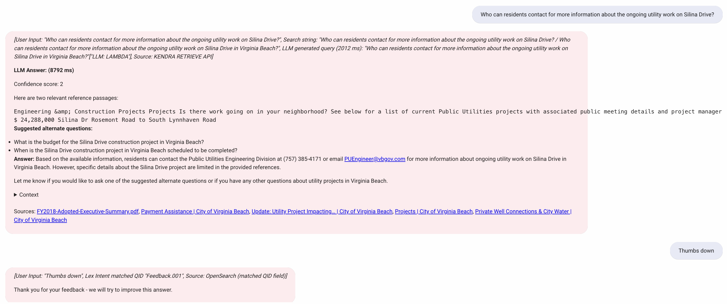

Figure : Feedback on Thumbs Down

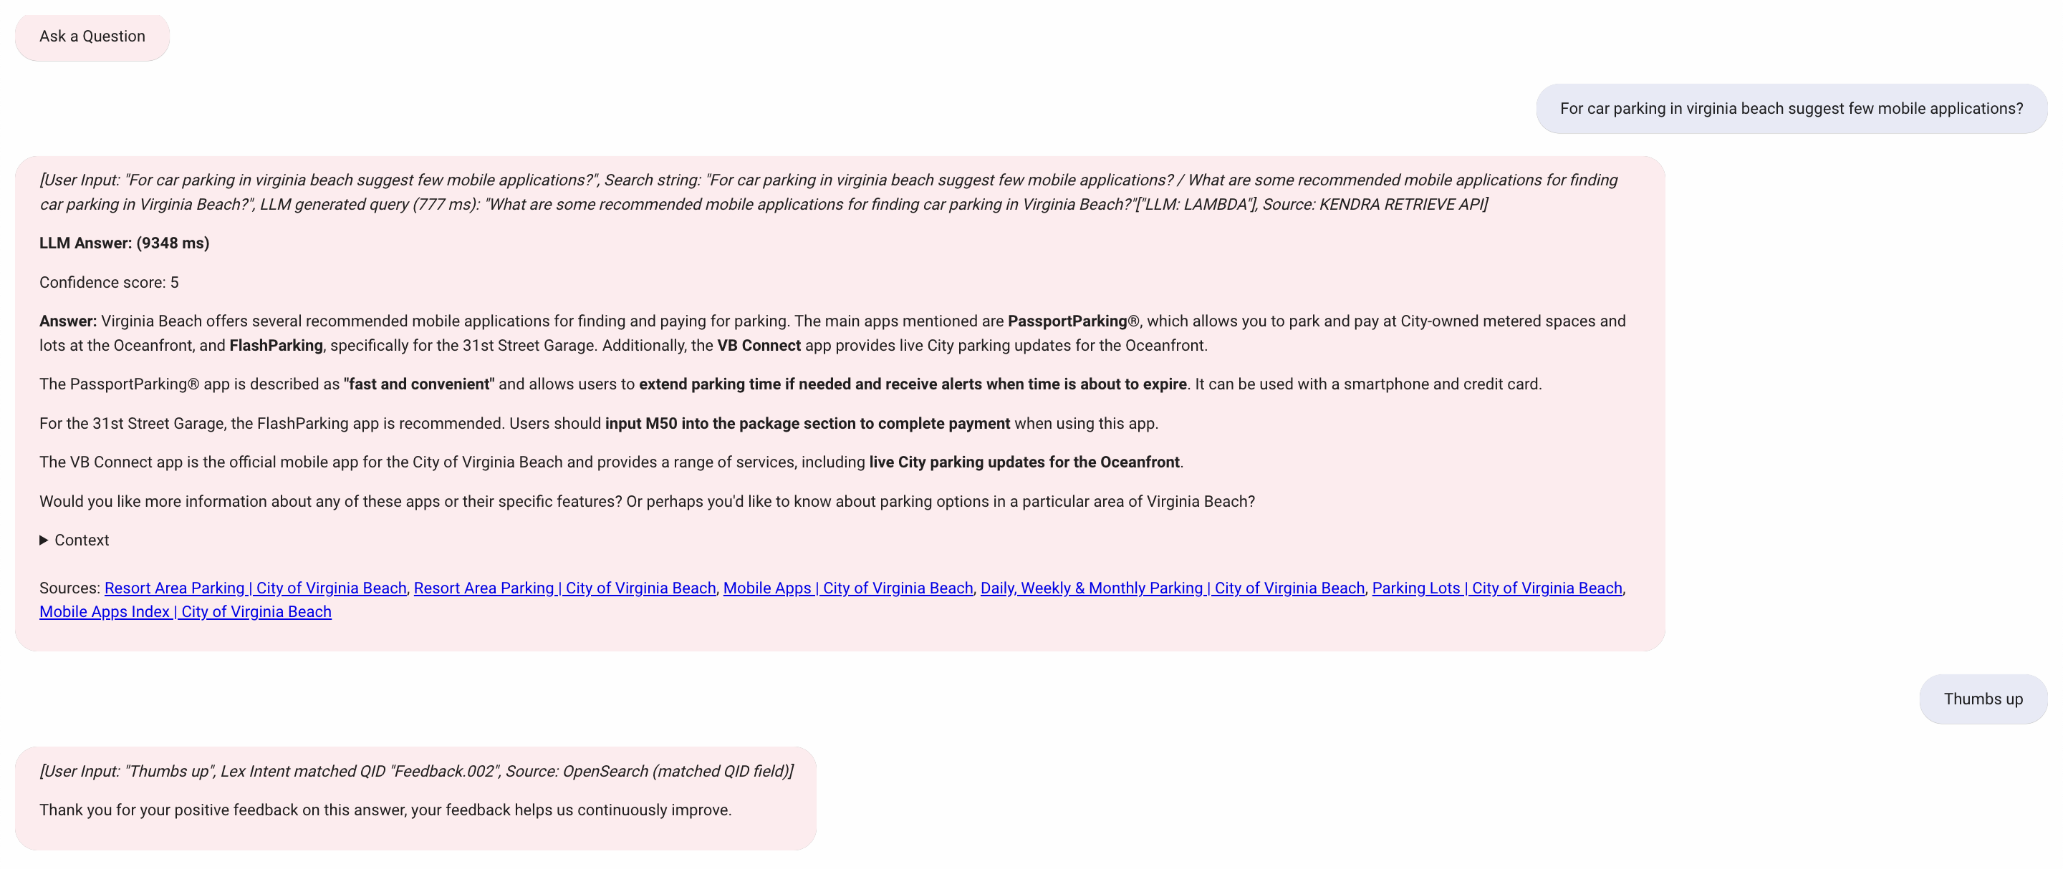

Figure : Feedback on Thumbs Up

## Validation

Validation processes involved analysis of each test case to refine the chatbot’s functionality. Insights gathered from manual testing helped identify critical improvement areas, particularly in handling complex queries and improving conversation continuity. The evaluation also leveraged user feedback to identify gaps in the chatbot’s understanding. This ongoing feedback loop is important for continuously enhancing the system, ensuring it meets the expectations and needs of users effectively. This structured approach aims to optimize the chatbot's accuracy, responsiveness, and user engagement, aligning closely with the capabilities of the Anthropic Claude 3.5 Sonnet LLM and ensuring the chatbot is an effective communication tool for the City of Virginia Beach.

# Findings

The Generative AI Retrieval-Augmented Generation (RAG) chatbot developed for the City of Virginia Beach is an initiative aimed at enhancing citizen engagement and streamlining access to city services. This project utilizes the latest in artificial intelligence through Amazon Web Services (AWS) and innovative RAG techniques to offer a highly interactive and responsive chatbot.

The chatbot leverages an extensive knowledge base, constructed through automated web scraping with Amazon Kendra, and maintained in AWS storage, enabling it to deliver accurate and context-aware responses. The chatbot significantly reduces the need for manual navigation through city resources, providing instant and contextually relevant responses to user inquiries. The chatbot's functionality is strengthened by the integration of several AWS services including Lambda, S3, Bedrock, and Kendra, ensuring scalability and reliability while keeping the data current through regular updates.

During the development phase, Anthropic Claude 3.5 Sonnet was selected as the best fit for our needs, excelling in processing complex inquiries and delivering contextually relevant answers. This model stood out for its effectiveness in accuracy, timeliness, and overall user engagement. This advancement marks an important step forward in using artificial intelligence to enhance public service communication, proving that this technologies can significantly improve interaction quality and efficiency for city administrations.

# Summary

This project establishes a strong foundation for a Generative AI Retrieval-Augmented Generation (RAG) chatbot aimed at redefining how city governments communicate with residents. Designed to address a critical need for timely, accurate, and easily accessible information, the chatbot provides real-time support for frequently asked questions, public services, and essential details such as policies, budgets, and community updates. By ensuring 24/7 availability, the chatbot enhances public engagement and bridges the communication gap during off-hours and high-demand periods.

The chatbot prototype is built on the AWS QnABot framework and integrates tools such as Amazon Kendra to create and maintain a knowledge base derived from city government resources. Powered by the Anthropic Claude 3.5 Sonnet language model via Amazon Bedrock, the system delivers context-aware and precise responses. Adherence to strict security, privacy, and ethical AI guidelines ensures compliance with public sector standards, fostering trust among users.

Manual testing formed a key component of this project, focusing on evaluating functionality, response quality, error handling, and personalization capabilities. Over 200 diverse queries, spanning multiple domains, were rigorously tested, demonstrating the chatbot's strengths in providing accurate responses with references and confidence scores. Areas for improvement were identified in multi-turn conversation management, and adaptability to nuanced and demographic-specific queries, offering valuable insights for refinement.

This project successfully demonstrates the potential of leveraging AI to improve public service communication. The final deliverables include detailed documentation on system setup, integration, and operations, ensuring a seamless transition to real-world implementation. By integrating innovative AI tools, conducting comprehensive testing, and addressing practical challenges, this project paves the way for an efficient, accessible, and user-friendly solution that aligns with the evolving needs of city governments and their residents.

**Overall Cost Breakdown for the 15-week Capstone project:**

The overall cost for the 15-week capstone project implementing the Generative AI Retrieval-Augmented Generation (RAG) Chatbot totaled $2,520.76, with expenses primarily driven by core services that powered the chatbot’s performance and capabilities. The largest cost contributor was Amazon Kendra at $1,898.15, which served as the backbone for data indexing and retrieval, enabling the chatbot to process and provide accurate responses by querying the City of Virginia Beach website data. OpenSearch Service, the second major cost at $376.00, played a crucial role in optimizing search functionality and ensuring efficient access to indexed content.

Additional costs included VPC ($93.27), which facilitated secure networking infrastructure, and EC2-Other ($76.32), which provided the required compute resources during testing and development. Smaller yet essential services included Claude 3.5 Sonnet ($11.94), integrated via AWS Bedrock for advanced text generation, as well as CloudWatch ($11.22) for system performance monitoring and Security Hub ($21.42) to ensure compliance and governance throughout the project.

The cost trends over the project duration reveal an initial spike during the setup and data indexing phase in early October, as significant resources were utilized for crawling and preparing the knowledge base. This was followed by a stabilization period throughout November, where testing, fine-tuning, and iterative improvements took place, ensuring the chatbot met quality standards. In December, the costs saw a notable decline as the project neared completion, with reduced resource usage during final evaluations and documentation.

The efficient allocation of resources enabled the successful development of a scalable and secure chatbot capable of providing timely and accurate information to citizens. By leveraging managed services such as Amazon Kendra and OpenSearch Service, the team minimized infrastructure overhead. This cost breakdown provides key insights into resource utilization, highlighting opportunities for further cost optimization in future implementations, such as exploring multi-region deployments, optimized indexing frequency, and fine-tuning model usage to balance cost and performance. Overall, the project demonstrates the value of integrating AWS cloud services with advanced AI models to deliver impactful solutions at a reasonable cost.

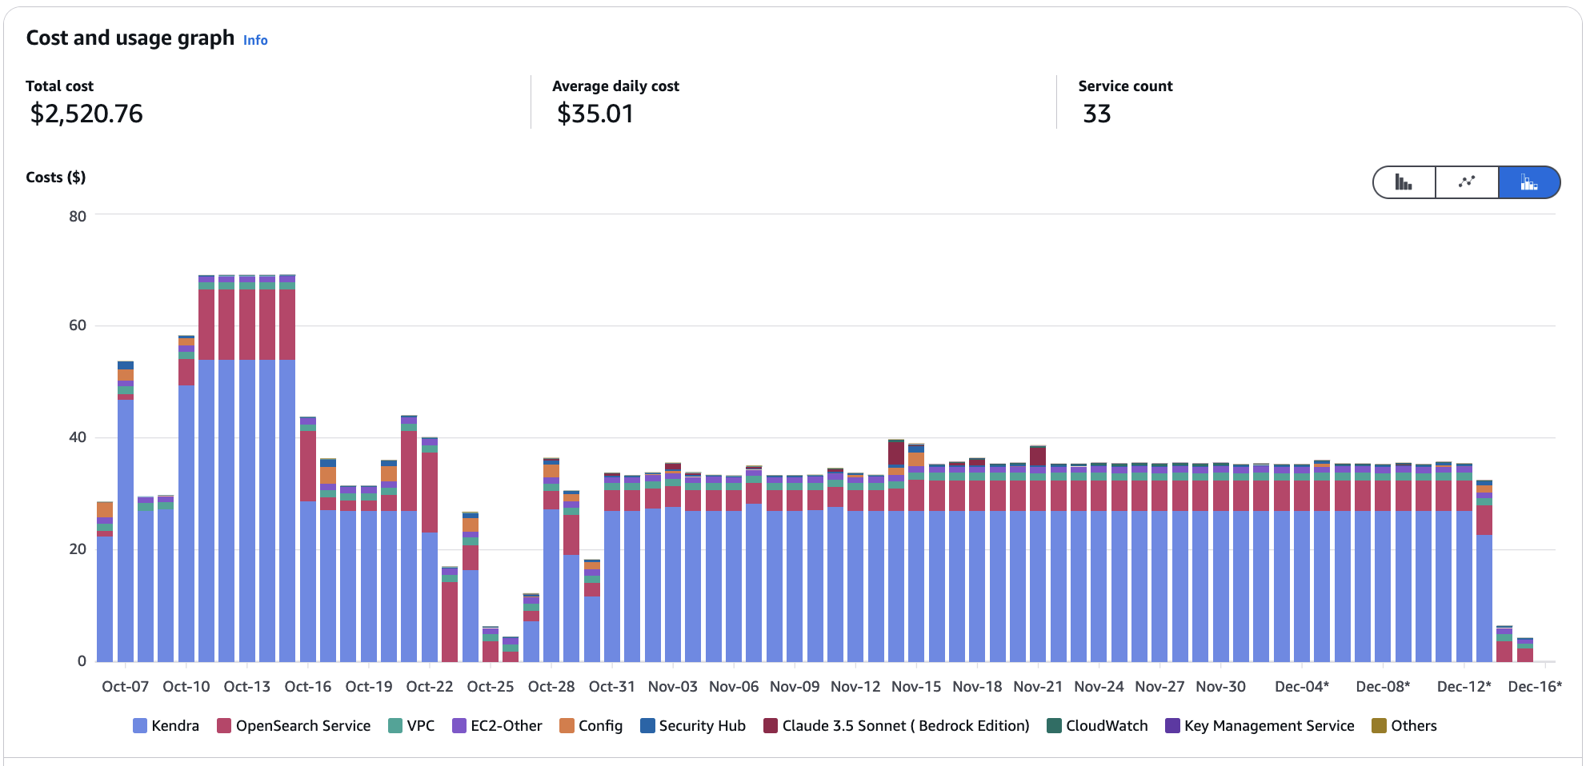

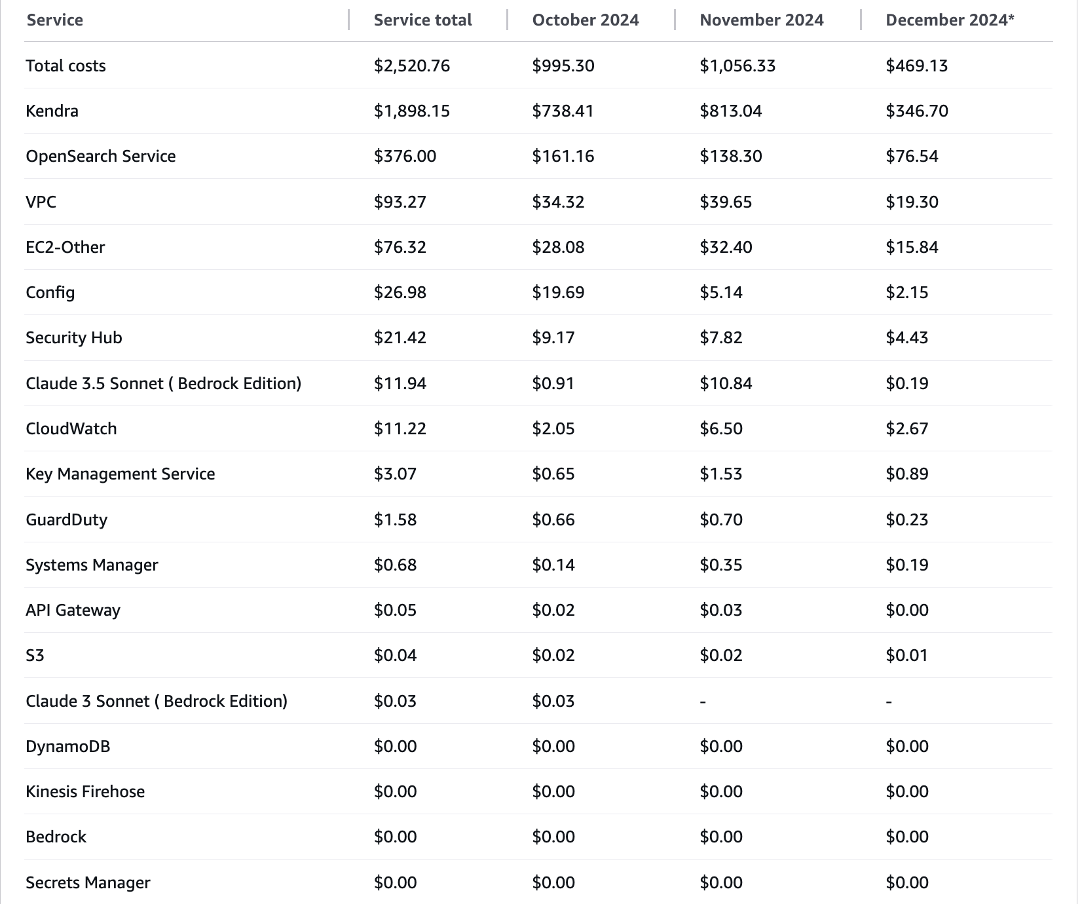

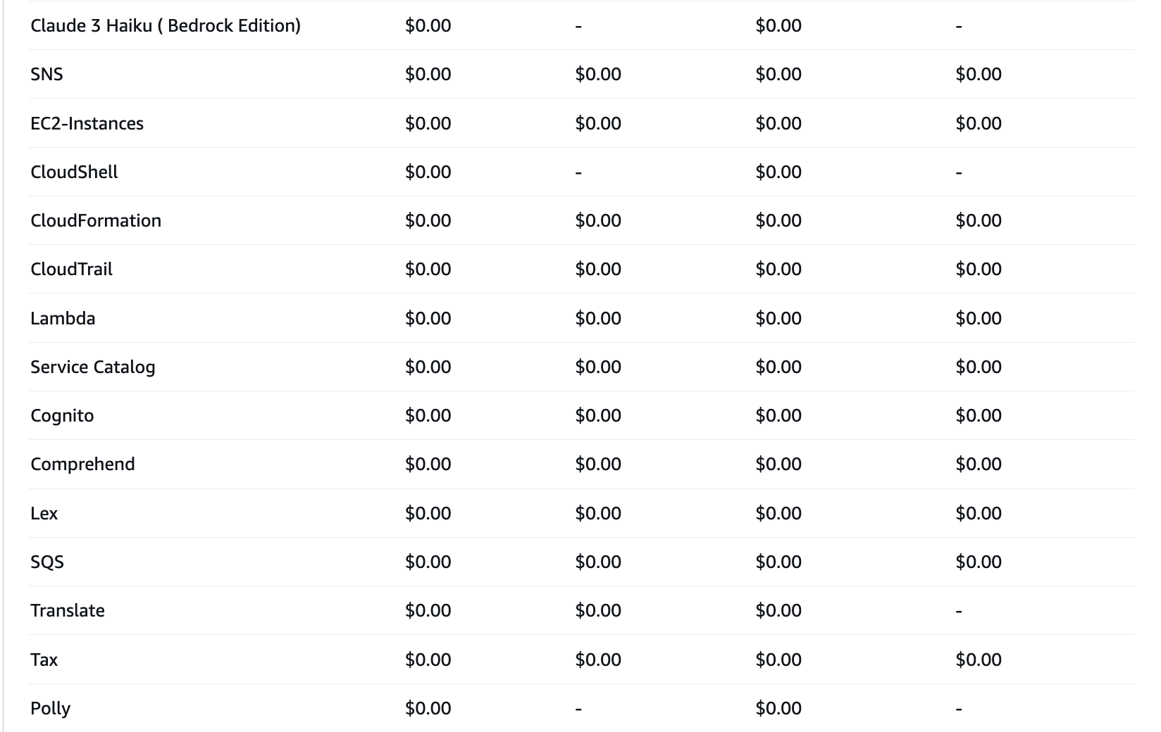

# Future Work

**1. Multi-Language Support**: Virginia Beach has a diverse population with many people who speak languages other than English. To make this chatbot accessible to everyone, Multi-language support can be integrated into the chatbot using Amazon Translate, enabling real-time translation and expanding accessibility for non-English-speaking users.

By using use Amazon Translate to automatically detect the language of user inputs and translate them in real time. We'll also create custom vocabularies for city-specific terms to ensure accuracy and incorporate Amazon Comprehend for deeper language analysis. The chatbot's interface will be updated to make it easy for users to select their language and see translations clearly.

**Advantages:**

Accessibility: Makes city information accessible to all residents, regardless of their primary language.

Engagement: Increases user satisfaction by removing language barriers.

Efficiency: Lowers reliance on human translators, which saves time and money.

**2. Integration with Other Bedrock Models:** We are considering integrating with other models like Meta LLaMA 90B Vision Instruct for its advanced capabilities in processing both visual and textual data. This could enhance how the chatbot handles tasks like analyzing images of city issues.

Image Processing: Allows residents to upload images directly to the chatbot for fast processing and response.

Enhanced Responses: Combines text and images for more accurate replies, particularly useful for city services requiring visual information.

**3. Fine-Tuning:** Currently, Claude 3.5 Sonnet, our primary model, doesn't support fine-tuning in AWS Bedrock. We are looking at models like LLaMA 90B that would allow for custom training to better meet local needs. If we switch to a model that supports fine-tuning, we can train it on specific data from Virginia Beach, like city records and service requests. This would help the chatbot understand local terminology and respond more effectively to common queries.

**Advantages:**

Customization: Tailors the chatbot to reflect Virginia Beach's unique context.

Accuracy: Improves how the chatbot understands and responds to user queries, leading to minimal errors and more relevant information.

Future-Readiness: Prepares the chatbot for future advancements in AI and evolving city needs.

**This page intentionally left blank**

Appendix

Appendix A: Domain Background

In modern times, it is essential for governments to establish effective communication channels with their citizens to address their needs efficiently. Traditional ways of getting information like making phone calls, visiting government companies in person, or using online websites are slow and frustrating. This traditional methods are not very efficient, which can make people feel upset and disconnected. As many people live in cities and technology gets better, number of questions and requests from citizens is increasing. Now people expect fast and personalized answers which the present systems struggle to provide. This shows a clear picture for better ways for the city governments to talk to and assist their citizens. [1]

In response, this project looks at using Generative AI technology to make government communication better. We are working on a Retrieval Augmented Generation(RAG) chatbot, which can talk to people and help answer their queries using advanced Generative AI technology. This chatbot provide fast and accurate responses, making it easier for everyone to get help from city government, anytime and from anywhere. This explains why we need this new solution and how it could change the way city government and citizens communicate. RAG chatbot can also makes the whole process of getting help simpler, which saves money and lets governments use their resources better. This is mainly important in large cities where resources are limited. This project not only meets the current need for better communication but also leads the way toward a more connected and advanced city management system.

The project employs Generative AI technology to enhance the efficiency and accuracy of communication between city governments and their citizens.

It is also important to look at traditional methods that are currently used for city government and citizen engagement and understand its faults. Initially, people call government offices to ask queries or to get help. This process mostly involves long wait time and being transferred to other departments, which can make people frustrated. Next, few people visit government offices in-person to get help they need. But it requires travelling and waiting in lines for long time, which is not always practical and by the way its waste of time. Finally, online webpages where people can find information and services they need. However, many websites are not easy to use and may not be updated with current information, which can confuse and prevent users who can’t find relevant information.

To leverage the limitations of traditional methods we are using advanced RAG Generative AI chatbot and NLP technologies hosted on Amazon Web Services(AWS), to offer more efficient, available, and responsive communication network [2]. AWS services used for this chatbot are:

**AWS QnA Bot:** It is a Generative AI enabled multi-language conversational interface that responds to your user questions, answers, and feedback. [2]

**Amazon Kendra:** It is an intelligent search service that uses NLP and advanced machine learning algorithms to return specific answers to search questions from Virginia Beach web data. [4]

**Amazon S3:** Amazon simple storage service(Amazon S3) is a storage service that offers industry leading scalability, data availability, security, and performance. Users and industries of all sizes can use Amazon S3 to store and protect any size of data like websites, mobile apps, backups, etc. S3 can be optimized, organized, and configured to control access to data in order to meet specific requirements.

**Amazon Lambda:** It processes the logic and manages the interactions between Amazon QnA bot and other services. Based on queries received it executes tasks and sending responses as needed. [7]

**Amazon Bedrock:** It is a service that offers a choice of high-performing foundational models from top AI Industries such as AI21 Labs, Anthropic, Cohere, Meta, Amazon, Mistral AI, and Stability AI with lot of capabilities needed to build generative AI applications with security, and privacy. With Bedrock you can easily experiment and evaluate top foundational models for your use case and customize them with your data using fine-tuning and RAG techniques that executes tasks using your data sources. [6]

**Amazon Cognito:** It is used to easily add user’s sign-ups and authentication to your web applications or mobile app.

**Amazon API Gateway:** It is fully managed service that makes easy for developers to create, publish, maintain, monitor, and secure APIs at any scale. This service act as “front door” for applications to access data or functionality from your backend services.

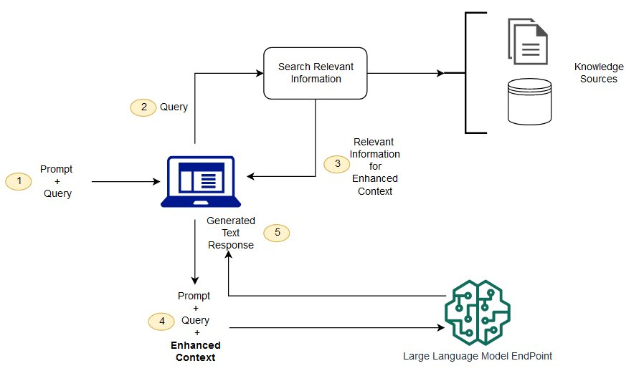

Figure : The conceptual flow of using RAG with LLMs

The above flow diagram shown in figure 1 outlines how a RAG chatbot system using a large language model processes and responds to user queries. The process starts first when a user types in a query(input). This input is combined with pre-set instructions known as prompt, that helps system understand how to process a user’s query. Then this combined prompt and query are sent as query for system, where it starts to process the user’s request. The system then searches information related to query through various knowledge sources such as documents or databases to find relevant information. Once it finds relevant information, then this data is used to expand the content of the original query. This is important step as it enriches the understanding of system, allowing it to make more accurate connections and conclusions based on user query. Now the original prompt and query are updated with this enriched content, which is more detailed, helping the system to generate better responses. Using this more detailed understanding of query, the system uses large language model to generate responses which are accurate and relevant to user’s initial query. [3]

In Conclusion, this project recognizes the challenges people often face when trying to communicate with city governments. So, we are creating a new RAG chatbot that uses advanced generative AI technology to give fast and accurate answers. This chatbot is built using Amazon Web Services helps city government communicate better and making it easier for everyone to get help without delays. This chatbot is prepared for today’s technology growing world, ensuring it can continue to serve citizens well as their needs evolve and to increase community satisfaction and knowledge by enhancing the relationship between city governments and their citizens.

Appendix B: Glossary

|  |  |
| --- | --- |
| Term | Definition |
| Artificial Intelligence(AI) | It is a technology that makes systems do things on its own rather than human intelligence. In this project, AI helps the chatbot answer questions all by itself. |
| Generative AI | This type of AI can create new information on its own. In this project Generative AI help chatbot to answer questions of citizens all by itself. |
| Chatbot | Chatbot is a program that can chat with the people. You can type in your query, and it replies right away like someone texting you. |
| Natural Language processing(NLP) | Natural Language Processing is a technology that gives systems the ability to interpret, control, and understand human language. |
| Large Language Model (LLM) | LLM is a computational model capable of generating language or performing other natural language processing tasks. These models acquire their abilities by learning statistical relationships from vast amounts of text during a self-supervised and semi-supervised training process. |
| Authentication | It is the process of verifying the identity of a user or system. |
| Retrieval Augmented Generation (RAG) | RAG is a unique tool used by our chatbot to make sure, the answers it generates are accurate. It thinks real and exact information from our data source records to help answer the queries properly. |
| Natural Language Understanding (NLU) | It is a branch of artificial intelligence that focuses on enabling computers to understand and interpret human language in a meaningful way. |

Table : Glossary Table

Appendix C: GitHub Repository

**GitHub Repository Link**

[Urban Brains GitHub Repository Link](https://github.com/PraneethReddyVattipally/Urban-Brain)

**GitHub Repository Contents**

Generative AI Retrieval-Augmented Generation (RAG) Chatbot Prototype for City Governments

**Overview**

This repository contains the code and documentation for a Generative AI Retrieval-Augmented Generation (RAG) chatbot prototype developed for the City of Virginia Beach Government. The chatbot aims to improve citizen engagement and streamline access to city services by integrating advanced AI technologies with AWS services.

**Project Structure**

**Problem Definition:** Generative AI Retrieval-Augmented Generation (RAG) chatbots represent a significant advancement in the field of artificial intelligence. By combining the strengths of generative models and retrieval-based systems, RAG chatbots provide accurate, timely, and contextually relevant responses to user queries. This project addresses challenges such as information accessibility, timely updates, and efficient query handling for city government services.

**Datasets:** The City of Virginia Beach government website (https://virginiabeach.gov/) serves as the primary data source for this project. The website contains essential information such as public policies, community announcements, events, permits, and city service updates, which are indexed and retrieved by the chatbot to answer citizen inquiries effectively.

**Implementation:** The chatbot development process focuses on integrating key AWS services with advanced Generative AI models:

**Amazon Bedrock:** Integrates the Anthropic Claude LLM for conversational AI. Amazon Kendra: Crawls and indexes the City of Virginia Beach website to provide relevant search-based content. Amazon Lambda: Facilitates serverless backend operations for processing user queries. Amazon S3: Secure storage for crawled data and chatbot configurations. Amazon Cognito: Ensures user authentication and access control. The implementation also includes prompt engineering and iterative testing to optimize performance.

**Testing:** The chatbot was tested through manual evaluation across multiple categories:

**Functional Testing**: Validated the chatbot’s ability to provide accurate responses to over 200 city-related queries. Error Handling Testing: Assessed how well the chatbot managed queries with typos or incomplete information. Response Quality Testing: Evaluated the chatbot's accuracy, confidence, and relevance when handling diverse inquiries. User Feedback Testing: Implemented a feedback system for thumbs-up/thumbs-down ratings to identify areas for improvement.

**Findings:** The chatbot successfully demonstrated its ability to deliver:

Accurate and contextually relevant responses for straightforward queries. Effective handling of paraphrased and reformulated questions. Limited ability to manage multi-turn conversations and ambiguous inputs, indicating areas for future improvement.

**Summary:** This project establishes a scalable and secure Generative AI RAG chatbot that enhances communication between city governments and citizens. By integrating AWS tools and Anthropic Claude LLM, the chatbot delivers timely, accurate, and user-friendly responses, improving public access to essential city services.

**Future Work:** Multi-Language Support: Implement Amazon Translate to enable support for Spanish, Tagalog, Vietnamese, Korean, and Arabic languages. Integration with Other Models: Explore integration with Meta LLaMA 90B Vision Instruct to enable image-based query processing. Fine-Tuning Capabilities: Investigate models that support fine-tuning to customize chatbot performance for local terminology and specific city service requirements.

**AWS Services Used**

Amazon S3: Storage for dataset and chatbot-related files.

Amazon Q&A bot: Handles user interactions and processes queries.

Amazon Kendra: Provides intelligent search capabilities.

Amazon Bedrock: Utilizes high-performing foundation language models (LLMs).

AWS Lambda: Facilitates serverless computing functions.

Amazon Cognito: Manages user authentication and security.

Appendix D: Risks

Sprint 1 Risks

|  |  |  |  |  |
| --- | --- | --- | --- | --- |
| Risk | Description | Probability | Impact | Mitigation |
| Lack of Knowledge on Generative AI | Team is unfamiliar with Generative AI may hinder their ability to define the problem accurately and develop a feasible solution | High | Low | Utilizing online resources, and documentations on Generative AI. |
| Group Errors | Errors made by team members during the problem definition phase could lead to  incorrect requirements and deliverables. | High | Low | Helping each other and reviewing as a team. Regularly review each other's work, hold team meetings to discuss progress. |

Table : Sprint 1 Risks

In Sprint 1, we identified 2 primary risks that could possibly impact our progress and outcomes. First there is high probability that our teams lack of familiarity with Generative AI can delay our ability to accurately define and address the problem, still the impact is expected to be low. To counter this risk, we planned to extensively utilize online resources and documentations on Generative AI to boost our understanding in Generative AI. Next, we expect a high probability of error within team during problem definition phase due to possible miscommunications between team members in capturing project requirements. The impact of these group errors is also expected to be low, and we planned to mitigate this risk by adopting a collaborative environment where team members can regularly review each other’s work and hold team meeting to discuss progress. By proactively addressing this risks, we aim to maintain the project integrity and ensuring its successful execution.

Sprint 2 Risks

|  |  |  |  |  |
| --- | --- | --- | --- | --- |
| Risk | Description | Probability | Impact | Mitigation |
| AWS  Services | Using the AWS tools and its interface | Medium | Low | Using 50$ free credit given to each teammate to understand the Interface of the tools. |
| AWS Cost Management | Inefficient use of AWS services leading to excessive costs exceeding budget limits | Low | Medium | Implement cost monitoring and alerts using AWS Budgets and Cost Explorer. Set up billing alerts and use AWS’s free tier and cost optimization practices to stay within budget. Regularly review AWS usage reports to adjustment as needed. |

Table : Sprint 2 Risks

We recognized two primary risks in Sprint 2 that might influence our advancement. The first concern is that our team might be holding down our workflow due to our lack of experience with AWS tools and their UI. The impact, however, should be low because we are making use of the $50 in free credits that each teammate receives to explore and understand the tools. The second risk relates to AWS cost management, if team use AWS services inefficiently it will lead to increased budget limits. The impact for this is medium but it can be mitigated by implementing cost monitoring and alerts using AWS budgets, cost explorer and team should regularly review AWS usage reports to do adjustments as needed.

Sprint 3 Risks

|  |  |  |  |  |
| --- | --- | --- | --- | --- |
| Risk | Description | Probability | Impact | Mitigation |
| Cost Management | Overspending on AWS services beyond budget limits | Low | Medium | Monitor costs with AWS Budgets and Cost Explorer. Set up alerts and use cost-saving practices. Regularly review usage and adjust as needed. |

Table : Sprint 3 Risks

In Sprint 3, we identified 2 risks that might impact our progress and outcomes. Our first risk is about AWS Costs, we are overspending than the estimated limits. The only way to mitigate this issue is by monitoring costs with AWS budgets and cost explorer and using cost-saving practices. Team should regularly review the usage and adjust the services as needed.

Sprint 4 Risks

|  |  |  |  |  |
| --- | --- | --- | --- | --- |
| Risk | Description | Probability | Impact | Mitigation |
| Limited Test Plan | Relying solely on manual testing may not fully capture all aspects of the chatbot's performance and functionality | Medium | Medium | Leverage automated testing tools to increase testing efficiency. |

Table : Sprint 4 Risks

In Sprint 4, we identified a risk related to our current testing strategy for the chatbot, where we primarily rely on manual testing. This approach may not fully capture all aspects of the chatbot’s performance and functionality. Given that this is a medium-level risk, there’s a possibility that some issues might be overlooked, potentially impacting the chatbot's overall performance. To mitigate this, we plan to incorporate automated testing tools to complement our manual efforts. By leveraging automation, we can improve testing efficiency and ensure a more comprehensive evaluation of the chatbot. This will help us identify performance gaps and functionality issues more effectively, providing a clearer understanding of the chatbot's strengths and areas for improvement.

Sprint 5 Risks

|  |  |  |  |  |
| --- | --- | --- | --- | --- |
| Risk | Description | Probability | Impact | Mitigation |
| Limited Test Plan | Relying solely on manual testing may not fully capture all aspects of the chatbot's performance and functionality | Medium | Medium | Leverage automated testing tools to increase testing efficiency. |

Table : Sprint 5 Risks

In Sprint 5, we identified a risk related to our current testing strategy for the chatbot, where we primarily rely on manual testing. This approach may not fully capture all aspects of the chatbot’s performance and functionality. Given that this is a medium-level risk, there’s a possibility that some issues might be overlooked, potentially impacting the chatbot's overall performance. To mitigate this, we plan to incorporate automated testing tools to complement our manual efforts. By leveraging automation, we can improve testing efficiency and ensure a more comprehensive evaluation of the chatbot. This will help us identify performance gaps and functionality issues more effectively, providing a clearer understanding of the chatbot's strengths and areas for improvement.

Appendix E: Agile Development

Scrum Framework Team Approach

Figure : Sprint project dates.

We managed to keep organized and focused on the objectives of the project by holding daily Scrum calls to assign tasks, discuss progress, and resolve any problems. For some team members who were unfamiliar with the Scrum framework, it took some time to get used to it, but the daily meetings made it easier. It was first difficult to manage the project using YouTrack as well. Since many of us were not familiar with the application, it took some time for us to figure out how to use its task tracking, sprint creation, and workflow management capabilities efficiently. We had to spend more time getting to know its interface and learning how to build up issues, connect them to sprints, and efficiently track progress. We discovered over time that maintaining regular updates and the creation of comprehensive tasks and subtasks in YouTrack were critical to the project's success. Even with the initial challenges, we were able to keep a clear picture of our progress and responsibilities because of the daily Scrum calls and the organized use of YouTrack. Any team thinking about taking on a project like this should allow time for training on new tools and show patience as everyone gets used to the new procedures. Adopting new frameworks and technologies might be challenging, but it can be overcome with regular communication and a willingness to learn.

**Sprint 1 Lessons Learned**

User Stories and Objectives:

In Sprint 1, we worked on various important aspects to improve our project further. We mapped our learning efforts towards YouTrack training, Agile and AWS technologies. To achieve complete coverage of these learning areas, every member of the team was given several tasks. Working together, we were able to outline a project architecture to direct us in our work. The purpose of this sprint was to come up with the problem statement for the project that we are working on, the Generative AI RAG (Retrieval Augmented Generation) chatbot prototype for city governments.

Task execution: The plans made for Sprint 1 have been successfully implemented. All the team allocated specific responsibilities, and we gained some knowledge in YouTrack, Agile methodology, and AWS technologies which included building architecture and focused on submissions.

Several challenges emerged: We experienced a few challenges in the first sprint. Our main emphasis was to grasp the technology relevant to the project. Through targeted training and useful talks with the clients, we were able to build up our knowledge. While there were few deliverables this sprint, the insights we got will be vital for the project's future.

What went well: Our daily scrum meetings facilitated effective communication and significantly improved our teamwork. The consistent interaction enabled us to complete the tasks assigned to each team member efficiently. The collaborative environment fostered by these meetings ensured alignment with our objectives and deadlines.

Room for improvement: We must move quickly forward to guarantee the project's success. Since the technologies are new, it is essential to have a comprehensive understanding from the beginning.

Lessons learned: We acquired substantial knowledge in AWS tools, Agile methodology, and YouTrack usage. These insights will be instrumental in guiding our future efforts and ensuring the successful execution of our project objectives.

**Sprint 2 Lessons Learned**

Working on the dataset of Virginia Beach website for the Generative AI RAG chatbot prototype for city governments was our focus during Sprint 2. Using AWS Kendra to start data crawling was our primary goal. Many of us had never used AWS Kendra before, so we took some time to become familiar with its features and UI. We worked on our report and presentation for the Sprint 2-week 1 submission concurrently.

User Stories and Objectives:The objective was to begin data crawling activity with AWS Kendra. Our goal was to organize and manage the dataset needed for our project by utilizing its features. As we gained experience with the tool, we made headway in configuring the data flow. We worked on cost estimation for the entire project in AWS Tools.

Task execution: We divided tasks among the team to explore different aspects of AWS Kendra. This involved learning how to configure it for data crawling, managing the dataset, and making necessary adjustments. We also worked on the report and presentation to capture the progress made during this sprint.

Several challenges emerged: We had difficulty with AWS Kendra's many functions because of its steep learning curve. But we started getting past the early challenges by reading tutorials, teamwork and frequent conversations.

What went well: Progress was steady because of the team's capacity for cooperation and adaptation. We managed to keep in sync with each other through our daily Scrum meetings, and in spite of the difficulties, we were able to begin deploying data crawls.

Room for improvement: We need to become more familiar with AWS tools more quickly to work more efficiently. Spending more time practicing and applying what we've learned will help us work through the tasks faster and with fewer issues.

Lessons learned: Quickly adjusting to new tools and technologies is crucial, as seen by Kendra's experience with AWS. As we proceed into the upcoming sprint and the project's execution phase, this information will become crucial.

**Sprint 3 Lessons Learned**

User Stories and Objectives:

In Sprint 3, we concentrated on building the core components of the Generative AI RAG chatbot for city government. After completing the data crawling with AWS Kendra in Sprint 2, our goal was to develop the chatbot system and ensure that everything worked as expected. The goal was to have a working version of the system at the end of the sprint.

Task Execution:

During this sprint, we focused on bringing the system into operation. Each team member was assigned tasks relating to constructing the chatbot based on the architecture we had already established. We also prepared the Sprint 3 project report and presentation. The primary goal was to connect all aspects of the system and ensure that they operated together smoothly.

Challenges:

We encountered some difficulties while connecting the various components of the AWS tools. Despite having a clear plan, ensuring that everything worked effectively together required time and effort. We also needed to properly test the system to identify and resolve any faults.

What Went Well:

We were able to address issues as they appeared because of the team's good collaboration daily. We managed to develop the chatbot's primary features and connecting them according to our design. Moving forward was made possible by the work we completed in the last sprint, particularly with the Kendra data crawling.

Room for Improvement:

We concluded that more time needed to be dedicated to evaluating and enhancing the prompt for chatbot. By doing this, we can make sure that the chatbot is completed without any problems.

Lessons Learned:

We found that the knowledge we acquired from working on the Kendra data crawling in Sprint 2, prompt engineering and QnABot solution in this sprint 3 was beneficial to us before going to testing stage. Going forward, our main goal is to test the chatbot responses and performance to increase the systems reliability.

**Sprint 4 Lessons Learned**

User Stories and Objectives:

Our main goal in Sprint 4 was to thoroughly evaluate the chatbot's operation to make sure it satisfies the needs of giving Virginia Beach residents accurate and dependable information. We initially considered using Amazon Bedrock's model evaluation for performance comparison, but this was not applicable as the chatbot uses only the Claude 3.5 Sonnet model. Rather, we concentrated on manual testing to evaluate its functionality in real-world scenarios.

Task Execution:

The goal of the manual testing procedure was to assess the chatbot in a number of different categories. We put it to the test by seeing how well it handled simple questions on local services like public safety, community programming, and working hours. The chatbot did well with these questions, but it had trouble answering more difficult or ambiguous ones. Testing for error handling revealed that while the chatbot could handle little typos and grammatical errors, it struggled with queries that were noticeably incorrect or lacking information. Additionally, we examined its ability to adapt to various user demographics, such as tourists, families, and seniors, and discovered that it could successfully meet their needs. Tests of response quality showed that the chatbot regularly provided accurate and relevant responses. One thing that needed work, though, was keeping multi-topic discussions consistent. Additionally, the chatbot performed well when asked questions that were rephrased and paraphrased, and the user feedback system offered insightful information about areas that needed improvement.

Challenges:

We first thought about utilizing Amazon Bedrock's built-in model evaluation, but we soon discovered that it wasn't appropriate for our chatbot, which solely employs the Claude 3.5 Sonnet model. As an alternative, we looked into automated testing solutions, but because of limitations, we didn't put any into practice. As a result, manual testing became essential to obtain the required output.

What Went Well:

The chatbot's advantages and disadvantages were successfully determined through manual testing. It worked well with simple queries, adjusted to different user types, and successfully handled little typos and amended searches. The feedback system yielded insightful user data that will inform future improvements.

Room for Improvement:

There is potential for improvement by implementing automated testing in subsequent future, even though manual testing produced useful findings. A more thorough review could be possible and the testing procedure could be streamlined. Enhancing the chatbot's comprehension of intricate queries and context in multi-turn interactions is also a top priority.

Lessons Learned:

The significance of manual testing in identifying functional areas that require improvement has been reinforced by this sprint. It also emphasized the potential advantages of automated testing for testing that is more scalable and effective. Going forward, we will investigate automated testing options for a more comprehensive assessment while concentrating on enhancing the chatbot's ability to handle complicated queries and maintain conversation continuity.

**Sprint 5 Lessons Learned**

User Stories and Objectives:

Finalizing Sections 6 (Findings), 7 (Summary), and 8 (Future Work) of the report as well as producing a final project presentation were the main objectives of Sprint 5. These deliverables sought to provide an overview of the chatbot's evolution, emphasize its accomplishments, and suggest enhancements.

Task Execution:

The team created a concise, visually appealing presentation and combined earlier ideas to finish the research process. The outputs showed the chatbot's advantages, disadvantages, and room for development.

Challenges:

Managing time well to balance the production of thorough report sections with a cleaned, well-organized presentation was one of the main challenges. In order to preserve clarity and the organization, it also took more work to combine the team's many inputs into a single report.

What Went Well:

With excellent collaboration, the report sections and presentation were finished on time. The results were thoroughly recorded, and the project was briefly summed up in the presentation.

Room for Improvement:

In order to identify discrepancies early on, future attempts should use a systematic review approach and give additional time for report refinement. The performance of the chatbot could be further validated by additional user input.

Lessons Learned:

Producing high-quality results requires clear communication and teamwork. To ensure effective completion, the process was streamlined by early planning, iterative reviews, and work division into smaller parts.

References

Works Cited

[1]. M. Pislaru, C. S. Vlad, L. Ivascu, and I. I. Mircea, “Citizen-Centric Governance: Enhancing Citizen Engagement through Artificial Intelligence Tools,” Sustainability, vol. 16, no. 7, p. 2686, Mar. 2024, doi: 10.3390/su16072686.

[2]. “Solving with AWS Solutions: QnABot on AWS,” Amazon Web Services, Inc. [Online]. Available: <https://aws.amazon.com/solutions/implementations/qnabot-on-aws/>

[3]. “What is RAG? - Retrieval-Augmented Generation AI Explained - AWS,” Amazon Web Services, Inc.<https://aws.amazon.com/what-is/retrieval-augmented-generation/>

[4]. “What is Intelligent Search? (2:57),” Amazon Web Services, Inc. [Online]. Available: <https://aws.amazon.com/kendra/>

[5]. “What Is Amazon Lex? - Amazon Lex V1.” <https://docs.aws.amazon.com/lex/latest/dg/what-is.html>

[6]. “Build Generative AI Applications with Foundation Models - Amazon Bedrock - AWS,” Amazon Web Services, Inc .<https://aws.amazon.com/bedrock/>

[7]. “Introduction to AWS Lambda - Serverless Compute on Amazon Web Services (3:01),” Amazon Web Services, Inc.[Online]. Available: <https://aws.amazon.com/pm/lambda/>

[8]. “Amazon Kendra Web Crawler - Amazon Kendra.” <https://docs.aws.amazon.com/kendra/latest/dg/data-source-web-crawler.html>

[9]. “Amazon S3 - Cloud Object Storage - AWS,” *Amazon Web Services, Inc.* <https://aws.amazon.com/s3/>

[10]. “Security best practices for Amazon S3 - Amazon Simple Storage Service.” <https://docs.aws.amazon.com/AmazonS3/latest/userguide/security-best-practices.html>

[11]. “Amazon S3 Simple Storage Service Pricing - Amazon Web Services,” *Amazon Web Services, Inc.* <https://aws.amazon.com/s3/pricing/?nc=sn&loc=4>

[12]. “Home,” *City of Virginia Beach*, Oct. 04, 2024. <https://virginiabeach.gov/>

[13]. “Security - QNABOT on AWS.” <https://docs.aws.amazon.com/solutions/latest/qnabot-on-aws/security-1.html>

[14]. “Anthropic’s Claude 3.5 Sonnet model now available in Amazon Bedrock - AWS,” *Amazon Web Services, Inc.* <https://aws.amazon.com/about-aws/whats-new/2024/06/anthropic-claude-3-5-sonnet-model-bedrock/>

[15]. “Build Generative AI Applications with Foundation Models - Amazon Bedrock Pricing - AWS,” *Amazon Web Services, Inc.* <https://aws.amazon.com/bedrock/pricing/>

[16]. “Choose the best performing model using Amazon Bedrock evaluations - Amazon Bedrock.” <https://docs.aws.amazon.com/bedrock/latest/userguide/model-evaluation.html>

[17]. “Create a model evaluation job in Amazon Bedrock - Amazon Bedrock.” <https://docs.aws.amazon.com/bedrock/latest/userguide/model-evaluation-jobs-management-create.html>

**This page intentionally left blank**